**WPI User Manual**

**Hardware and Software**

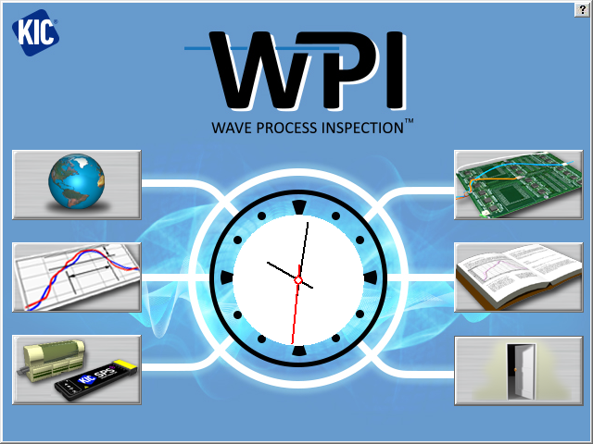

Version 3.5

Publication Number SFT-326000-000



**KIC WPI Hardware and Software User Manual**

Copyright © 2021 KIC. All rights reserved. Patents pending.

16120 West Bernardo Drive

San Diego, CA 92127

Phone: +1 858 673 6050 Fax: +1 858 673 0085

A Division of Embedded Designs Inc.

This document contains information that is proprietary to KIC. Said information, is copyrighted as is all associated software and hardware. All rights are reserved. Patents are pending.

This document and the information contained in it may not be sold, duplicated, used, or disclosed, in whole or in part, except as specifically authorized in writing by KIC. The information contained in this document and associated software is subject to change without notice.

There are no warranties with respect to the information contained in this document, express or implied, except as provided by written contract between KIC and the customer.

All KIC product names and logos are trademarks of Embedded Designs, Inc. All other trademarks used herein are the property of their respective owners.

**Software Licensing Agreement and Product Warranty**

The KIC software is subject to the following license terms and conditions.

**KIC SOFTWARE LICENSE**

* 1. This is a software license granted by *KIC*, mailing address 16120 West Bernardo Drive San Diego, CA 92127.
  2. The KIC software is licensed to you as the end user and is not sold.
  3. The KIC software is copyrighted material.
  4. The KIC software is licensed for use with one or more pieces of associated hardware that together constitute a thermal process management system. This license allows you to use the software with the purchased system. You must purchase additional copies of the software if used with additional system hardware.
  5. You may not change, modify, decompile, disassemble, or otherwise reverse engineer the licensed software or any associated hardware.

**LIMITED WARRANTY**

* 1. KIC warrants that the system hardware and software are free from defects in material and workmanship under normal use. KIC warrants that the system as a whole will perform substantially in accordance with the specifications set forth in the documentation provided with it.
  2. Warranty regarding rated temperature: Components of the system hardware are rated by KIC for proper performance up to a specified maximum temperature. Any component that KIC determines to have been exposed to temperatures higher than the rated temperature is not covered under this warranty.
  3. Start of the Warranty period. The warranty period begins the day the KIC product is delivered to you as the first customer.
  4. Obligations of KIC during the warranty period:
     1. Return for complete refund: If, within the first thirty (30) days after the start of the warranty, the customer returns, for any reason whatsoever, any of the purchased hardware or software in its original condition, KIC will refund the associated money paid and accept the return as payment for any money owed.
     2. Replacement: Within the first year of the start of the warranty, KIC will replace, on an exchange basis and without additional charge, any product proven defective in materials or workmanship.
     3. Correction of software: KIC will either replace or repair, without additional charge, any software that does not perform in substantial compliance with its documented specifications. In the foregoing circumstances, KIC will deliver either corrective code or a corrected copy of the software.
     4. Final Remedy: If KIC is unable to replace defective media or provide a corrected copy of the software within a reasonable amount of time, KIC will either replace the software with a functionally similar program or refund the license fees paid for use of the software.
  5. **Exclusion of Other Warranties**
     1. KIC does not warrant that the functions contained in the software will meet your requirements or that the operation of the software will be uninterrupted or error free. The Warranty does not cover any copy of the software that has been altered or changed in any way by you or others. KIC is not responsible for problems caused by changes in the operating characteristics of the computer hardware or operating system which are made after delivery of the software.
     2. **EXCEPT WHERE LIMITED BY LOCAL JURISDICTIONS, KIC SHALL NOT IN ANY CASE BE LIABLE FOR SPECIAL, INCIDENTAL, CONSEQUENTIAL, INDIRECT OR OTHER SIMILAR DAMAGES ARISING FROM ANY BREACH OF THESE WARRANTIES EVEN If KIC OR ITS AGENT HAS BEEN ADVISED OF THE POSSIBILITY OF SUCH DAMAGES.**
  6. **Other Conditions**
     1. **The warranties set forth above are in lieu of all other warranties, whether oral, written or implied, INCLUDING BUT NOT LIMITED TO ANY IMPLIED WARRANTIES OF MERCHANTABILITY OR FITNESS FOR ANY PARTICULAR USE. the remedies set forth above are the customer’s sole and exclusive remedies**. Only an authorized officer of KIC may make modifications to this warranty, or additional warranties binding on KIC. Accordingly, additional statements such as advertising, collateral or presentations, whether oral or written, do not constitute warranties by KIC and should not be relied upon as such. This warranty gives you specific legal rights, and you may have other rights, which vary by state and/or country.

**LIMITATION OF LIABILITY**

* 1. In no case shall KIC's liability exceed the license fees paid for the right to use the licensed software or One Hundred Dollars ($100.00), whichever is greater.

Table of Contents

[Introducing the WPI System 1](#_Toc51666597)

[The Hardware 2](#_Toc51666598)

[Install the Software 5](#_Toc51666599)

[Start the Software 6](#_Toc51666600)

[The Main Screen 8](#_Toc51666601)

[Global Preferences 9](#_Toc51666602)

[Global Tab 9](#_Toc51666603)

[WPI Tab 10](#_Toc51666604)

[Disable Alarm Tab 13](#_Toc51666605)

[Barcode Tab 14](#_Toc51666606)

[Process Window Setup 15](#_Toc51666607)

[Flux Menu 16](#_Toc51666608)

[Edit Specs 17](#_Toc51666609)

[Specify Different Specs for Individual TCs 18](#_Toc51666610)

[Use Sweet Spot Target (Optional) 19](#_Toc51666611)

[Change Specs Name 19](#_Toc51666612)

[Save - Process Window 20](#_Toc51666613)

[Hardware Status 21](#_Toc51666614)

[Run A Profile 22](#_Toc51666615)

[Enter the Wave Solder Machine Recipe 23](#_Toc51666616)

[Attach Thermocouples 24](#_Toc51666617)

[Select Thermocouples 26](#_Toc51666618)

[Start the Profile 27](#_Toc51666619)

[Live Profile Graph 29](#_Toc51666620)

[Profile Retransmission 30](#_Toc51666621)

[View the Profile and Statistics 31](#_Toc51666622)

[Description Tab 38](#_Toc51666623)

[Optimization Tab 39](#_Toc51666624)

[Manual Profile Prediction 40](#_Toc51666625)

[Profile Explorer 43](#_Toc51666626)

[Find VP Production Run Data by Lot ID Code 44](#_Toc51666627)

[Browse for Historical Data 45](#_Toc51666628)

[View Historical Data Over a Network (History Mode) 45](#_Toc51666629)

[Profile Explorer Buttons 46](#_Toc51666630)

[Profile Explorer – Virtual Profiling 47](#_Toc51666631)

[History Data Files 49](#_Toc51666632)

[Insert Data Files from an Outside Source 49](#_Toc51666633)

[Rename Profiles 49](#_Toc51666634)

[Virtual Profiling 50](#_Toc51666635)

[Get a Valid Baseline Profile 50](#_Toc51666636)

[Create/Load a Virtual Profile 51](#_Toc51666637)

[Use the Profile Grouping Utility 52](#_Toc51666638)

[Monitor Production in Live Mode 57](#_Toc51666639)

[How to Avoid a Grey Crystal Ball 57](#_Toc51666640)

[Live Mode - General Tab 58](#_Toc51666641)

[Live Mode - Description Tab 61](#_Toc51666642)

[Live Mode - Charts Tab 62](#_Toc51666643)

[Live Mode- Troubleshooting Tab 64](#_Toc51666644)

[VP Live Mode Buttons 65](#_Toc51666645)

[Verify The Virtual Profile 66](#_Toc51666646)

[Historical Mode 68](#_Toc51666647)

[View Historical Data While Running a Live Virtual Profile 68](#_Toc51666648)

[Historical Mode - General Tab 68](#_Toc51666649)

[Historical Mode - Description Tab 71](#_Toc51666650)

[Historical Mode - Chart Tab 72](#_Toc51666651)

[Historical Mode - Troubleshooting Tab 74](#_Toc51666652)

[Barcode Functions 75](#_Toc51666653)

[Barcode Types 76](#_Toc51666654)

[Scanner Installation 79](#_Toc51666655)

[Virtual Profiling and Barcodes 80](#_Toc51666656)

[Enable Barcoding Per Product 83](#_Toc51666657)

[Display the Current Barcode Queue 83](#_Toc51666658)

[View Barcode Traceability Information For Boards Previously Run 86](#_Toc51666659)

[Search For Barcode Entries 86](#_Toc51666660)

[Live Data Output And Barcodes 87](#_Toc51666661)

[Live Data Output 88](#_Toc51666662)

[LDO Formats 89](#_Toc51666663)

[Details of Output Files 89](#_Toc51666664)

[Configure LDO 90](#_Toc51666665)

[Delete Accumulated LDO Files 91](#_Toc51666666)

[Remote Process Monitoring 92](#_Toc51666667)

[Configure RPM Output 94](#_Toc51666668)

[KIC Server 95](#_Toc51666669)

[KIC Viewer 97](#_Toc51666670)

[O2 Live (Optional) 104](#_Toc51666671)

[Configuration 104](#_Toc51666672)

[Operation 105](#_Toc51666673)

[VP Idle Mode (Optional) 106](#_Toc51666674)

[Configuration 106](#_Toc51666675)

[Units Per Hour 107](#_Toc51666676)

[Configuration 107](#_Toc51666677)

[Auto-VP 108](#_Toc51666678)

[Password Protection 109](#_Toc51666679)

[Profile Printing 110](#_Toc51666680)

[Portrait Mode 110](#_Toc51666681)

[Landscape Mode 111](#_Toc51666682)

[Write Data To and View WPI Data Over A Network 112](#_Toc51666683)

[Write Data To A Network Drive 112](#_Toc51666684)

[View Historical Data 115](#_Toc51666685)

[Status Messages And Alarms 116](#_Toc51666686)

[Acknowledge Alarms 116](#_Toc51666687)

[Messages During Profiling and Baseline Profiling 117](#_Toc51666688)

[System Message and Alarms 117](#_Toc51666689)

[Light Tower 131](#_Toc51666690)

[Standard Light Tower 131](#_Toc51666691)

[3 Color USB Light Tower 131](#_Toc51666692)

Appendices

[Appendix A: The Process Window Index 132](#_Toc51666910)

[The Problem 132](#_Toc51666911)

[Define the Process Window Index 132](#_Toc51666912)

[Calculate the PWI 133](#_Toc51666913)

[Benefits of Ranking Thermal Profile Performance 134](#_Toc51666914)

[Conclusion 134](#_Toc51666915)

[Appendix B: Configuration Program 135](#_Toc51666916)

[User Settings Tab 135](#_Toc51666917)

[Use Baseline Profile Expiration 136](#_Toc51666918)

[Shifting Tab 137](#_Toc51666919)

[Machine Configuration 137](#_Toc51666920)

[Decimal Tab 137](#_Toc51666921)

[Hardware Tab 137](#_Toc51666922)

[LDO Tab 138](#_Toc51666923)

[Auto-VP Tab 138](#_Toc51666924)

[RPM Tab 138](#_Toc51666925)

[Message Config Tab 138](#_Toc51666926)

[Password Control – Multi-User 139](#_Toc51666927)

[Access to the Password Control Tab 139](#_Toc51666928)

[Multi-User Control 140](#_Toc51666929)

[Password Control Tab 141](#_Toc51666930)

[User Type Area 143](#_Toc51666931)

[Password Area 144](#_Toc51666932)

[Password Timer Area 144](#_Toc51666933)

[Main Screen With Password Control 145](#_Toc51666934)

[Example of Limited Access to Functions 147](#_Toc51666935)

[Responding to an Alarm 147](#_Toc51666936)

[Alarm Tab 148](#_Toc51666937)

[Alarm Relay Matrix configuration 148](#_Toc51666938)

[USB Light Tower configuration 149](#_Toc51666939)

[Barcode Tab 150](#_Toc51666940)

[Barcode Interface Method Area 151](#_Toc51666941)

[Missing Barcode Trigger Area 151](#_Toc51666942)

[Process Control String Area 152](#_Toc51666943)

[Disable Missing Barcode Option Area 152](#_Toc51666944)

[Barcode Filter Area 152](#_Toc51666945)

[Contact KIC 153](#_Toc51666946)

# Introducing the WPI System

The WPI (Wave Process Inspection) system is a comprehensive suite of thermal process management tools designed to give you the ultimate in PCB soldering quality control. WPI can monitor the entire wave solder process, giving advanced warning before a product drifts out of specification.

WPI combines software and hardware components into an integrated system. The software supplements its thermal profile analysis core with special tools for performance optimization, changed variable prediction, and data file management. The WPI hardware utilizes an array of sensors that measure process temperatures, sensors to track product movement and conveyor speed, a profiler (not included) to move through the process accumulating thermal data, an Ethernet communication hub, and alarm system.

## The Hardware

The major hardware components to a WPI system are:

* KIC DAU (Data Acquisition Unit) or eTPU (ethernet Thermocouple Processing Unit)
* Probes – 30 thermocouples
* Conveyor speed encoder
* Board sensor
* Fixed Pyrometer sensor
* Alarm relay/light tower
* Profiler

### DAU/eTPU

The DAU or eTPU interfaces with the computer using an Ethernet cross-over cable that connects from the UpLink port on the device directly to a USB to Ethernet adapter (or to an installed Network Interface Card (NIC)). Please follow manufacturers’ instructions to install the USB adapter or NIC.

The computer used with the WPI system can be a machine that is dedicated to only supporting WPI or it can also serve as the machine controller PC.

The DAU/eTPU must be plugged into an AC power source. It utilizes a universal A/C transformer power supply and ships from the factory with multiple AC connectors to accommodate any connector/voltage requirement.

### Probes

The probes are mounted in the machine process chamber. They are usually suspended above and below the product. The probes are connected to the DAU/eTPU - Odd/Even ports. Each probe connector is stamped with an **E** or **O** in order to designate **Odd** or **Even**. See the [Hardware Diagram](#_Hardware_Diagram_1).

### Conveyor Speed Encoder

The conveyor speed encoder is mounted to read pulses from a gear that turns while the conveyor is operating. The conveyor speed encoder connects to channel #1 of the DAU/eTPU Sensor ports.

### Board Sensor

The board sensor is mounted near the entrance of the machine and provides for product tracking. It is connected to channel #2 of the DAU/eTPU Sensor ports.

### Fixed Pyrometer Sensor

The fixed pyrometer sensor is mounted outside the process tunnel, at the exit of the machine to read the direct temperature of each board as they exit the machine. It connects to channel #4 of the DAU Sensor ports, or to a USB port on the PC (through an adapter module) when used in conjuction with an eTPU.

### Alarm Relay/Light Tower

The Alarm Relay connects to the Alarm/Barcode port of the DAU/eTPU and allows for integration to an infeed conveyor (available with SMEMA interface connections) to prevent products from entering machine when an alarm condition occurs or hardwiring to an external device of your choosing. Additionally, it allows for a standard KIC supplied audible light tower to be powered and triggered. The Alarm Relay is required to have an external AC power source.

There are two audible light towers available – one model connects directly to the Alarm Relay device; the other model connects directly to the USB port of the PC. See the [Light Tower section](#_Light_Tower).

### Profiler

The profiler is the product specific data acquisition component of the WPI system. It provides the on-board, through-the-process temperature data. WPI analyzes this data together with machine temperatures and conveyor speed factors to graphically display the thermal profile.

### Profiler Models

You can use WPIsoftware with the following profiler models:

1. SPS Smart Profiler
2. X5
3. K2

The software works the same with any of the profilers. Once you have the software running, you indicate your specific profiler model. (The artwork that appears throughout this manual reflects a variety of profiler models.)

Certain profilers can operate in either of two modes—datalog and wireless*.* In standard datalog mode, the profiler records temperature data as it moves through the thermal process. A cable then transfers the data to the WPI software computer. In wireless mode, the profiler transmits data directly to the computer by radio signals or Wi-Fi instead of an attached cable. WPI software can then display the accumulating data in real-time.

For specific information regarding your profiler, consult one of the following KIC publications:

* SPS Smart Profiler Hardware Guide, (Publication Number PTG-330310-000)
* X5 Profiler Hardware Guide, (Publication Number EXP-337310-000)
* K2 Profiler Hardware Guide, (Publication Number EXP-331310-000)

### Barcode Reader

A user-supplied, serial port barcode reader can connect through the DAU/eTPU Alarm/Barcode port. When used in conjunction with the alarm relay, the barcode reader hardware is connected using the alarm relay Y- cable. Alternately, a USB barcode reader can connect through one of the DAUs built-in USB ports. For additional information about using barcode scanners, see [*Appendix C – Barcode Tab.*](#_Barcode_Tab_1)

### Hardware Diagram - DAU

The interconnection of the WPI components is illustrated in the hardware diagram below:

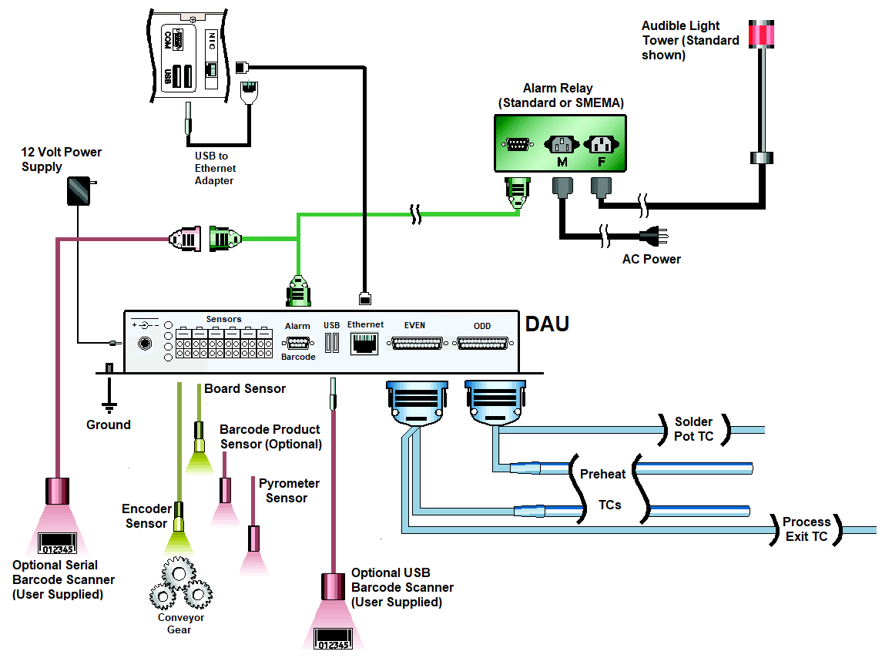

Figure 1: Hardware Configuration Diagram

Note #1: When an eTPU is used, a USB Barcode Scanner (user supplied) would be connected to a USB port directly on the PC.

Note #2: When an eTPU is used, the Fixed Pyrometer Sensor connects to a USB port on the PC through an additional adapter (additional hardware and cables included with system).

It is critical that all WPI hardware is properly installed and configured. If one of the system components is setup incorrectly or is malfunctioning, the WPI system will not allow you to run Virtual Profiling or provide accurate data. If you have any questions or are unsure about any of the following, call or email [KIC Technical Support](#_Contact_KIC) for assistance.

## 

## Install the Software

### Minimum PC System Requirements

* Dual Core / 1GHz processor PC with 2GB RAM
* 2GB available storage
* Video 1024 x 768 / 16-bit color
* 1 available USB port for data download
* 1 available USB port (for software key)
* 1 available Ethernet port or 1 available USB port with Ethernet-to-USB adapter
* For product compatibility with Windows® operating systems, visit our website at <http://kicthermal.com/support-download/os-compatibility-chart>

**Note**: Additional powered USB ports may be needed for additional accessories.

### Notes Before Installation

* Shut down all other applications as a precaution against software conflicts.
* If PC uses different login accounts, login using an Administrator or comparable access level to ensure proper installation/setup of all files and drivers.

### Languages

The software supports the following languages:

|  |  |
| --- | --- |
| * English | * Japanese |
| * German | * Korean |
| * Spanish | * Simplified Chinese |
|  | * Traditional Chinese |

The use of specific languages depends on the operating system:

* English, German, and Spanish can be run on any of the supported Windows operating systems.
* Japanese, Korean, Simplified Chinese, and Traditional Chinese cannot be used with English versions of Windows operating systems.
* To run the software in Japanese, the operating system must be Windows-Japanese version.
* To run the software in Simplified or Traditional Chinese, the operating system must be Windows-Chinese version.

### Install

1. Insert the USB flash drive into a USB port on your computer.
2. Depending upon your computer setup, a dialog box may appear. If it does, select **Open** folder to view **files**. If a dialog box does not appear, use Windows Explorer to browse to the USB flash drive directory.
3. Double-click the installation file in the root directory to begin the installation.
4. Follow the instructions for the installation program as the screens appear.

\*When installing the software over an existing WPI directory, the installation will automatically create a backup folder of the existing directory. A warning message will be displayed when selecting an existing directory, and a checkbox can be de-selected if you do not wish to create a backup.

The name of the backup directory created will be C:\WPI\_Old\_MM-DD-YYYY

**Note**: If you have questions regarding your hardware or software configuration contact [KIC Tech Support](#_Contact_KIC).

## Start the Software

**Note**: The installation automatically adds a **KIC** folder to the main Windows Start Menu.

|  |  |
| --- | --- |
| 1. Click the **Windows Start** button to locate the **WPI icon**.   **Note**: The icon may appear in the Start button’s list of frequently used applications or you can click the **All Programs** command to find it in the **KIC folder** that appears among the displayed folder/icon list. | Start button |

1. Click the icon. 

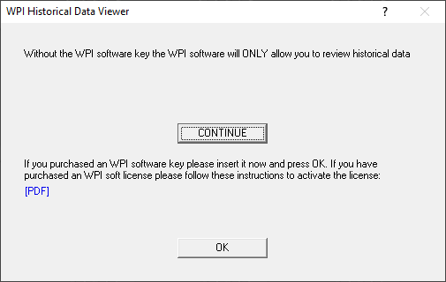

1. A specifically programmed USB dongle key is required to run the WPI software. When starting, if you see the above message, insert the key and click **OK**.

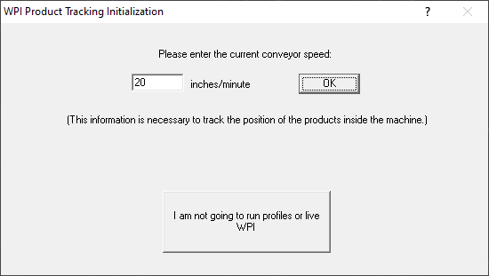

**View History Mode-**

Choose this button to view Virtual Profile history, browse to a different hard drive or computer on the network.

**Production Mode -**Choose this button to run profiles and Virtual Profiles.

Figure 2: Product Tracking Initialization

**Production mode -** If you wish to run profiles or Virtual Profile, enter the current conveyor speed for your machine and choose the **OK** button, this will activate Production mode. You can view historical data while in Production mode, but not while a Virtual Profile is running.

To view historical Virtual Profile data from the same PC while Virtual Profiling live, launch a separate KIC Host.exe file located in: C:\WPI\AppforViewer\KICHost.exe. This will open a separate Profile Explorer that lets you browse through the history of any product including the one currently running VP. Historical data will be available for any boards that have already exited the machine.

**View History mode** - If you wish to work offline and do not plan to profile or Virtual Profile, choose *I am not going to run profiles or live WPI* button, this will activate History mode. While History mode is active, you cannot run profiles or Virtual Profile, as the software will not communicate with the WPI hardware. The software will not even check for KIC hardware unless Production mode is active. If working in History mode you can browse to any working directory in Profile Explorer, even over a network.

# The Main Screen

The main WPI screen has six buttons. The buttons on the left are for setup and status; the buttons on the right are for running and viewing profiles and exiting the software. Placing the mouse pointer over each button will display a description for each button. See Figure 3.

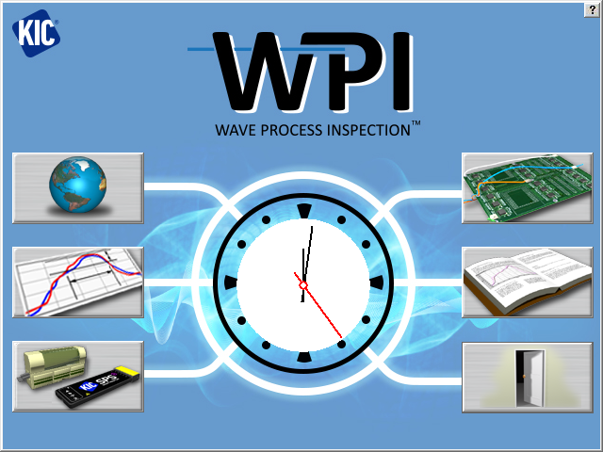

**Status**

**Exit**

**Run**

**Setup**

**View**

Figure 3: WPI Main Screen

|  |  |  |
| --- | --- | --- |
| **bt-NAV_Prefs Global Preferences**  Set units of measure, Maximum product start temperature, Machine name, Password, Board sensor, Cpk and Optional equipment setup.  **bt-NAV_Process-menu Define/Edit Process Window**  Create or edit Process Window files for flux and profile specifications.  **Hardware Status**  Shows the status of the Profiler, Software Protection key, and the KIC Probes |  | **bt-NAV_Run-profile Run a Profile**  Begins the step-by-step procedure for running a product profile.  **bt-NAV_Log-book Profile Explorer**  Filing system used to manage and view all profiles and Virtual Profiles run using the WPI software.  **bt-NAV_Exit Exit**  Exits the WPI software. |

# Global Preferences



## Global Tab

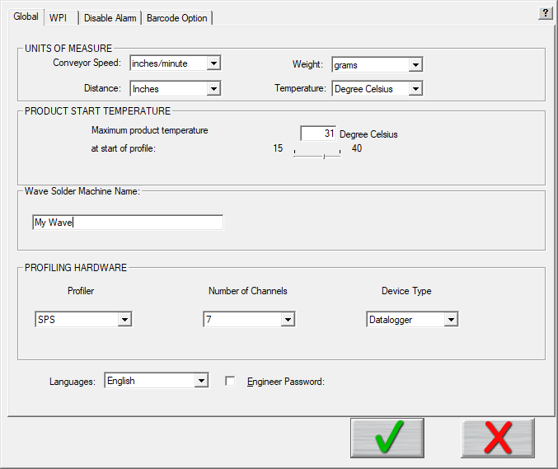

Figure 4: Global Tab

* **Units of Measure** – There are four drop down menus to choose units for *Conveyor Speed, Distance, and Temperature.*  Auto Focus users enter the units for weight.
* **Product Start Temperature** – The software cannot accurately analyze a profile while a board is too hot. Before it can begin, the temperature of all thermocouples connected between the product and the profiler must be below the value you specify here with the slider bar. Profiling automatically starts when the Air TC temperature drops to less than 2° C above the product start temperature.
* **Wave Solder Machine Name –** Enter a name for your machine. Configuration of the machine is done in a separate application. See [Appendix C - Configuration Program](#_Appendix_C:_Configuration) section for details.
* **Profiling Hardware** – Specify the model of your profiler, the number of channels (7, 9, or 12), and, if using the SPS Smart Profiler or X5, specify the data transmission mode (Datalogger or Transmitter).
* **Languages –** Select the language (English, Spanish, German, Traditional Chinese, Simplified Chinese, or Japanese) you prefer to see displayed in the software. A restart of software is required after change of language.
* **Engineer Password** – By checking this and entering a password you can control access to certain menus in the software. See the [Password Protection](#_Password_Protection) section of this manual for details.

## WPI Tab

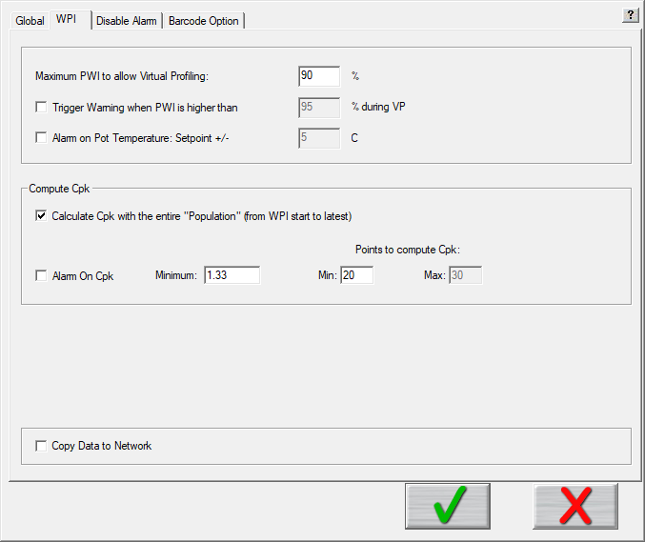

Figure 5: WPI Tab

**Maximum PWI to enable Virtual Profiling**

This value will determine the maximum PWI allowable in order for any given profile to qualify as a Virtual Profile baseline. If the PWI for a profile is lower than this value, it can be used as a Virtual Profile baseline. By default this value is 90%. Profiles that exceed this value can not be used for as a Virtual Profile baseline.

**Trigger Warning when PWI is higher than**

When enabled, the software posts a Warning status if the PWI during Virtual Profiing exceeds a specified value.

**Alarm on Pot Temperature**

When enabled by clicking the check box, this option lets you specify an alarm threshold for both minimum and maximum solder pot temperatures. A solder pot alarm condition can then activate the alarm relay and display the condition on a light bar.

### Compute Cpk

**Statistical Process Control** (SPC) for the thermal process is critical for any manufacturing program that involves continuous quality monitoring and improvement. SPC provides the ability to understand the predictability of the process and to know in real-time when a process may be changing and affect product quality.

**Process Capability Index** (Cpk) gives a continuous indication of how current production is keeping within specifications and will indicate if the process is drifting towards a condition where defective product may be produced. It is a measure of where the process spread falls within the Process Window. By monitoring this and alarming when it becomes too low, you can proactively address issues in the process before a single defect occurs.

* **Calculate Cpk with the entire “Population” (from WPI start to latest) –** When selected, the software will calculate Cpk across an entire production batch once the specified minimum points to has been exceeded.
* **Alarm on Cpk –** Enable or disable the Cpk alarm when running Virtual Profiling. If the Cpk drops below the defined value, the software can activate an onscreen and/or hardware alarm. (Default = 1.33.)
* **Minimum –** When Alarm on Cpk is enabled, and the Cpk value drops below this minimum, the software activates a software and/or hardware alarm. (Default = 1.33.)
* **Points to compute Cpk**
  + **Minimum –** Specify the minimum number of data points (boards) needed for the software to begin calculating Cpk.
  + **Maximum –** This value is active ONLY when you deselect calculating over the entire “Population”. The Cpk value is instead calculated over a rolling window of data, only using up to the maximum data points at any given time.

### How the Software Calculates Cpk

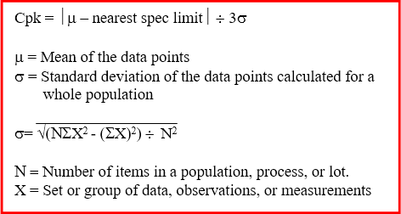

Figure 6: How WPI calculates Cpk

Values used for the spec limits and the data are translated in terms of the Process Window Index.

Here is a simple example. Let us set the Points to Compute Cpk to 5, and the five PWI values are as follows: 68%, 88%, 70%, 64%, and 65%.

Mean = (68 + 88 + 70 + 64 + 65) ÷ 5

= 71

StdDev = √ ((5 • (682 + 882 + 702 + 642 + 652)) – (68 + 88 + 70 + 64 + 65)2) ÷ 52

= √ (127945 – 126025) ÷ 25

= √ 76.8

= 8.76

By definition, the overall PWI is always positive and the limit is always 100%.

Cpk = ⏐71 – 100⏐ ÷ (3 • 8.76)

= 29 ÷ 26.29

= 1.10

So, while the worst PWI is 88%, the Cpk is 1.10 which is below the typical target minimum of 1.33. This tells us that the chance that the process drift out of spec is too high and this process should be improved.

Here is five more sample PWIs: 91%, 91%, 92%, 89%, and 90%.

Mean = 90.6.

StdDev = √ (205235 – 205209) ÷ 52

= 1.02

Cpk = ⏐90.6 – 100⏐÷ (3 • 1.02)

= 3.07

Even though every PWI in the second list is considerable higher/worse than the worst PWI in the first list, the Cpk is a very good 3.07. Such a high Cpk indicates that there is very little chance this process will drift out of spec. The reason second process is better than the first is because the second process has very little variation in it.

### Copy Data to A Network

The *Copy to Network* tool enables automatic copying of all WPI files and data to a network location for backup or archival purposes. When you click the check box, a separate application launches, and an icon appears in the system tray area. Right click, and then choose *Settings* to configure the *CopyToNetwork* settings.

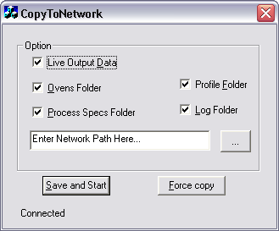

Figure 7: CopyToNetwork Software Tool Screen

Select the folders and/or data to be copied and then enter or browse to the network location. You must enter a valid network path. Click the Save and Start button to begin copying the selected files and folders to selected network location.

The software will prompt you to either, copy all the data now or save the settings without copying the data.



Figure 8: CopyToNetwork Message

**Yes** – The selected data is copied to the selected network location and the settings are saved.

**No** – The settings are saved, but no data is copied.

**Notes:**

* If the network location is not available, is an invalid path, or the network is disconnected, WPI temporarily writes the selected data to the C:\WPI\\_Data\_Backup\_ folder until the network path or connection has been reestablished.
* The *CopyToNetwork* tool launches automatically as long as the Copy to Network option is checked in the Global Preferences-WPI tab.
* Whenever any selected folder is updated with new/modified information, the new information is automatically backed up to the network location without any further user interaction.

## Disable Alarm Tab

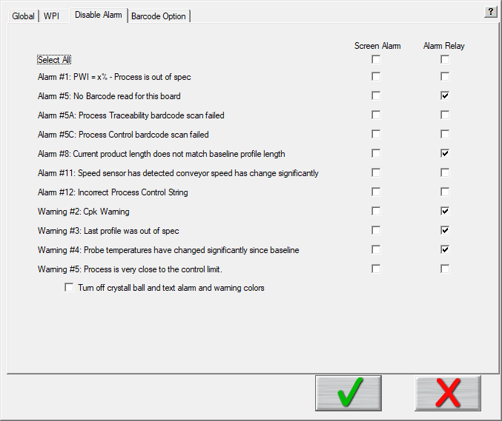

Figure 7: Disable Alarm Tab

By default, WPI software provides many on-screen notifications and alarm relay signals to help keep your process within spec and your production flowing. Selecting the *Disable Alarm* tab displays a matrix of options to let you *selectively disable* any alarm, warning, or relay signal *that does not suit your workflow*.

The column of checkboxes under *Screen Alarm* lets you specify when alarms and warnings appear on your monitor. The checkboxes under Alarm Relay let you specify the conditions under which a DAU/eTPU signal energizes the alarm relay to let it power an audible or light indicator or to stop an infeed conveyor.

NOTE: For some alarms, if you disable a *Screen Alarm* selection, but leave the corresponding *Alarm Relay* selection active, you will have no way of acknowledging the alarm condition. This type of configuration is NOT recommended.

Clicking the top *Select All* checkboxes selects or deselects all of the options in the column below. Toggling Select All resets the options to let you more easily choose individual items.

|  |  |
| --- | --- |
| A checkbox at the bottom of the screen lets you turn off the crystal ball graphic that provides a color-coded status during Virtual Profiling. | cb-grey_sm01 cb-green_sm01 cb-yelo_sm01 cb-red_sm01 |

## Barcode Tab

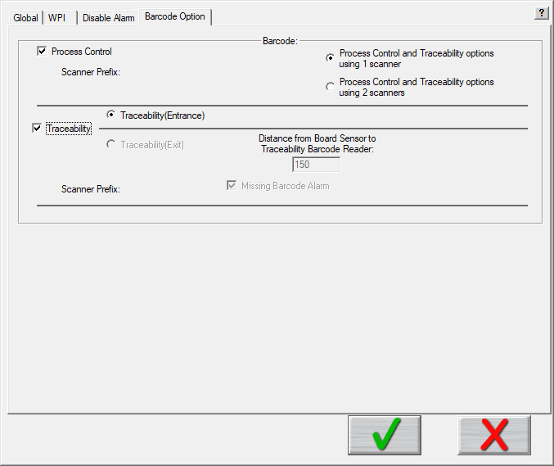

Figure 10: Barcode Option Tab

**Process Control –** Enable or disable the *Process Contro*l barcode feature. The feature allows control of the process by comparing the barcode string of a product to the corresponding process currently running. It ensures that the product matches the process.

**Process Traceability -** Enable or disable the *Process Traceability* barcode feature. This feature links each product’s profile data with its barcode.

**Note:** When both Process Control and Traceability are selected, radio buttons appear that let you specify using *one or two* scanners, together with fields for entering identifying prefixes for the scanners. The feature enables the choice of applying traceability at the machine entrance or exit.

**Scanner Prefix** – If you selected the option for 2 scanners, a text entry box displays allowing you to enter the predefined prefix number to identify each barcode scanner. The software uses this prefix to determine which scan goes to which feature—process control or traceability. The prefix is programmed using the barcode manufactures software program. Contact the barcode scanner manufacture for more information.

**Missing Barcode Alarm –** This option can be enabled or disabled when the Traceability (Exit) function is selected. The software uses the board sensor to track product location in the machine. If the board sensor detects a product entering the machine, but the barcode reader doesn’t read its code, the system can activate a software or hardware alarm. The Traceability (Exit) function also requires entry of the Distance from Board Sensor to TraceabilityBarcodeReadervalue**.**

**Distance from Board Sensor to TraceabilityBarcodeReader -** Measure and enter the distance between the board sensorand the Traceability Barcode Readerwhen installed at the machine exit in this field. The software uses this measurement to track product position so it can associate the correct board when the barcode is scanned.

# Process Window Setup

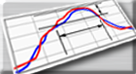

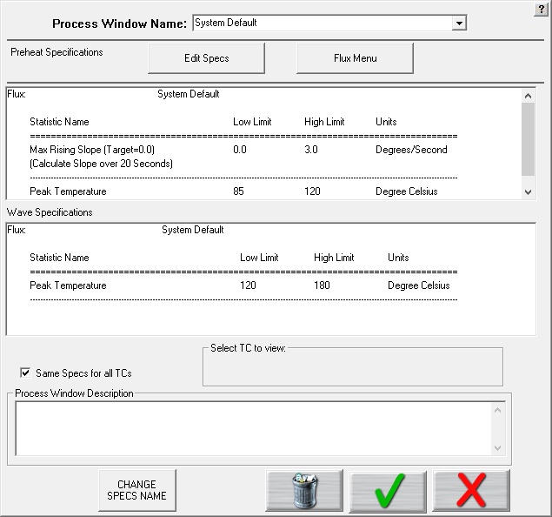

Deselect this check box to assign separate specs for each thermocouple used. See details below.

Figure 11: Process Window Setup

**Process Window Name** – Name of the Process Window file that includes the statistics chosen and limits for those statistics, along with whatever text appears in the Description field.

**Edit Specs** – Screen allowing you to edit or choose statistics and limits for a chosen flux or define your own specs.

**Flux Menu** – A read only library list of fluxes along with the statistics and limits suggested by the flux mfg.; also included is a user-defined option in the list which allows you to create a spec. of your own. See below for additional details.

**Read only text box** – Shows the flux name, statistics name, and limits for a Process Window chosen, edited, or saved by you. The top half displays the specs chosen for the ‘Preheat’ side of the process, and the bottom half for the ‘Wave’ side of the process.

**Same specs for all TCs** – By deselecting this checkbox, you can assign separate specifications for each individual thermocouple you are using. This option would be used if you had component specific specifications that differ from the general specs. Another use for this would be if you wanted to monitor the actual board temperature as well as component temps. You would then only select the statistics for that TC that are relevant. If you wish to use the same specifications for all thermocouples, leave the box checked.

**Select TC to view** – This dialog box will appear only if the *Same Specs for all TCs* checkbox is deselected. By clicking on the dropdown menu, you can view the specifications that have been defined for that number thermocouple. If a description was included, it appears next to Label.

**Process Window Description** – Field allowing for freehand notes for a particular Process Window.

**Change Specs Name** – Opens an external application allowing you to customize the name of any individual statistic. (See below for additional details)

**Use Sweet Spot Target** - When the *Sweet Spot Target* option is purchased, enabling it allows you to manually define the target (0 % PWI) for each statistic. (See below for additional details)

## Flux Menu



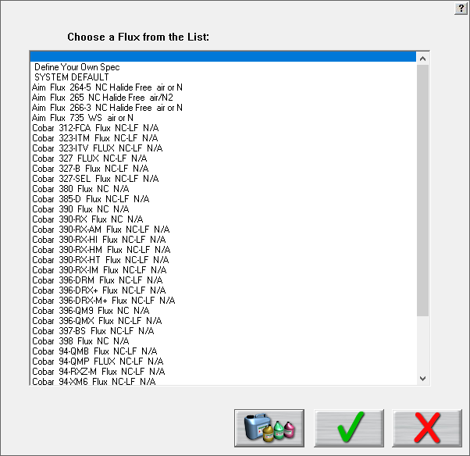

Figure 12: Flux Menu

**Flux Menu** - When you click the *Flux Menu* button, a list of fluxes appears. Use the scroll bar on the right to find your flux in the list and click to select it. If your flux is not on the list, choose the Define Your Own Spec option from the list, and then manually enter the process limits.

* Clicking on the **green check** accepts the selected flux and loads its specs automatically. You then return to the *Process Window* screen after being presented disclaimer information.
* Clicking the **flux jars** button displays a disclaimer information about the selected flux/process specifications.
* Clicking on the **red X** cancels your selection and returns you to *the Process Window* screen without making any changes.

## Edit Specs



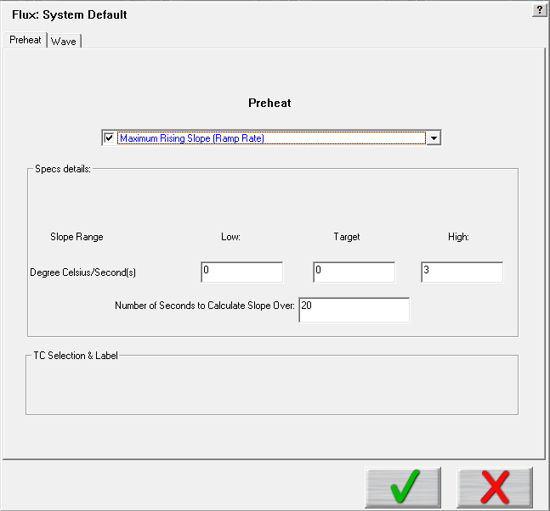

Figure 13: Process Window Edit Specs

The *Edit Specs* screen allows you to choose and/or edit a variety of available statistics that will be calculated during profiling and production.

At the top left of the screen are two tabs – *Preheat* and *Wave* – allowing you to select and define different specifications and limits for the two different halves of the wave solder process. When you select a tab, it will display that name (Preheat in the example above) at the top of the screen to let you know which selection area you are working in.

There is a single drop-down list at the top that contains all available specifications that are available for that part of the Process Window. These specifications are specific limits or a group of limits that define the overall Process Window for your product. These specifications include Slope, Preheat, Peak temperatures, Dwell Time in Wave, etc.

**Spec Details** – The Spec Details coincide with the selected Specification. For each Specification selected, enter the Temperature, and Time limits. These limits are usually dictated by the flux being used. The limits are used to measure the profile PWI.

**Caution**: Changes made within this screen will have a direct effect on the profile PWI value.

Once you have completed all spec modifications you can click on the **green check** (Save and Exit) button and your changes are applied. Clicking on the **red X** button will cancel your changes and exit.

## Specify Different Specs for Individual TCs

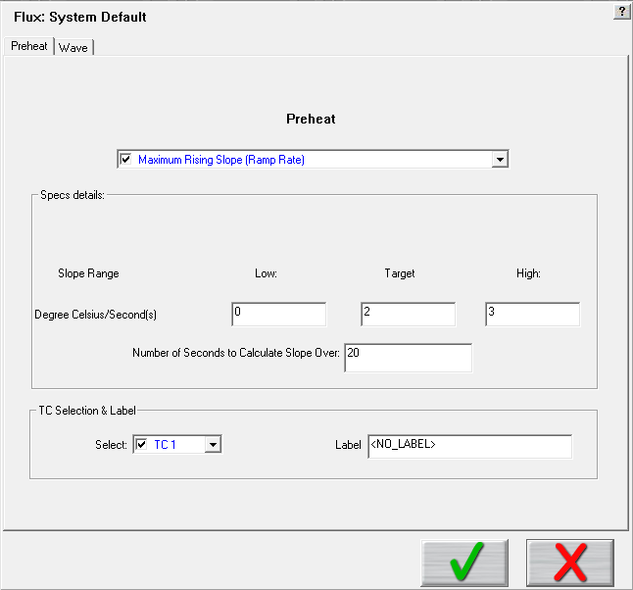

This Section is specific for *Separate Specs* for each TC

Figure 14: Edit Specs screen with TC Selection & Label panel displayed

### TC Selection & Label

If you have deselected the Same Specs for all TCs option on the Process Window Setup screen, when the Edit Specs screen appears, it will display an additional TC Selection & Label.

* **Select** – Use the Select drop-down menu to select the TC whose specifications you wish to view/edit. The Spec Details for the selected TC appear.
* **Label –** This area lets you type in a description or label to identify that particular TC. If left blank, the TCs will simply be identified as TC2, TC3, etc.

**Note**: When using separate specs, the Edit Specs screen is the only place where you can select or deselect which TCs are used for a profile.

Once you have completed all edits of the specs you can click on the green check button and your changes are applied. Clicking on the red X(Cancel) button will cancel your changes and exit.

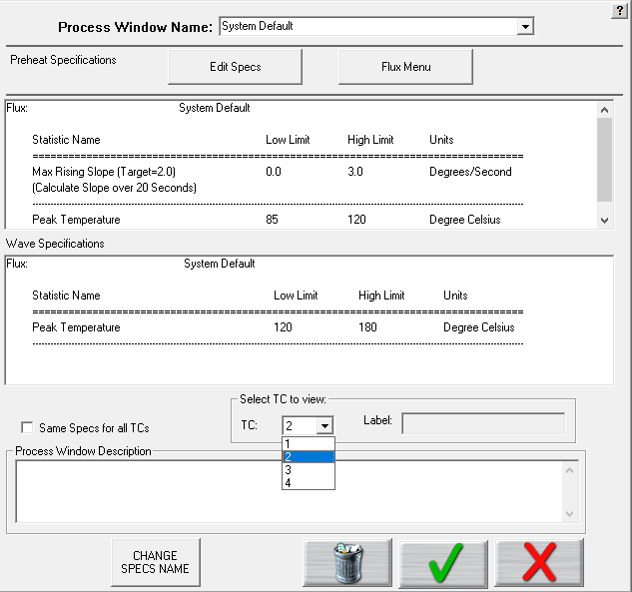

Figure 15: Process Window Select TC to View

**Select TC to View** – Drop-down menu containing the TCs that have already been defined. (Previous step)

## Use Sweet Spot Target (Optional)



Normally, when selecting a specification, only an upper and lower limit is defined, and the “target” value is automatically the center of the upper/lower limits. If you have purchased the *Sweet Spot Target* option, enabling this feature allows you to manually define your own Target value for each statistic. This function may be desired when there is a defined specification window, but the desired optimal value may not be the exact center of the limits.

## Change Specs Name





If you wish to rename the label for a particular statistic, start by clicking on the *Change Specs Name* button, which opens a separate window. Put a check mark in the checkbox at the top of the screen to enable the change function. Next, locate the desired specification in the greyed out columns, and type in the new name in the corresponding editable column. Click the Save, then Exit to close the window and return to the Process Window screen.

## Save - Process Window



Figure 8: Save Process Window

To create a Process Window, follow these steps:

1. **Choose a flux** from the Flux Menu.
2. **Edit the specs** if necessary.
3. **Name the Process Window**
4. **Save** the Process Window by clicking the green check (save and exit) button

A dialog box appears asking if you want to add this Process Window to your current list of Process Windows.

1. Click **Yes** will save it and exit to the main screen.

You can click **No** and then click the red X (cancel) button to exit without accepting or saving any changes.

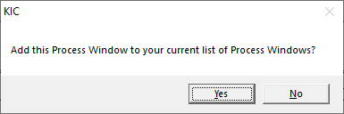

Figure 9: Add Process Window Prompt

# Hardware Status

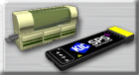

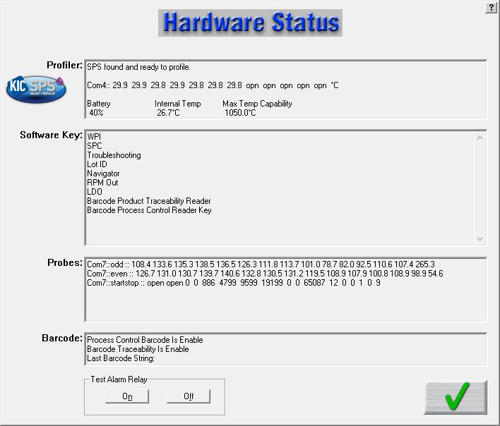

Figure 10: Hardware Status Screen

**Profiler –** Shows the status of the profiler. This box displays the following information:

* Profiler communication status
* Temperature display – for all connected thermocouples
* Battery Voltage
* Internal Temperature – Temperature inside the profiler
* Maximum Temperature Capability – The maximum temperature the profiler can read

**Software Key –** Displays all the features currently programmed on the USB Dongle key.

**Probes –** The current live temperatures for the probes are displayed. A third line displays hardware information regarding the Board Sensor, Barcode Product Sensor, and Conveyor Speed Encoder. If you do not see any data displayed in this field, the WPI software is not communicating properly with the *DAU/eTPU* hardware.

**Note:** If you are using the barcode capabilities, an additional section will display showing the last barcode read.

**Test Alarm Relay** – Use this button to test the alarm relay function of the software. The alarm relay hardware must be properly connected. You can also use this button to manually disable the alarm, should it stay active after Virtual Profiling has been stopped. The button appears only when the software is detecting the *DAU/eTPU* hardware.

**Note**: The alarm relay is not energized until VP is first running and then goes out of spec. To learn more about this see the alarm relay section.

# Run A Profile

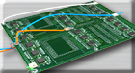

The *Run a Profile* button will guide you through a series of screens. Use the **Back** and **Next** arrow buttons at the bottom to move through the screens in the process, which will end with a completed and graphed profile. The **Cancel** button returns you to the main menu

**Note**: If you have already profiled your product using the WPI software, you can go directly to Profile Explorer, start a Virtual Profile, or load the most recent profile for your product, then use the WPI prediction capabilities to improve the profile PWI and generate new machine settings.

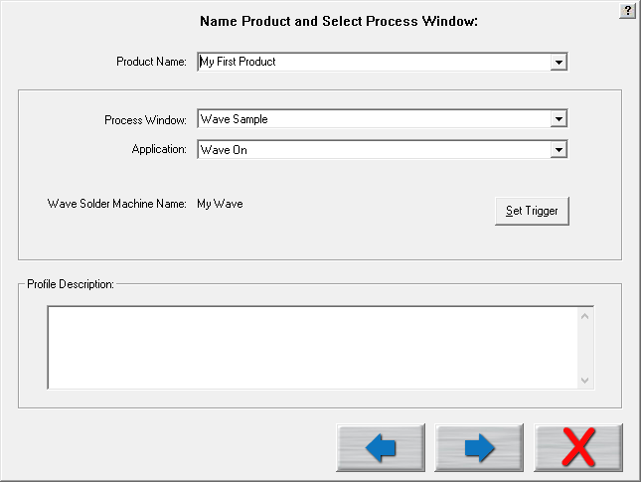

**Back**

**Next**

**Cancel**

Figure 11: Run a Profile Screen #1

**Product Name** – Enter a unique product name (long file names are acceptable) or choose an existing product name from the drop-down list.

**Process Window** – Choose a *Process Window* from the drop-down list. These Process Windows are created in the Define/Edit Process Window screen that is accessed from the main screen.

**Application** – Select your application type from the list. Three different application types are available – *Wave On, Wave Off, and Wave Surfer*. *Wave On* is used for profiling through the entire process – Preheat and Wave; *Wave Off* is available if you only want to collect data from the preheat area; *Wave Surfer* is used in conjunction with a separate product offered by KIC – the Wave Surfer fixture.

**Wave Solder Machine Name –** Name defined for machine in the Global Preferences tab.

**Set Trigger –** This allows you to set a Midpoint and Stop trigger temperature. The Profile start temperature trigger is determined by the Maximum Product Temperature at Start of Profile setting in the Global Preferences screen. The start trigger value is always 2ºC above this value. Select only if you need to change the temperature triggers (not typical) for the profiler. It is common to leave the default settings.

**Profile Description** – Allows for freehand typing of any notes you may want to include with this profile. These notes can be changed later from the Profile Explorer.

## Enter the Wave Solder Machine Recipe

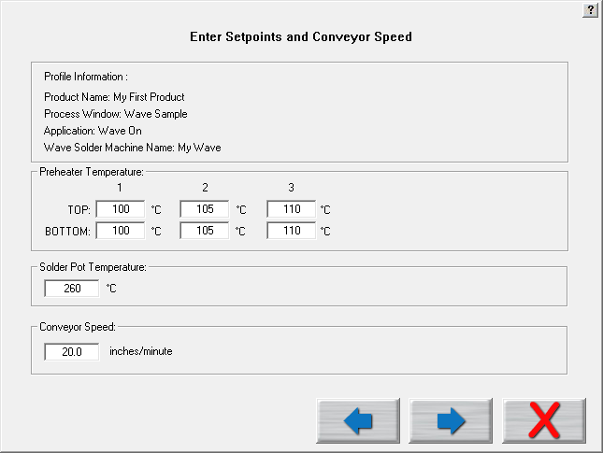

Figure 22: Run a Profile Screen #2

The layout of the machine recipe screen will be based on the configuration of the wave solder machine, as defined in the ConfigurationProgram.exe. See [Appendix C – Configuration Program](#_Appendix_C:_Configuration) for details.

**Preheater Temperature; Solder Pot Temperature; Conveyor Speed**

Enter the setpoint temperatures and speed of the recipe currently loaded in the wave solder machine.

**Click the Next button to continue.**

## Attach Thermocouples

Thermocouples (TCs), attached to solder joints or other important sites on the board, directly measure the temperature at the point that the TC bead is in contact with the PCB. The TC measurements are collected by the profiler and the KIC software to create thermal profiles.

Two methods are typically used to attach TCs—*aluminum tape* and *high temperature solder*. Both methods are discussed below.

The system works with multiple TCs— *Air TC, Dwell TCs, and Product TCs –* depending on what type of data you want to collect. Product TCs record the temperature data for various sites on the board. The Air TC gets specific positioning because its temperature *triggers the start of the profile* data processing, aids with data alignment, and is used in the prediction capabilities of the software. Dwell TCs will be used for collecting contact time in the wave.

### Attach The Air TC

Important considerations regarding the Air TC:

|  |  |
| --- | --- |
| * It must be attached at the leading edge of the board, extending approximately one inch (25 mm) in front of the leading edge of the board. * It MUST be plugged into **channel 1** on the profiler. * If you selected Wave On as the application type, ensure that the Air TC is angled downward so that it contacts the solder wave.   **Click the Next button.**  The *Wave On* application allows you to include a measurement of the *Dwell Time* and *Parallelism* during your profile. If you chose the *Wave Off* or *Wave Surfer* application types, this message will not appear and it will skip over the screens referring to Dwell calculations.  If you want to include these calculations in your profile, select *Yes* and the screen that follows will show an example of how you may set up a product with additional TCs to perform these measurements.  If you do not want to include these calculations, click *No*. |  |

### Attach Dwell TCs

|  |  |
| --- | --- |
| If you selected Yes to measuring Dwell Time, you will be required to use two additional TCs for performing this measurement.  These TCs will need to be secured to the left and right ***bottom*** side of the board and both must contact the molten solder as the board is passing over the solder wave. The screen at the right shows one example of how these TCs might be attached. You may also be able to wrap aluminum tape (or similar from the top side, around the front edge, to secure the TCs. The layout, or physical characteristics of the product you are profiling will dictate how you may be able to attach them, but for repeatable data, you’ll want to ensure the TCs are securely attached no matter which method is used. |  |

### Connect Dwell TCs

|  |  |
| --- | --- |
| When connecting the *Dwell TCs* to the profiler, you will attach the *Left* side TC into channel *#2*, and the *Right* side TC into channel *#3*.  The software will display a screen as a reminder of attaching the *Dwell TCs* to the correct channel inputs on the profiler.  **Click the Next button.** |  |

### Attach Product TCs

|  |  |
| --- | --- |
| Attach the TCs at selected sites on the board, and plug them into the remaining connectors on the profiler. Order is not important, unless you plan on labeling where each TC is attached.  When selecting a position for the standard TCs, you want to measure points on the product that represent the mass-range of the product. Select at least one position that is a high mass (large component) area of the board and at least one position that is a low mass (small component) area of the board. If you can develop an acceptable profile for the low and high mass areas of the board, you can process the other areas of the board within the same parameters.  **Click the Next button.** |  |

## Select Thermocouples

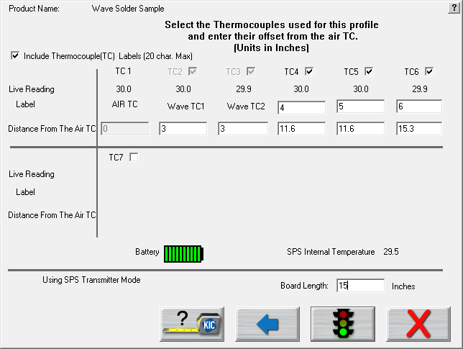

Figure 12: Run a Profile Screen #6 – Select TCs

**Include Thermocouple (TC) Labels (20 char. Max)** – Checking this will display a field below each TC that is selected. Up to 20 characters can be used to describe the placement or description of the TC.

**TC Check Boxes** – Place a check next to each TC channel that is going to be used for this profile. TC number 1 is always used for the AIR TC. If you selected *Wave* On and are calculating *Dwell Time,* channels 2 and 3 will automatically be selected and labeled (as shown above). You must use at least one other TC as well.

**Distance From The Air TC** – For Wave On profiles, you need to specify the location of the TCs, relative to the Air TC. Entering these values allows the software to automatically align the data to the proper positioning. Click the tape measure button for an example of how to determine the distance correctly.

**Live Reading** – When the KIC profiler is on and communicating with the software, you will see live temperature updates for the TCs plugged into the KIC profiler. The TC checkbox must be selected for each TC you are using to view the temperature readings.

**Battery Voltage** –Displays the live readings of the KIC profiler battery voltage. The software will recognize if your battery voltage is too low and will not allow you to start a profile until you have batteries with enough voltage to complete the profile.

**Profiler Internal Temperature** – Displays the internal temperature of the KIC profiler. If the temperature is too high to complete the profile and stay under the maximum rating for the unit, it will not allow you to start the profile. You must wait until the KIC profiler is cool enough. The software will let you know what temperature you will have to cool below.

**Board Length** – Enter the length of the board to be profiled.

## Start the Profile

**Note**: Make sure your profiler is powered on and ready to operate.



Select this button to start a profile.

Once the wave solder machine has stabilized and you are ready to load the profiler and profile board, click the start profile button (green traffic light).

|  |  |  |
| --- | --- | --- |
| The software will ask if all the zone control thermocouples in the machine are within 2 degrees of the setpoint temperature values. See Figure 13. | Figure 13 | |
| **If you answer yes**, the WPI software will display a prompt telling you that the next board to pass under the Board Sensor must be the board being profiled. Select **OK**. See Figure 14.  If the control thermocouples are NOT within 2 degrees of the setpoints, click **No**, then reference Appendix B. | Figure 14 |

|  |  |
| --- | --- |
| Next, the software will prompt you to put the profiler and profile board into the wave solder machine. Then choose the forward button. See Figure 15.  In order for the board sensor to properly calculate the length of the profile board, make sure the KIC profiler is at least 8” behind the profile board. For profiling and Virtual Profile Verification profiling, the software will ignore any boards including the KIC profiler that fall within 24” of the trailing edge of the profile board. | Figure 15: Run a Profile screen #7 – Insert Profiler/Product |

**IMPORTANT NOTE**: All profilers have a maximum operating temperature that, to avoid damage, should never be exceeded. See the product datasheet for temperature tolerance information:

|  |  |
| --- | --- |
| Profiler model | Maximum operating temperature |
| X5 | 85°C/185°F |
| K2 | 85°C/185°F |
| SPS Smart Profiler | 85°C/185°F |

## Live Profile Graph

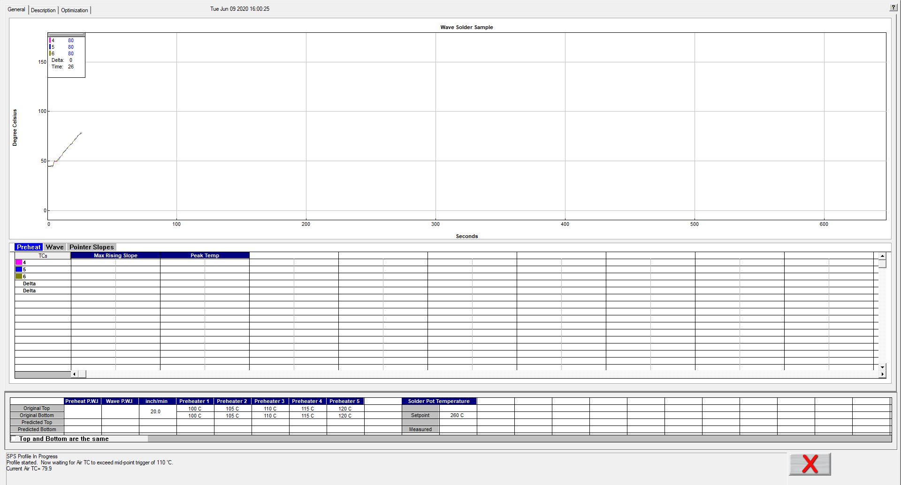

Machine temperature settings and conveyor speed

Live profile status

Temperature plots

Live temperature readings and Delta

Figure 16: Live Profile Graph Display

The live profile graph screen shows the real-time plot (when using RF or Wi-Fi enabled profilers) of the product as it travels through the machine. See Figure 16. (With Datalog profilers, a blank graph screen will display until the profile is completed and the profiler is connected to download the data.) During the live profile, all the tabs on the screen are deactivated and are inaccessible to you. The only action that you can take at this point (besides waiting for the profile to complete) is to cancel the profile by clicking on the red X button. This will bring you back to the main menu.

The bottom area of the screen displays the status of the profile:

1. Waiting for the Air TC to exceed the start trigger temperature.
2. Profile started- Waiting for the Air TC to exceed the midpoint trigger temperature.
3. Profile will stop when all thermocouples drop below ‘x’ temperature.
4. Profiler currently retransmitting.
5. Profiler retransmission successful.

**During the live profile:**

(Wireless models only.)

* The live profile is plotted on the graph.
* The current temperatures for each thermocouple and the Delta between them are displayed in a small window in the upper-Left hand corner of the profile graph. The elapsed time is also displayed.
* The current machine temperature setpoints and conveyor speed for this profile is displayed beneath the Statistics table.

## Profile Retransmission

**Note**: For users of profilers with wireless capability.

While the profiler transmits the live profile data to the computer running the WPI software, it simultaneously stores the profile data in its onboard memory.

Once the KIC profiler detects that all of the thermocouples have cooled below the profile-end trigger value, it will begin retransmitting the profile data. The status of the profiler mode will display in the lower left corner of the graph screen. See Figure 17.

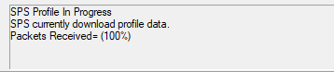

Figure 17: Profile download status

If you have a Data logger version, you must remove the KIC profiler from the machine and thermal shield and then connect the USB download cable to the KIC profiler. The profile data will automatically begin downloading to the WPI software.

**Caution**: The profiler and your product may be hot when exiting the machine. Use gloves when handling.

When all the data packets have been received, the software will display a message asking you to turn the profiler off, choose OK. **Failing to turn the profiler OFF will drain the battery when using a K2 profiler.**

After the KIC profiler has completed its retransmission, click “OK” and you are brought to the Graph screen, with the profile and statistics displayed for the current profile run.

* If the Air thermocouple was more than 10C cooler than any other TC, you will get an error message. At this point you must check to see that the Air thermocouple is plugged into the first channel on the KIC profiler and that all the other thermocouples are firmly attached to the product. Then you will have to rerun the profile.
* If the message, *Waiting for the board to exit* appears, wait till *Turn off the profiler* message appears and follow any subsequent messages that may appear.

Next, the software will automatically analyze the profile data and presents the profile and statistics.

## View the Profile and Statistics

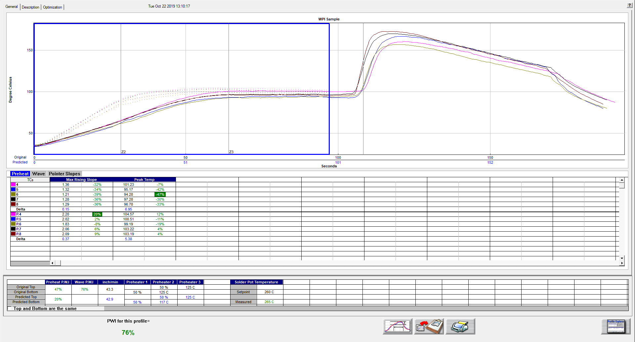

Figure 18: Profile General Tab – Shows graph, statistics, and recipe

### General Tab

The General tab shows the profile graph, profile statistics, current, and predicted recipes. To enlarge the graph portion of the General Tab, simply double click on the graph. To enlarge the statistics portion of this screen, double click on the statistics table. See Figure 18.

**Note**: If you have run a profile that meets the Virtual Profile criteria, then the “Start Virtual Profiling” button will appear once the profile has completed. Click the Start Virtual Profiling button to start Virtual Profiling for this product.

### Profile Graph Display



***Predicted*** profile plot (dotted lines)

***Original*** profile plot (solid lines)

Figure 38: Profile Graph Display

The PWI for the profile appears in the bottom-Left corner of this screen. See **Error! Reference source not found.**. If the measured PWI is below 100%, the value appears in a green font. If the measured PWI is 100% or higher, the value appears with a red font. This enables you to easily identify whether the profile is in or out of spec.

 

A PWI under 100% is acceptable

A PWI above 100% is unacceptable

Figure 39: Profile PWI

### Graph Controller Menu

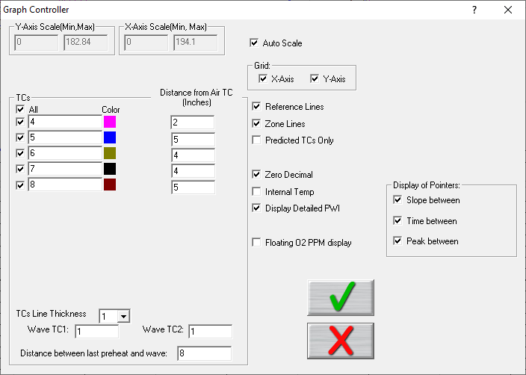

The *Graph Controller* allows you to modify the view of the WPI-profile graph. See **Error! Reference source not found.**. To open the Graph Controller, click on the button labeled ‘TC’ on the column header in the Statistics table, or left click anywhere just on the left side of the profile graph.

**Auto scale –** The Auto Scale feature will automatically adjust the X and Y-axis scales to fit all of the data in the profile graph. When the Auto Scale feature is disabled, you must manually input the minimum and maximum scale settings for the X and Y-axis scales of the profile graph.

Figure 40: Graph Controller

**TCs**

The TCs section is a list of the thermocouples used for the profile. In the event that you wish to view the profile without a particular or multiple thermocouples, you can deselect individual thermocouples, or deselect the “All” check box, and choose only the thermocouples you wish to view. The software recalculates the PWI and updates the profile statistics based on the remaining thermocouples selected. You must select at least one product thermocouple. You can also update the distance measurement if a value was input incorrectly when the profile was started.

**Grid –** Enables/disables the view of the X and Y-Axis scales.

**Reference lines –** Enables the view of Reference Lines displayed on the profile graph. These lines represent any temperatures referenced in the selected Process Window.

**Zone lines –** Enables the view for the zone lines on the profile graph.

**Predicted TCs only** - Removes the Original profile plot from view, displaying only the prediction profile plot on the graph.

**Zero decimal** – When viewing the Examine tool, this setting enables or disables the decimal display. When unchecked, the software will display one decimal point.

**Internal temp** – Enables the view of the profiler’s internal temperature profile plot on the graph.

**Display Detailed PWI** – With this unchecked, you will only see the “overall” PWI for the profile. It will not display the individual TC PWI values.

**Floating O2 PPM display** – When the *O2 Live* option is purchased, you can enable/disable a window on the graph that shows the O2 measurement recorded during that profile.

**Display of Pointers** – Allows you to control which information is displayed when the *Pointer Slopes* tab in the Statistics table is selected (see below for additional details on pointers).

### Graph Option Menu

To view the graph option menu, right-click anywhere within the profile graph area. See **Error! Reference source not found.**.

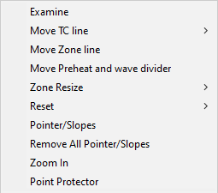

Figure 41: Graph Option Menu

#### Examine Line

The feature displays the temperature for the location of the examine line on the profile graph. See **Error! Reference source not found.**.

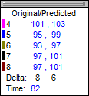

Figure 42: Examine line window

Wherever the pointer is moved across the profile, the following data appears:

* The first column is the actual temperature for each TC.
* The second column is the temperature of the predicted profile data – based on setpoint or speed changes.
* The Delta T for both actual and predicted TC data.
* The time during the profile at which the pointer is placed

#### Move TC Line

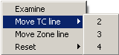

Figure 43

The Move TC line feature allows you to manually move the thermocouple plot on the profile graph. Moving the plot lets you fine-tune the profile or make corrections in the event the WPI software did not properly display the plot. See Figure .

Select the thermocouple you wish to move and then click and drag the highlighted plot and move it to the desired location on the profile graph. See Figure .

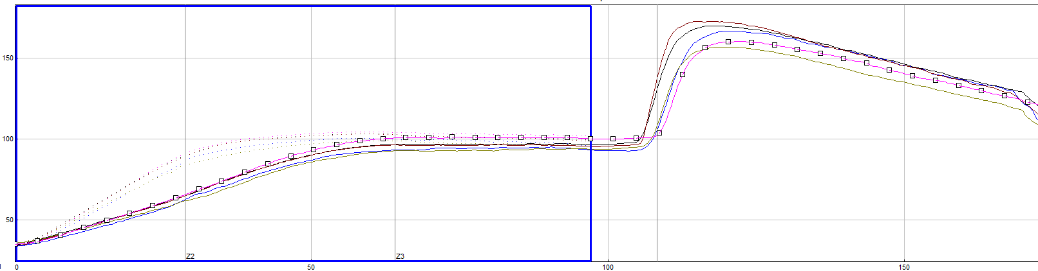

Figure 44: Move TC Line

#### Move Zone Line

The *Move Zone line* feature lets you manually move the zone separation lines on the profile graph. You can use this feature to fine-tune the profile or make corrections in the event the software did not properly display the zones.

#### Move Preheat and wave divider

The *Move Preheat and wave divider* feature lets you manually move the dividing line that separates the two halves of the data plot – preheat and wave. You can use this feature to fine-tune the profile or make corrections in the event the software did not properly display.

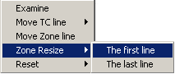

#### Zone Resize

Select to move the first line (Zone beginning) or the Last line (Zone ending) (See Figure ) and then click and drag it to the desired location on the profile graph. See Figure .

Figure 45: Zone Resize

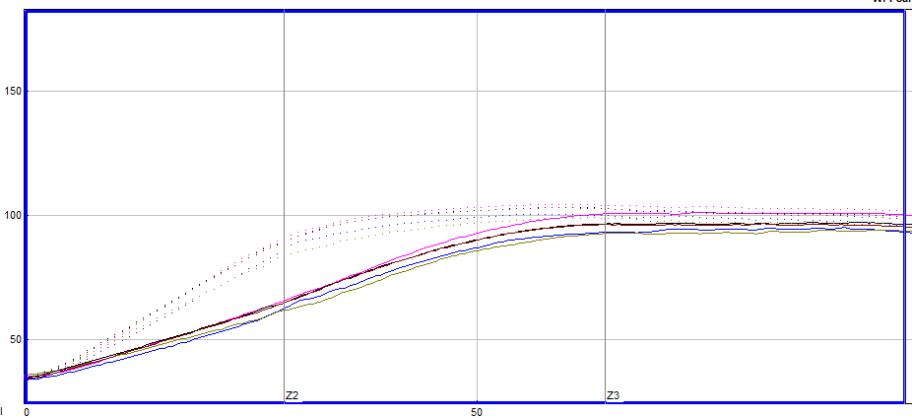

Figure 46: Move Zone Line

#### Reset

|  |  |
| --- | --- |
| The Reset feature will reset the profile and undo any changes you have made to the graph using the Graph Option Menu. Select the TC Line, or Zone Line option. See Figure . | Figure 47: Reset |

#### Pointer Slopes

The *Pointer/Slopes* selection allows you to place multiple pointers on the graph screen, manually move them to specific points of interest, and calculate various statistics at and between the pointers.



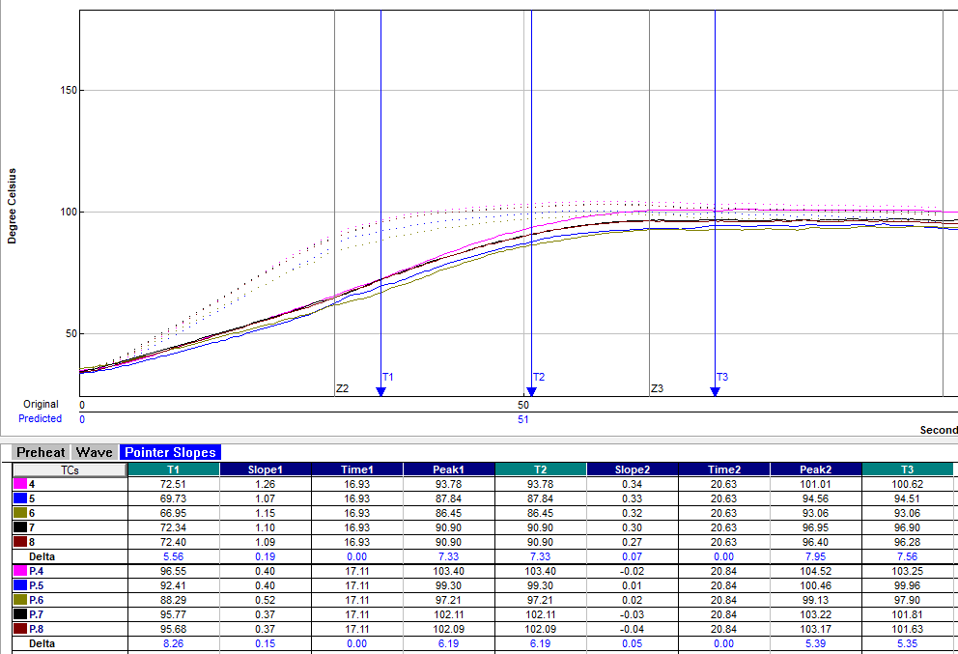

Figure 48: Pointer Slopes

#### Zoom In

The *Zoom In* allows you to scale and zoom in the graph display of a specific part of the profile. Click and drag a box around the area you want to see, then select OK.

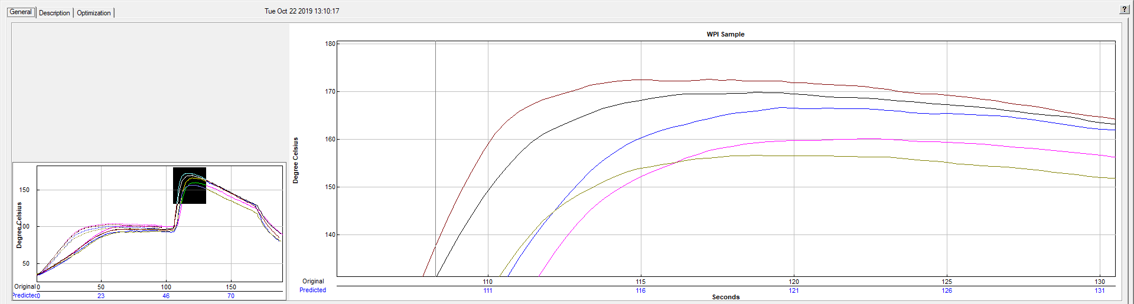

Figure 49: Zoom In

### Statistics Table



Figure 50: Preheat Tab

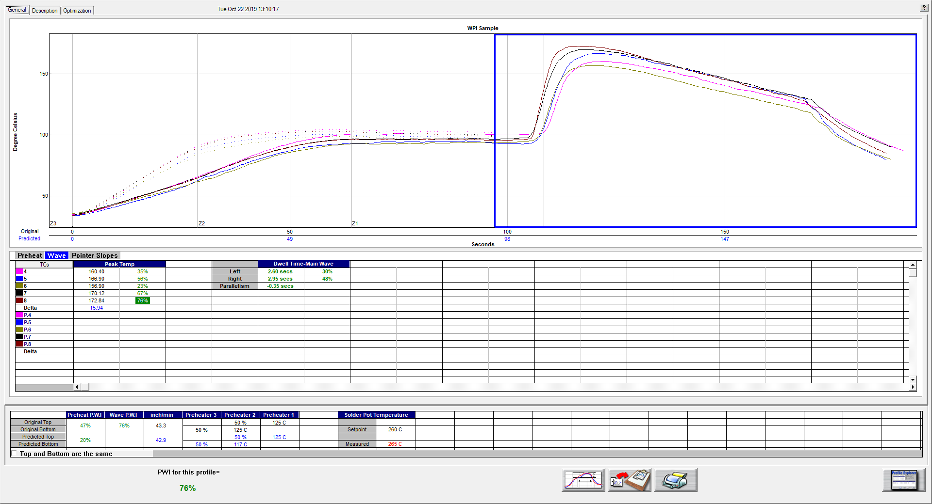

Figure 51: Wave Tab

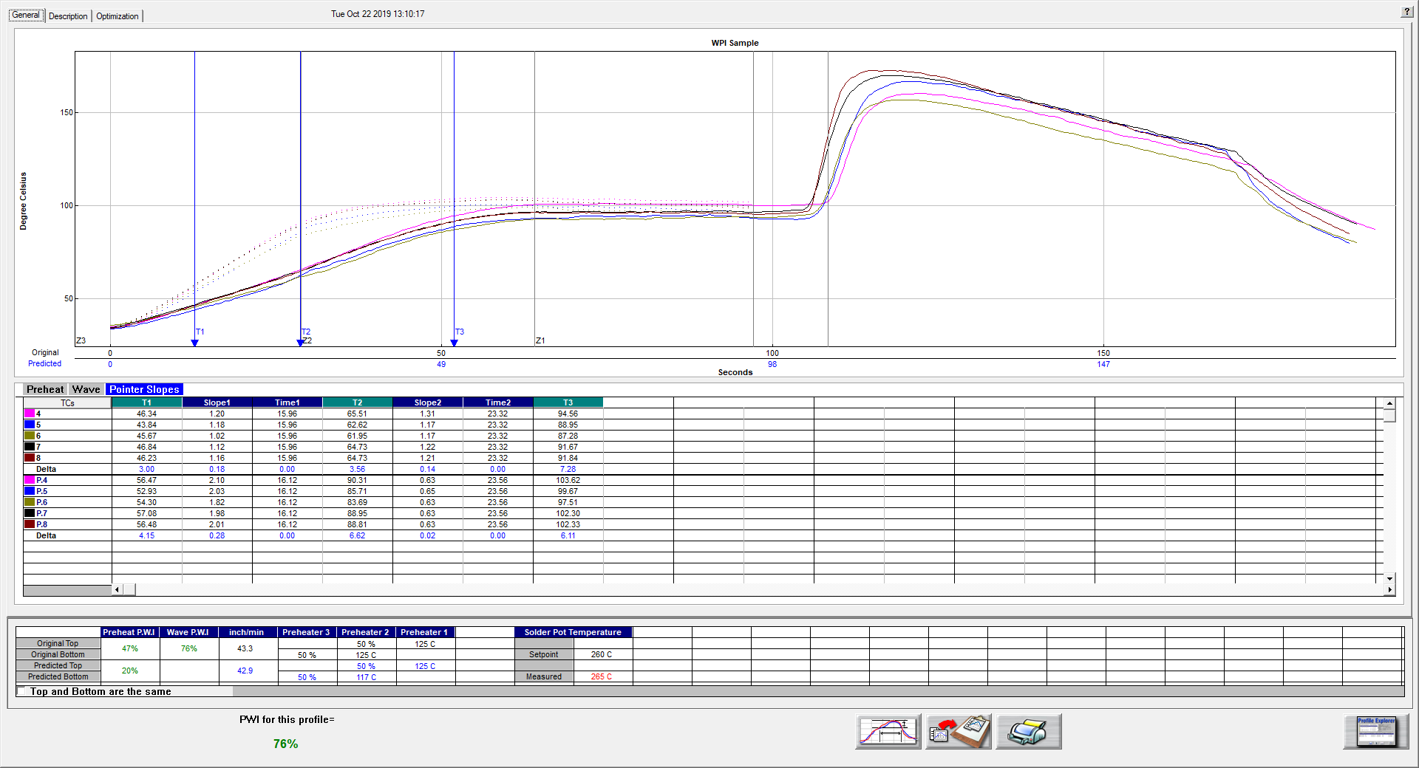

Figure 52: Pointer Slopes Tab

The statistics table is displayed in the center of the graph screen and lists a variety data, depending on which tab is selected, for the current profile being shown. It will list any measured value, as well as the corresponding PWI value (where applicable). Three separate tabs provide for displaying of the statistical information – Preheat, Wave, and Pointer Slopes.

**Preheat Tab –** Displays any statistical value, previously selected in the Process Window setup, related to the *Preheat* portion of data. Any statistic displayed in green is within the specification limits. Any statistic in red is outside of the spec limits defined.

**Wave Tab –** Displays any statistical value, previously selected in the Process Window setup, related to the *Wave* portion of the data. Any statistic displayed in green is within the specification limits. Any statistic in red is outside of the spec limits defined.

**NOTE:** If no specification was made for Dwell Time, but Dwell Time calculation was selected during the *RUN A PROFILE* steps, the corresponding Dwell/Parallelism data will be displayed in black.

**Pointer Slopes –** This tab will display the calculations for any *Pointers* that were placed on the graph. It can display the temperature at each pointer location, as well as the Slope, Time, and Peak temperature between any two Pointers. Right click on the graph and click *Pointer/Slopes* then left click to add a pointer on the plot. Open the *Graph Controller* menu to select which data to show in this table.

**Automatic calculation of Delta T + Delta (or range) for all stats**

The software will automatically calculate, and display in the statistical chart, the Delta for both the original and predicted profile data for all TCs for all Statistics. This is the range of the highest to the lowest value for any given specification. This information is strictly being displayed and is not factored in to the PWI value and is not used in any predictive calculations.

### Machine Recipe Settings



Figure 53: Machine Recipe Settings

At the bottom of the screen will be the machine recipe settings you entered during the RUN A PROFILE screens, including individual Preheat Zone setpoints, Solder Pot Temperature setpoint (plus Measured Pot temperature), and Conveyor Speed setpoint.

Additionally, the table includes the overall PWI for each section of data – Preheat and Wave – as well as the Predicted setpoints for optimizing the profile.

## Description Tab

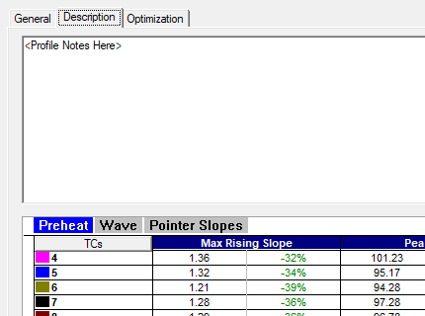

Figure 54: Profile Description Tab

The Description tab provides an for viewing/editing any profile notes that may have been entered on the first *RUN A PROFILE* screen. If notes were not previously entered, they can be added into this area at any time.

## Optimization Tab

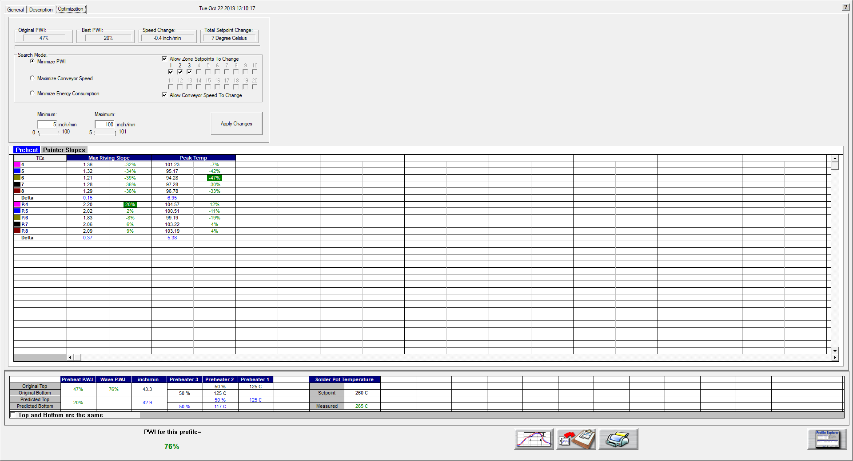

Figure 55: Profile Optimization Tab

The *Optimization* tab allows you to set the search parameters for Navigator. Thesoftware will search through millions of setpoint and conveyor speed combinations to find the optimal machine settings for each product. These optimization calculations are based on the selections you make on this tab. See Figure .

**Original PWI** – The Process Window Index for the original profile

**Best PWI** – The best Process Window Index that can be found based on the machine recipe optimization constraints selected.

**Speed change** – The total change to the conveyor speed for the best machine recipe found.

**Total setpoint change** – The sum of all setpoint changes for the best machine recipe found.

### Search Mode for Optimization

* **Minimize PWI** – Search for the combination of setpoint temperatures and conveyor speed that will minimize the Process Window Index.
* **Allow zone setpoints to change** – This option will determine if Navigator will include zone setpoint changes when predicting new solutions. It also allows you to exclude individual zones from suggested changes.
* **Allow conveyor speed to change** – Choose whether to allow Navigator to vary the conveyor speed. If you choose this feature, you can set the minimum and maximum speeds.
* **Maximize conveyor speed** – Search for the setpoint temperatures that will maximize conveyor speed.
* **Minimize energy consumption** – Used by the Power software feature. The software searches for the machine settings that will minimize the power consumption by finding setpoint solutions with slower conveyor speeds and lower temperature settings.

### Conveyor Speed Constraints

As long as the *Allow Conveyor Speed to Change* feature is selected, these options are available.

**Minimum** – Select the slowest conveyor speed you would like Navigator to recommend for new products.

**Maximum** - Select the fastest conveyor speed you would like Navigator to recommend for new products.

## Manual Profile Prediction

The WPI software has automatic (Navigator), and manual prediction capabilities. Manual prediction gives you the flexibility to easily predict changes to the machine settings (temperature settings, conveyor speed), and view the results without having to spend the time actually running unnecessary profiles. This feature is very helpful to you, minimizing the time spent fine-tuning or developing a thermal profile.

### Make Changes

To predict changes to the machine settings, or modify the Navigator prediction results, click on the zone you wish to change. In the example below, zone 1 has been selected. See Figure .



Figure 56: Prediction Settings

Type the new temperature setting, and then press Enter.

The Navigator prediction tool will predict the results of that change, and then automatically update the PWI, predicted Statistics, and the profile graph. The new predicted results appear on the graph in a dotted-line format. This format lets you quickly determine the difference between the original and predicted profiles.

**Note**: When separate Top and Bottom setpoints are used, the Navigator prediction will maintain the same delta between the Top and Bottom setting that was used in the original profile.

### Profile Screen Buttons

There are four buttons at the bottom of the profile screen:

|  |  |
| --- | --- |
| bt-NAVint_Proc-menu | **View/Edit Process Window –** Choose this button to either view or edit the process specification(s) for the product used in this profile. |
| bt-NAVint_Copy2Clipbd | **Copy to Clipboard –** Choose this button to copy the profile data to the windows clipboard. You can then paste the data to a different application. |
| bt-NAVint_Print | **Print –** Choose this button to print a copy of the profile that is currently on your screen. |
| bt-NAVint_Check | **Green check button –** When finished viewing or analyzing the profile select this button to either run another profile with this product or return to the WPI main menu. You return to the Profile Explorer if the profile was opened from there. |

### Exit the Graph Screen

|  |  |
| --- | --- |
| Upon exiting the graph screen, you will be prompted if you want to run another profile with this same product.  If you select **No**, you return to the WPI main screen or the Profile Explorer if the profile was originally opened from there. | Figure 57 |
| If you select **Yes**, you will need to choose from the Original, or Predicted recipe settings.  **Original –** The same recipe settings used when this profile was originally run.  **Predicted -** The recipe settings as predicted by Navigator, or a standard prediction that you manually input. | Figure 58 |

The following message will appear reminding you of the settings that should be entered into the Wave Solder Machine controller:

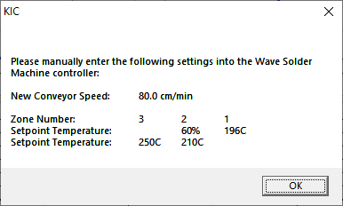

Figure 59

WPI software automatically applies the changes to the Run a Profile –Enter Setpoints screen. You will exit to theRun a Profile –Enter Setpoints screen.

#### Save Changes to the Profile

|  |  |
| --- | --- |
| Any changes to the Description Notes or the Process Window can be saved with the profile. This will permanently update this profile with the changes. Changes to the Process Window saved here only save the changes with this specific profile. To save the changes to Process Window file see next dialog box. See Figure . | Figure 60 |

#### Save Changes to the Process Window

|  |  |
| --- | --- |
| If you have made changes to the Process Window from the Graph screen you can save these changes when you exit the graph screen. The Process Window will permanently have these changes whenever it is used to profile from this point forward. | Figure 61 |

If you choose *Yes*, you will be taken to the Process Window screen in order to save the changes that you have made.

The first dialog – “Do you want to run a profile with this product?” will appear each time you exit the graph screen. Click on **No** if you do not wish to profile.

You are sent back to the WPI main menu if you had just completed running a profile. If you opened the profile from the Profile Explorer, you are returned to the Profile Explorer. The other two dialogs will only appear if changes are made to the Description notes or Process Window.

# Profile Explorer



The Profile Explorer is a powerful and simple data file management tool. For each unique product name you use when profiling, the software will create a folder with the same name. (See Figure .) The software saves all the profiles run using that product name in that folder.

This field is only active when running in ***History*** mode.

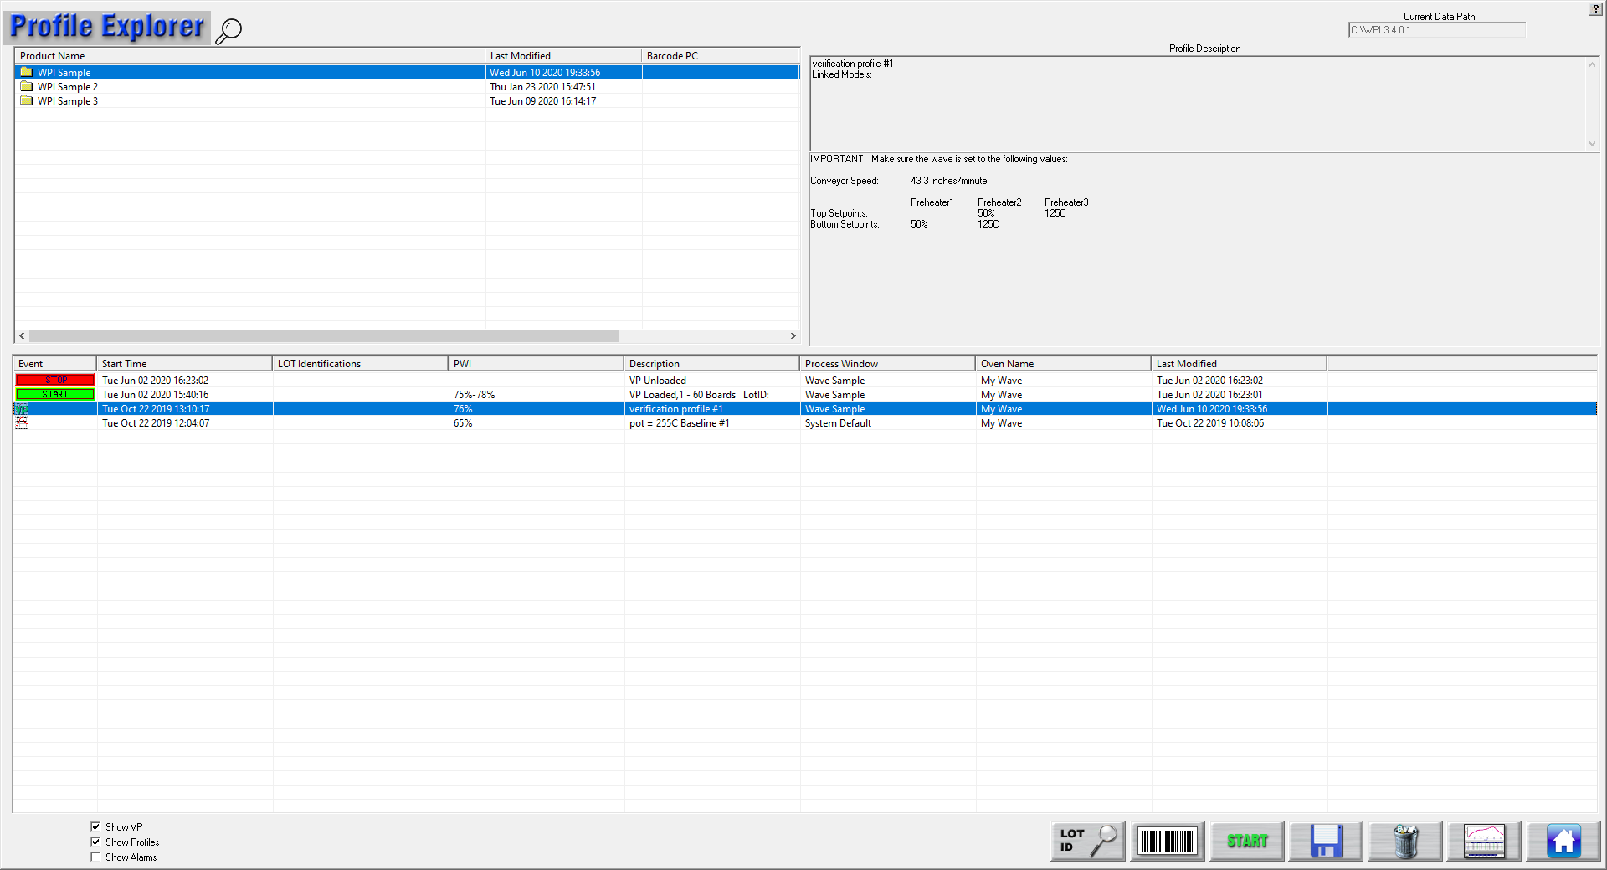

Product Name folders

Lot Identification Column

This button will only display when running in ***Production*** mode.

Lot Identification

Figure 62: Profile Explorer

The list of product folders is in the upper left of the Profile Explorer.

* **View a profile** - Click on a product folder to display the profiles that have previously been run for any product. Highlight the profile you wish to view and then select the Graph button at the bottom of the screen or double-click the profile to display it.

**Note**: Once the profile appears on screen, you can use the Control + Up Arrow to view the next profile, and Control + Down Arrow to display the previous profile.

* The profile section can be sorted by clicking on any of the column headers. Single clicking on a profile will display the Profile description in the upper right corner.
* Double-clicking the profile to display the graph and statistics for that profile. Clicking the “Display Graph…” button can also do this.

## Find VP Production Run Data by Lot ID Code

WPI software lets you search for Virtual Profile production runs based on the Lot ID code. If you do not know the complete code, you can use the asterisk symbol (\*) as a wildcard to begin searching with a partial code.

1. On the Profile Explorer screen, click on the **Lot ID** button. 

Figure 63

The *Lot ID* search screen appears:

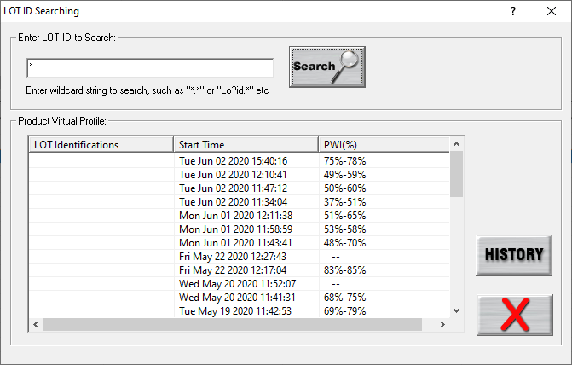

Figure 64: Lot ID Search

1. In the Lot ID search screen, type the code in the **Enter LOT ID to Search** field.
2. Click on the **Search** button.

Matching VP production runs appear listed in the table.

1. Mouse over the row in the table to display pertinent data from the production run in a tooltip popup window:

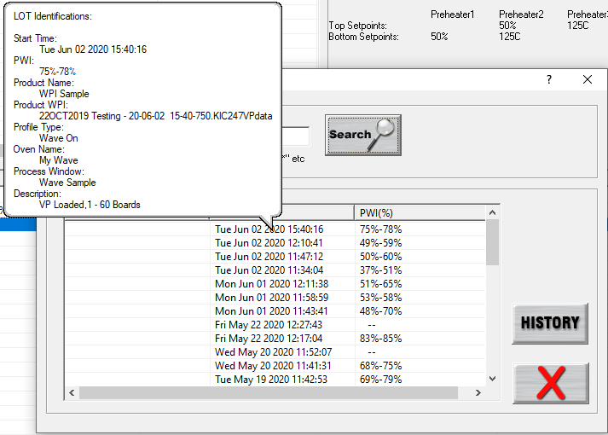

Figure 65: Lot ID Search Results

1. Highlight the row and click on the **History** button to display the virtual profile historical data.

## Browse for Historical Data

The current data path for the data viewed in the Profile Explorer appears in the upper-right corner. This is grayed out if running in production mode. It is active, if you clicked on the ‘*I am not going to run profiles or live WPI’* button (enabling History mode), when first launching the WPI software.

**The data path can be changed but must be done through the** \WPI\Log\KIC2000DataPath.kiccfg file.

To view historical Virtual Profile data from the same PC while Virtual Profiling is live, you launch a separate KIC Host.exe file located: C:\WPI\AppForViewerforViewer\KICHost.exe. This will open a separate Profile Explorer that lets you browse through the history of any product including the one currently running VP. Historical data is available for any boards that have already exited the machine.

**Note**: This feature was designed to allow you to view WPI historical data stored in a different directory on the same computer or on remote PC over a network.

## View Historical Data Over a Network (History Mode)

While in *History* mode you can view all collected data over a network from any PC with WPI software loaded.

|  |  |
| --- | --- |
| **Step 1** - From your remote PC, start the WPI software, and click on the ‘*I am not going to run profiles or live WPI*’ button. See Figure 19.  **Step 2** - The software will open up normally. When the main screen appears, click the Profile Explorer button. | Figure 19: Product Tracking Initialization |

**Step 3 -** Now, a Browse button is enabled in the upper right-hand corner of the Profile Explorer screen. See Figure 20 below:



Figure 20: Profile Explorer – Browse Data Path

You can click the Browse button and point to the root directory where your profiles are stored. Keep in mind that you want to direct it to the root directory of the main “Profiles” folder.

For example: if the profiles are stored in a directory named **F:\WPI\Profiles\Board A**, you would direct it only to the **F:\WPI\** folder.

## Profile Explorer Buttons

|  |  |
| --- | --- |
|  | **Lot ID history search –** Click on this button to search for a VP production run based on the Lot ID. |
| b | **Process Traceability Search –** Click on the Barcode button. A dialog box pops up with a field to enter the barcode value with a Search button next to it. Below this is a field that will list the time, date, and PWI for that barcode if it exists for the chosen product. Either double-click the listing or highlight it and click on the View Selected Profile button. |
| bt_Inspection_Start | **Start Virtual Profiling –** Click this button to start Virtual Profiling. The WPI software will always use the latest qualifying profile as the baseline profile needed to start Virtual Profiling. |
| b | **Save Selected Profile –** Click this button to save an event or profile to the location of your choice, either hard disk, network drive, or USB flash drive. |
| b | **Delete –** Click this button to delete an event or profile. |
| b  b | **Display the Graph and Statistics for this profile –** Click this button to display the graph and statistics for the selected profile. If you have an event other than a profile, the Display Graph and Statistics button will change to a Charts button. |
|  | **Return to WPI Main Menu –** Click this button to return to the WPI main screen. |
|  |  |
|  |  |

### Profile Explorer Checkboxes

At the bottom-left of the Profile Explorer are checkboxes to select what information to display:



**Show VP –** Display all VP Start and Stop events for the selected product.

**Show Profiles –** Display the Profiles for the selected product.

**Show Alarms –** Display the Alarm state changes for the selected product.

**Note**: Double click any event to view the details including alarm event history.

**Note**: If two alarm/alert acknowledgements appear at the same time, only one will appear in Profile Explorer.

## Profile Explorer – Virtual Profiling

The profile that meets Virtual Profiling criteria will be displayed with a green VP  overlaying the standard profile icon.

The software will always use the most recent qualifying profile as the Virtual Profile - Baseline profile.

### View Virtual Profile Data

1. Select your product folder from the upper left- corner of the Profile Explorer.

This will display the profiles and events for that product.

1. Choose a Virtual Profile event and double-click.

### Profile Explorer Event Icons

#### Profile Icons

 **Profile –** This icon appears for any valid profile that does not fit Virtual Profile criteria.

 **Virtual Profile Capable –** This icon appears for the most recent Virtual Profile capable profile. This file will automatically be used as the baseline or reference profile.

### Virtual Profile Event Icons

The WPI Profile Explorer will display an event icon for any event that occurs while Virtual Profiling is running and only when Virtual Profiling is running. These events include:

 **VP Start –** This icon appears when Virtual profiling is enabled.

 **VP Stop –** This icon appears when Virtual Profiliing is disabled.

#### Alarm Icons

 **In Spec. – Alarm state change –** This icon appears when the Virtual Profiling alarm state changes back to Ready. There are three ocassions when this icon may appear:

* Back into Spec
* Back into Control
* Process Temperatures Back to Normal

 **Warning – Alarm state change –** This icon appears when the Virtual Profile alarm state changes to Warning. There are three ocassions when this icon may appear:

* Cpk Warning
* Significant Process Temperature Variation
* Process Is Likely to Go Out of Spec Soon.

 **Out of Spec. – Alarm state change –** This icon appears when the Virtual Profile alarm state changes to Out of Spec. There are nine ocassions when this icon may appear:

* Process temperatures are Out of Spec
* Product length is different from the Virtual Profiling baseline profile
* Missing barcode (Process Traceability only)
* The number of barcodes that have not been read. (Process Traceability only)
* Encoder stopped, or changed signifigantly.
* DAU/eTPU lost communication

 **Warning Acknowledged –** This icon appears once the operator acknowledges the Warning alarm state change.

 **Alarm Acknowledged –** This icon appears once the operator acknowledges the Out of Spec. alarm state change. Not all alarms require acknowledgement.

#### Communications Icons

 **DAU/eTPU Communication Error –** This icon appears if the software loses communication with the DAU/eTPU.

 **DAU/eTPU Communication Restored –** This icon appears when the software re-gains communication with the DAU/eTPU

 **Process Traceability** **Barcode failure –** This icon appears if the software detects a board, but does not read the barcode for that product.

## History Data Files

As the software process Virtual Profiles, it generates data files. It automatically stores these *Event* and *VPdata* files associated with each specific product to a *History* folder.



## Insert Data Files from an Outside Source

If you receive WPI data files from another system, you can copy them to the **WPI\Profiles** folder in Windows Explorer. The next time you enter the Profile Explorer screen the software will automatically create folders for those profiles based on the profile name and put the profiles in the folders.

## Rename Profiles

In situations that require it, you have the ability to edit the profile name. This can be especially useful when products are identical but have different names. Once the profile has been optimized, it can be renamed and used as a baseline profile for a different product name if the need arises. This eliminates the need to re-profile products unnecessarily.

**Note**: Renaming a profile includes the name that is embedded in the profile that shows up on the printout

1. Manually create a new folder in the C:\WPI\Profiles folder using the new product name.
2. Copy the desired profile into this new folder.
3. A folder with that new Product Name will appear in Profile Explorer.
4. When you open that profile, it will display in the software with the new Product Name

* The new profile name will appear on all the screens (Profile Explorer, General Tab, Charts Tab, and Troubleshooting Tab). The new name will also appear in the data that is copied to the Clipboard.
* None of the files on the PC are actually renamed, when viewing the profiles in Profile Explorer, they all look the same. However, profiles run after the name has been changed will use the new product name as part of their file names.

**Note**: Virtual Profiling is most accurate for products that have their own baseline profile.

# Virtual Profiling

*Virtual Profiling* (VP) is a means of reliably predicting the thermal profile *of every board in a production run* based on a comparison of real-time temperature and conveyor speed data against a *baseline* profile established by an earlier profiler run through the machine. For a given product, this baseline needs to represent an optimum machine recipe with a good PWI value and a quality soldering result.

During the profiler run, the WPI software simultaneously collects temperature data from the board, from the probes installed at product level, and the other installed sensors. The software calculates a mathematical correlation between these temperature readings and stores this data as part of the baseline profile.

Once the baseline is established, the WPI software can be put into inspection mode, recording real-time speed and temperature data as a production run of the same boards passes through the machine. Comparing real-time data to the baseline profile, WPI algorithms accurately extrapolate a simulated thermal profile for each board. WPI updates and saves the VP profile data as each board exits the machine, creating a valuable quality assurance record of each production unit.

During inspection mode (VP), the software displays each boards profile chart and a table of data based on its process window. Other screens show PWI and SPC control charts. When machine data varies significantly from the baseline profile, WPI displays appropriate warnings to system operators.

**Note**: Before you start Virtual Profiling, ensure the WPI system hardware is properly installed and configured.

## Get a Valid Baseline Profile

Virtual Profiling makes use of a special profile, called the *baseline* profile, as the data model for its predictions. The software requires that you first establish this baseline before it enables Virtual Profiling. The baseline profile should represent your optimum machine recipe for your product and needs to meet the Virtual Profile criteria shown below:

* The PWI must be below the Maximum PWI to allow the VP value as set in Global Preferences.
* The conveyor speed measured by the encoder must be within 20% of the specified conveyor speed.
* Probe temperatures must be valid; if any probe thermocouple reports a range of greater than 30°C between adjacent readings (every 2.5 seconds), the WPI software will consider them invalid.

If your profile meets the above criteria, it can work as a baseline profile. The baseline profile will display differently in the Profile Explorer screen—the profile’s icon will have an overlying green VP. 

If you suspect the current baseline profile needs replacement by a newer version that more closely matches current production conditions, the software lets you create a new baseline during ongoing production. As long as this *verification profile* meets VP criteria, it can become the new baseline profile. See [Verify The Virtual Profile](#_Verify_The_Virtual).

### Integrate Empty Machine Data

For a baseline to work as a good predictive model, it needs to use temperature data that reflect both *board present* and *board absent* states along the length of the probes. To obtain this data most efficiently, KIC recommends running the profile board with similar *boards moving ahead of it and an empty conveyor behind it.* The downstream flow of boards stabilizes the temperatures and gives a good approximation of normal production conditions. As the profile board progresses, the probes can measure the temperature when a board is not present. The software can integrate this comparative data for a more accurate predictive capability. The machine should remain empty until the profiler and board completely exits the process chamber.

**Note**: Be aware of the potential to put the system into a state where the software lacks sufficient empty machine data to make reliable VP predictions. The condition can occur during a verification profile run where you insert the profile board into an ongoing production flow. With other boards both ahead of and behind the profile board, no interval for gathering empty machine data occurs. A grey crystal ball indicates an unable to predict state. See [Monitor Production In Live Mode](#_Monitor_Production_In).

## Create/Load a Virtual Profile

There are several ways to begin Virtual Profiling:

1. Open the Profile Explorer. Select your product folder in the upper-left corner. This will display the profiles and events for the selected product. If you have a profile that meets Virtual Profiling criteria, the profile icon is overlaid with a green VP. This qualifying profile (baseline) will always be the most recent profile that meets Virtual Profiling criteria (only one profile can qualify as the baseline).

No need to highlight the baseline profile, simply click the Start Virtual Profiling button. This will start Virtual profiling for the selected product.

|  |  |
| --- | --- |
| 1. If you have run a profile that meets the Virtual Profile criteria, then the *Start Virtual Profiling* button will appear once the profile has completed. Click the button to begin Virtual Profiling for the indicated product. | bt_Inspection_Start |
| 1. If you have enabled the Profile Grouping utility, click the link button to associate groups of product models with a baseline profile and to select an individual model for a Virtual Profile production run. When using the Profile Grouping utility, the Start Virtual Profiling button does not appear on the Profile Explorer screen. | bt_Profile_Group |

**Caution**: Your software security key must be connected prior to enabling Virtual Profile mode. If the key is removed from the computer while Virtual Profiling mode is enabled an alarm message appears.

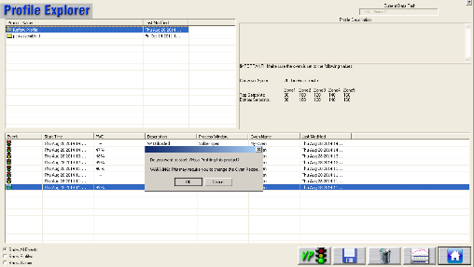 

Figure 21: Profile Explorer – Start Virtual Profiling

A series of prompts will appear on the screen, depending on the configuration of your system and what features you may or may not have enabled. Once the messages have been acknowledged, the live WPI graph screen will appear, and the system is ready to start collecting production data.

### 

## Use the Profile Grouping Utility

WPI includes a utility that lets you identify and group together different products that share the same thermal profile. For example, one might use a physically identical printed circuit board to manufacture many distinct product models. The manufacturer needs to specifically identify and track all the different models, but the thermal process specifications used to solder or cure them is identical throughout the product range. Once a successful process window setup is identified for one model, the Profile Grouping utility lets you *link* that setup with other models that can use the same process and thus save the time and cost of entering the same setup specifications repeatedly. In Virtual Profile mode, the baseline profile of a *parent* *product* can be matched to multiple *child models*, permitting smooth production transitions between models.

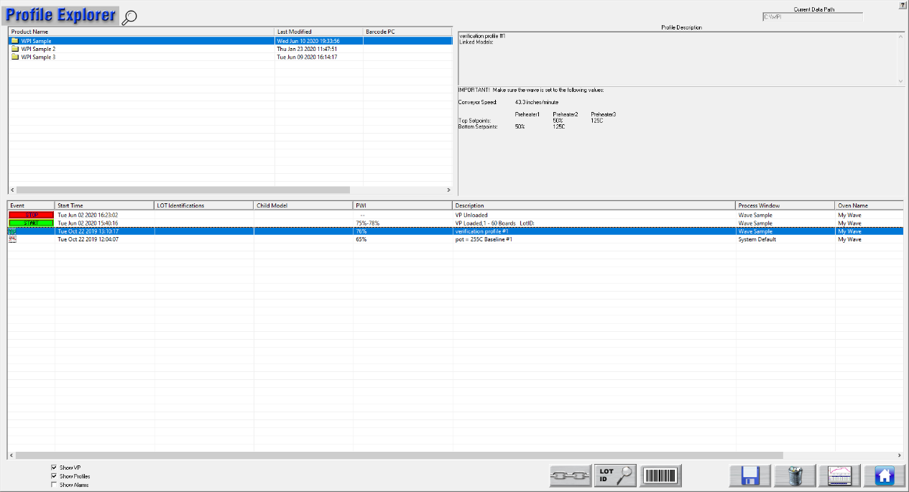

Profile Grouping

Start Button no longer displayed

Child Model Column

You enable the *Profile Grouping* functionality by adjusting settings in the **C:\WPI\Log\KIC2000UserSettings.kiccfg** file. Once accessing the APPLICATION CONFIGURATIONS section of the file, make sure the settings are as shown below:

[APPLICATION CONFIGURATIONS]

EnableProfieGrouping=1

### Use Wildcard Characters to Identify Child Models

Anticipating the need to group closely named product models, the software lets you substitute the asterisk (\*) symbol as a universal *wildcard* character when adding models to a group or linking them with a specific profile. You can use wildcards in any position within the model name string.

|  |  |
| --- | --- |
| 1. On the Profile Explorer screen, click the **Profile Grouping Utility** button. |  |

The *Profile Grouping Utility* screen appears.

1. Select the **Grouping** tab.

The Grouping tab screen appears, displaying a pull-down list of products that already have defined in-spec, baseline profiles:



1. From the **Baseline Profile** list, select the product to which you want to link models.
2. In the **Add New Model** field, type in a model name (using wildcards as appropriate) and click the **Add** button.

The model name appears in the Linked Models list

1. Repeat the steps for any additional models that you want to link to that baseline.

**Note**: The **Remove** button will delete any selected model that was mistakenly included in the list.

### Use the Utility with Virtual Profiling

When Profile Grouping is enabled, you can only start Virtual Profiling by using the utility to identify properly linked product/model pairs. The normal Virtual Profile *Start* button no longer appears on the Profile Explorer screen.

#### Load A Specific Model

While many models can be grouped together in association with a baseline profile, *only one at a time can be processed in Virtual Profiling.* The software provides an interface for *loading* a specific model into VP, paired with a specific product baseline. The software does a search through the existing baseline profiles and grouped models to seek a matched pair. The search can yield results of *match*, *no match* and *multiple matches*. The procedure below describes how to resolve all possible outcomes into a product baseline/single model pairing that can run in VP.

|  |  |
| --- | --- |
| 1. On the Profile Explorer screen, click the **Profile Grouping Utility** button. |  |

The *Profile Grouping Utility* screen appears.

1. Select the **VP Load** tab.

The *VP Load* tab appears:

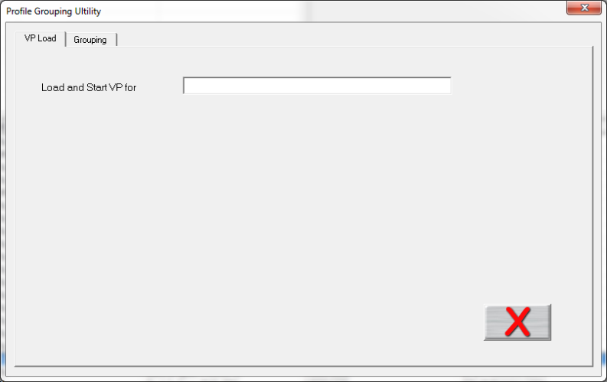

1. In the **Load and Start VP for** field, either type in a model number or use a barcode scanner to input an identification string.
2. Press the **Enter** key to start the software search for linked pairs of product baselines and models:

|  |  |  |
| --- | --- | --- |
| If the software finds a single linked product/model pair, they appear as linked on the screen, together with the VP Start button: | C:\Users\dklueck\Desktop\Matched pair Good to VP screen.png | 5a. Click the **VP Start** button to start Virtual Profiling with the selected model. |

|  |  |  |
| --- | --- | --- |
| If there are multiple matches, the Matched Model Links screen appears, displaying pull-down lists for products and models. | C:\Users\dklueck\Desktop\Matched Model Links screen.png | 5b. Select a product/model pair from the pull-down lists and click the **green check** (OK) button to return to the VP Load tab screen and start Virtual Profiling with the selected model. |
| If there is no match, the software displays a message about the model and a Link button. | C:\Users\dklueck\Desktop\No match message Detail.png | 5c. Click the **Link** button. |

The *Matched Model Links* screen appears:



1. Input the model number and select a product baseline profile from the **Product Name** pull-down list.
2. Click the green check (OK) button.

The VP Load screen reappears with the newly linked product/model pair displayed:



1. Click the VP Start button to begin Virtual Profiling with the selected model.

#### View the Linked Model On Other Screens

During Virtual Profiling, the name of the linked model appears in several places in the user interface. On the Profile Explorer screen, all linked models for a selected profile appear at the top of the screen and in the Child Model column:

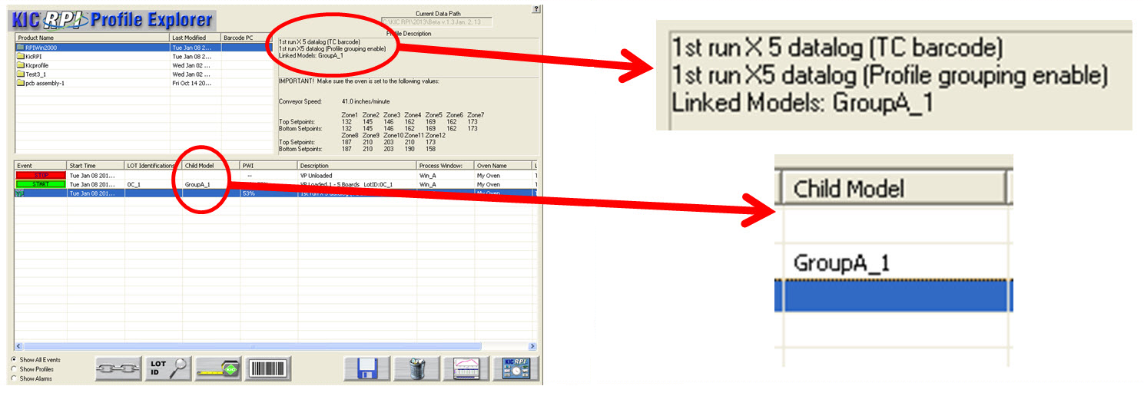

The name also appears at the top of the profile data screen.

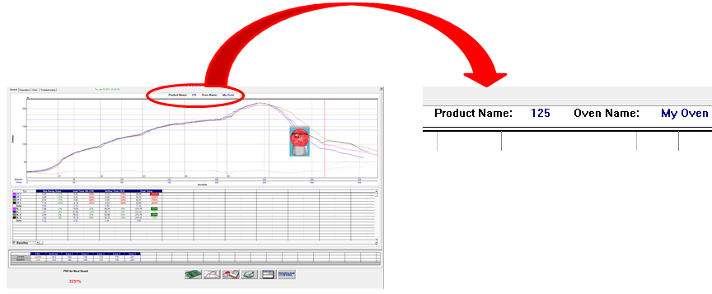

# Monitor Production in Live Mode

In VP *live mode*, the WPI software displays real-time data for the VP it generates for every production board processed. The software displays the data in various charts, graphs and statistical tables.

|  |  |
| --- | --- |
| During live mode, it also displays a crystal ball indicator that shows the current Virtual PWI, and Cpk values for your process as measured by the software. The crystal ball indicator appears continuously while VP is enabled. You can move the crystal ball, but not close or minimize it. See Figure 22.  The crystal ball color will indicate the current Virtual Profiling status:  **Green**  Ready  **Yellow**  Warning  **Red**  Alarm  **Grey**  Unable to Predict | Figure 22: Virtual Profile Crystal Ball indicator |

**Note**: A VP status message appears when you place the mouse pointer over the crystal ball.

## How to Avoid a Grey Crystal Ball

While a green crystal ball reports the system as VP-capable, and yellow/red alert you to problems, the grey color indicates that the software has insufficient data to make useful VP predictions. The condition can occur during a verification profile run where you introduce the profiler into an ongoing production flow. With boards both downstream and upstream of the profile board, the system lacks necessary data obtained by sampling empty machine conditions. To avoid the grey status KIC recommends running the profile with no boards following behind. For more information, see [Integrate Empty Machine Data](#_Integrate_Empty_Oven).

## 

## Live Mode - General Tab

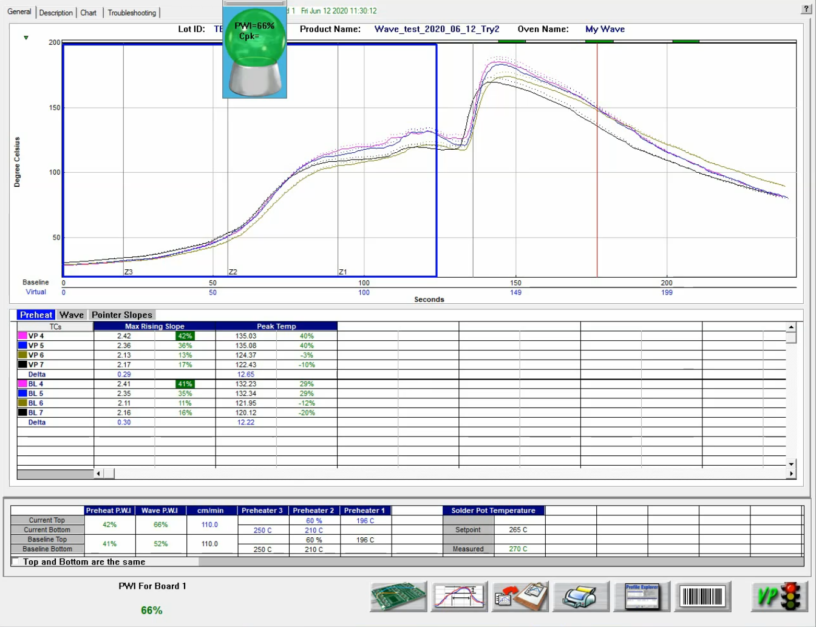

Figure 23: Virtual Profiling – General Tab

On the live-mode screen, the software displays both the baseline and virtual profile. To distinguish between the two, the baseline profile appears in a solid line format, while the virtual profile appears in dashed lines.

**Note**: To enlarge the graph portion of the General Tab, simply double click on the graph. To enlarge the statistics portion of this screen, double click on the statistics.

### Board Sensor Indicator

|  |  |
| --- | --- |
| The software indicates the physical location of the board sensor at or near the machine entrance by a small triangle above the graph.  When the sensor first detects a board, the on-screen indicator changes color from green to red. The indicator stays red as long as the board remains beneath the sensor. | Board in oven indicator |

### Profile Statistics



As described in the profiling section, any process specifications defined will appear in the statistics table in the center of the screen. The rows marked *BL* indicate the statistical calculations from the *Baseline Profile.* The rows marked *VP* indicate the current statistical calculations made during the current live *VP.*

### Recipe and Overall PWI



The bottom of the screen shows the recipe currently loaded, the *Baseline* and *Current* *PWI* for the Preheat and Wave sections of the profile.

### Graph Controller

|  |  |
| --- | --- |
| The Graph Controller allows you to modify the view of the WPI profile graph. See Figure 24. To open the Graph Controller, Left-click on the TC column header in the Statistics table or Double Left-click, anywhere just outside the profile graph.  **Auto scale –** The Auto Scale feature will automatically adjust the X and Y-axis scales to fit all of the data in the profile graph. When the Auto Scale feature is disabled, you must manually input the minimum and maximum scale settings for the X and Y-axis scales of the profile graph.  **TCs –** You cannot disable or rename a TC in a live Virtual Profile. You can only perform this function on the Baseline Profile. Those changes would then be reflected in the Virtual Profile display. | Figure 24: Graph Controller |

**Grid –** Enables/disables the view of the X and Y-Axis scales.

**Reference lines –** Enables the view of Reference Lines displayed on the profile graph. These lines represent any temperatures referenced in the selected Process Window.

**Zone lines –** Enables the view for the zone lines on the profile graph.

**Predicted TCs only** - Removes the Original profile plot from view, displaying only the prediction profile plot on the graph.

**Zero decimal** – When viewing the Examine tool, this setting enables or disables the decimal display. When unchecked, the software will display one decimal point.

**Internal temp** – Enables the view of the profiler’s internal temperature profile plot on the graph.

**Display Detailed PWI** – With this unchecked, you will only see the “overall” PWI for the profile. It will not display the individual TC PWI values.

**Floating O2 PPM display** – When the *O2 Live* option is purchased, you can enable/disable a window on the graph that shows the O2 measurement recorded during that profile.

**Display of Pointers** – Allows you to control which information is displayed when the *Pointer Slopes* tab in the Statistics table is selected (see below for additional details on pointers).

### Automatic Calculation of Delta T + Delta (Or Range) For All Statistics

The software will automatically calculate, and display in the statistical chart, the Delta for both the original and predicted profile data for all TCs for all Statistics. See Figure 25. This is the range of the highest to the lowest value for any given specification. This information is strictly being displayed and is not factored in to the PWI value and is not used in predictions.

### Examine Tool

|  |  |
| --- | --- |
| You can also view the Delta T (∆T), or Delta Temperature, at specific points across the profile by right mouse clicking on the graph. This will bring up a pointer and a chart will appear in the upper left corner of the graph. See Figure 25. | b  Figure 25: Examine Tool Display |

Wherever the pointer is moved across the profile, the following data appears:

* The first column is the actual temperature for each TC, Original.
* The second column is the temperature of the predicted profile data – based on setpoint or speed changes.
* The Delta T for both actual and predicted TC data.
* The time during the profile at which the pointer is placed

### Board Spacing

It is best to maintain at least a 1” space between production boards that enter the machine. A 1-inch gap ensures that the WPI system will accurately count and track boards through the machine. If two boards become pushed together leaving no space, the system should be able to detect the correct number of boards processed.

If the board length as determined by the system differs by more than 15% from the baseline-product length while Virtual Profiling – live, an alarm will appear after five boards.

The number of boards to trigger an alarm on can be changed if needed, contact KIC Technical Support for help, [tech@kicmail.com](mailto:tech@kicmail.com).

## Live Mode - Description Tab

|  |  |
| --- | --- |
| The Description tab displays the profile Description notes for the baseline profile. See Figure 26.  You can edit these notes by clicking in the description area.  Below the description area, the Virtual Profile and Baseline Statistics, and recipes are displayed. In the bottom-left corner, the current PWI appears. Enlarging the description area and statistics are not possible while viewing this tab. | A screenshot of a cell phone  Description automatically generated  Figure 26: Virtual Profiling – Description Tab |

## Live Mode - Charts Tab

|  |  |
| --- | --- |
| The Chart tab will display a control chart for the overall profile PWI, and statistics as defined in the Process Window setup. Select the *Preheat* tab to view the *Preheat* statistics; the *Wave* tab to view *Wave* statistics See Figure 27.  The alarm limits for each specification appears on each chart using red horizontal lines.  Each time a board is detected exiting the machine, the WPI software will plot a data point for each product thermocouple on each chart. The chart data will coincide with the live Virtual Profile data.  The software will update the overall PWI for each chart and calculate the Cpk and display the results above each chart. | A screenshot of a social media post  Description automatically generated  Figure 27: Virtual Profiling– Chart Tab, all charts |

**Note**: You can enable or change the Cpk alarm values in the “Global Preferences” screen before you start Virtual Profiling.

Above the control charts is a bar display showing the board sensor location. Similar to the General tab, when a board is detected under the sensor, the indicator color will change from green to red as long as the sensor detects a board. This display also shows the current location and number of boards in the machine. In the bottom-left corner, the current PWI appears. If the Barcode capabilities are enabled, the barcode number for the last board processed appears in the lower-left-corner as well.

### View Chart Data

To view individual chart data, click inside the chart area of your choice. This will display that particular chart in a full screen view.

Move the mouse pointer over the chart data, a display box will appear. This display box data includes barcode number, PWI, Cpk, date, and time for each board. See Figure 28.

Click in the chart area to return to the regular Chart tab view.

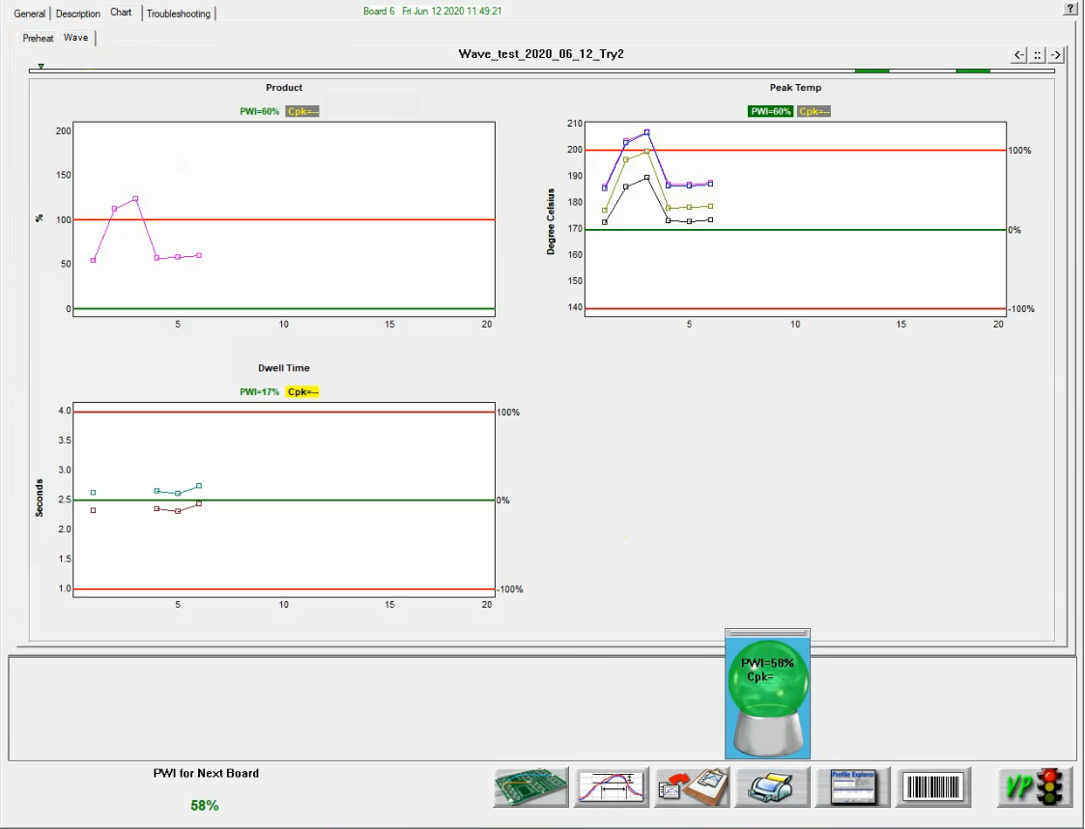

Figure 28: Virtual Profiling – Chart Tab, zoom chart

## Live Mode- Troubleshooting Tab

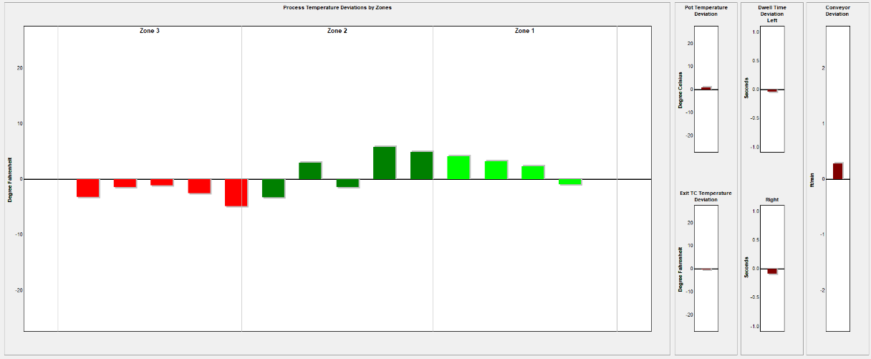

Figure 29: Virtual Profiling – Troubleshooting Tab

The Troubleshooting tab will display the deviation of the various WPI sensors on bar charts. The deviation data is measured against the baseline profile. This data is updated for every board, or every 25 Seconds. See Figure 29.

**Tool tips –** Moving the mouse pointer over the deviation chart data will enable tool tips that show the deviation value for each of the probes. Moving the mouse pointer over the conveyor speed chart will show the baseline profile conveyor speed, and the conveyor speed for the last board to exit. See Figure 30.

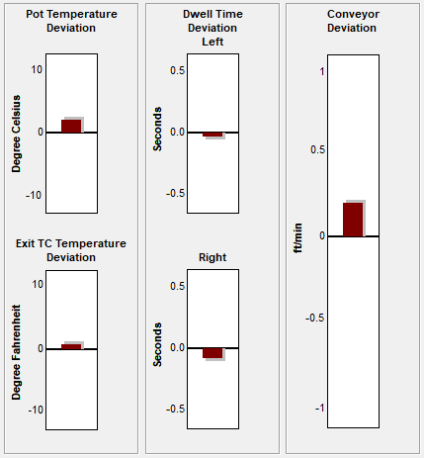

Figure 30: Probe Deviation Value Display

## VP Live Mode Buttons

While in Virtual Profiling - live mode the software displays several buttons at the bottom of the screen.

|  |  |
| --- | --- |
| bt-NAV_Run-profile | **Run Verification Profile –** Select this button to run a Virtual Profile Verification profile. The software may require you to run a Verification profile if it has determined that the current process temperatures have changed significantly from the baseline. |
| bt-NAVint_Proc-menu | **View/Edit Process Window –** This lets you to view the Process Window specifications and limits in a read-only format. |
| bt-NAVint_Copy2Clipbd | **Copy to Clipboard –** This button will copy the profile or Virtual Profile data to the clipboard for use with third-party software such as a spreadsheet application, or SPC software. |
| bt-NAVint_Print | **Print –** This button will print the current profile.  **Note**: If you wish to print a tab besides the General tab, pressing F9 on your keyboard will print the contents of any screen in the software. |
| graphic_104p | **Profiler Explorer –** This button will take you to the Profile Explorer screen. You can view profile and Virtual Profile event data. This feature is especially useful to ascertain which alarms have occurred and have been acknowledged during production. There is only one button at the bottom, which will return you back to Virtual Profiling - live mode. |
|  | **Stop Virtual Profiling –** This button will stop Virtual Profiling and return to the Profile Explorer screen. |
|  |  |

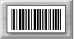 **Barcode Queue –** Displays a text box showing the current barcodes yet to be assigned.

## 

## Verify The Virtual Profile

The *Virtual Profile* is a prediction of the process profile (inside the machine) generated from a model created when the Baseline profile was run. A *verification* *profile* is a comparison run against the Virtual Profile model. If you think the process has changed significantly or you have purposely changed the recipe, running a verification profile lets you verify the prediction model. This comparison can either verify that the process profile is still within specification or create a new baseline profile based on the recent changes.

The verification profile updates the Baseline profile for the current Virtual Profile, ensuring that its prediction model yields the most accurate possible results, using the most recent profile. The software always recognizes the latest in‑spec profile as the Baseline for any Virtual Profile.

The software recognizes when the process temperatures change significantly as compared to the current Baseline profile, and then prompts you to run a verification profile. You can intentionally run a verification profile at any time during Virtual Profiling Live Mode.

**Note**: The software will only accept a verification profile as a new baseline if meets the standard VP criteria. See [Get A Valid Baseline Profile](#_Get_A_Valid).

|  |  |
| --- | --- |
| 1. Verify that VP is running in live mode 2. Select the Run Profile button at the bottom of the VP live screen. See Figure 31. | bt-NAV_Run-profile  Figure 31: Run Profile Button, VP Live Mode Screen |
| 1. The software displays a message asking if you want to run a verification profile with: See Figure 32.  * If you choose **No**, the software will return to the previous screen. * If you choose **Yes**, the software will begin stepping through the run profile routine. | Figure 32 |

1. Verify the following before profiling:

* The profiler is on and ready to profile.
  + If a Transmit model – Receiver or Base Station is plugged into computer.
  + If a Datalogger model – The profiler is plugged into the download cable and download cable is plugged into the computer.
* Profiler batteries and internal temperature are at the proper levels to profile.
* All thermocouples attached to the profiler are below the defined product start temperature.

1. To begin profiling, click the Profile Start button (green traffic light).

Once the verification profile is complete, and the KIC profiler has downloaded the profile data that meets Virtual Profile criteria, the software will display the dialog box shown below. See Figure 33.



Figure 33: This dialog box will display the PWI and the  
predicted PWI for the verification profile.

Alternatively, if the profile is out of spec, the dialog box shown below will appear stating that the PWI is too high. See Figure 34.

If you choose to continue running Virtual Profiling, you will receive WARNING #2, “The last profile was out of spec”. In which case, you would need to run profiles until an in-spec profile is achieved before the software lets you continue Virtual Profiling.



Figure 34: Out of Spec Verification profile

The dialog box will present two choices:

1. **Continue Virtual Profiling –** If the verification profile meets Virtual Profiling criteria, it will automatically be used as the new baseline profile. If you choose this option, the software will update the baseline and continue Virtual Profiling, using the verification profile as a new baseline profile.
2. **Unload Virtual Profile and go to Prediction mode** – If the verification profile does not meet Virtual Profiling criteria or is out of spec, it can’t be used for Virtual Profiling. If you choose this option, you can predict changes to the profile in order to bring the profile back within its process specification. You will have to run at least one more profile in order to produce a profile that meets Virtual Profiling criteria.

**Note**: For an explanation of VP criteria, see [Virtual Profiling](#_Virtual_Profiling).

## Historical Mode

The WPI software has an historical mode feature. This feature allows you to view Virtual Profile data for any board processed when the Virtual Profiling has been running. Open the Profile Explorer and select any event other than a profile**.** The *Display the Graph and Statistics for this profile*buttonwill change from a single graph button display to a HISTORY button display, indicating there is Historical data associated with selected event. See Figure 35 and Figure 36.

|  |  |
| --- | --- |
| Figure 35: Profile Explorer–Display Graph and Statistics for this profile | bt_Inspection_History  Figure 36: Profile Explorer–Display Historical Graph and Statistics |

## View Historical Data While Running a Live Virtual Profile

To view historical Virtual Profile data from the same PC while Virtual Profiling - live, you launch a separate KIC Host.exe file located in: C:\WPI\AppforViewer\KICHost.exe. This opens a separate Profile Explorer that lets you to browse through the history of any product including the one currently running VP. Historical data will be available for any boards that have already exited the machine.

## Historical Mode - General Tab

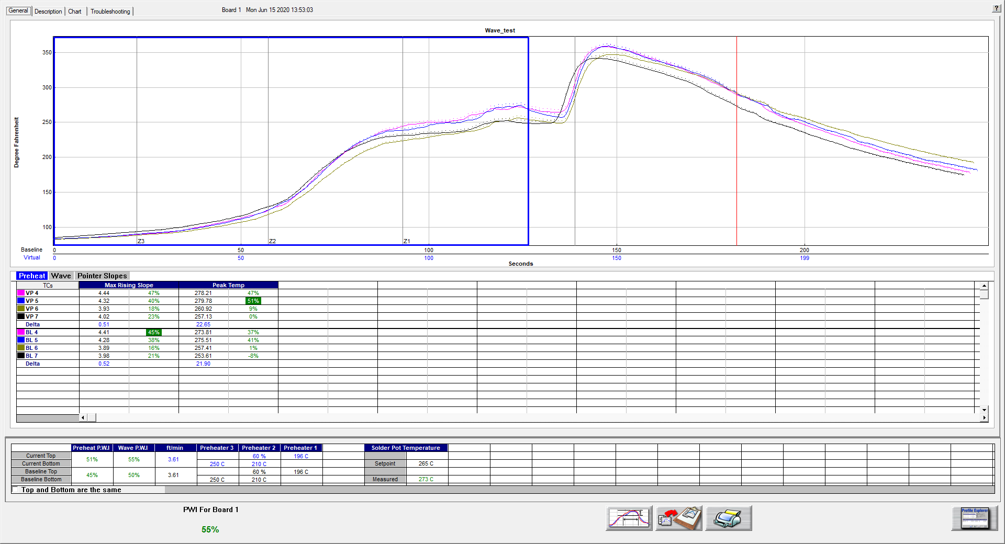

Figure 37: Virtual Profiling History – General Tab

The WPI software will display the baseline profile on the profile graph in a solid line format. Also on the profile graph is the Virtual Profile for the selected board, date/time. The Virtual Profile appears on the profile graph in a dashed-line format. This display method allows you to easily distinguish between the baseline and Virtual profiles.

Below the profile graph, the Virtual Profile and baseline profile statistics are displayed. Below the statistics, the Virtual Profile and baseline profile PWI values, machine recipes, and Solder Pot setpoint and measured values are displayed.

### Graph Controller

|  |  |
| --- | --- |
| The Graph Controller allows you to modify the view of the WPI profile graph. See Figure 38. To open the Graph Controller, Left-click on the TC column header in the Statistics table or Double Left-click, anywhere just outside the profile graph.  **Auto scale –** The Auto Scale feature will automatically adjust the X and Y-axis scales to fit all of the data in the profile graph. When the Auto Scale feature is disabled, you must manually input the minimum and maximum scale settings for the X and Y-axis scales of the profile graph. | Figure 38: Graph Controller |

**TCs**

The TCs section is a list of the thermocouples used for the profile. In the event that you wish to view the profile without a particular or multiple thermocouples, you can deselect individual thermocouples, or deselect the “All” check box, and choose only the thermocouples you wish to view. The software recalculates the PWI and updates the profile statistics based on the remaining thermocouples selected. You must select at least one product thermocouple. You can also update the distance measurement if a value was input incorrectly when the profile was started.

**Grid –** Enables/disables the view of the X and Y-Axis scales.

**Reference lines –** Enables the view of Reference Lines displayed on the profile graph. These lines represent any temperatures referenced in the selected Process Window.

**Zone lines –** Enables the view for the zone lines on the profile graph.

**Predicted TCs only** - Removes the Original profile plot from view, displaying only the prediction profile plot on the graph.

**Zero decimal** – When viewing the Examine tool, this setting enables or disables the decimal display. When unchecked, the software will display one decimal point.

**Internal temp** – Enables the view of the profiler’s internal temperature profile plot on the graph.

**Display Detailed PWI** – With this unchecked, you will only see the “overall” PWI for the profile. It will not display the individual TC PWI values.

**Floating O2 PPM display** – When the *O2 Live* option is purchased, you can enable/disable a window on the graph that shows the O2 measurement recorded during that profile.

**Display of Pointers** – Allows you to control which information is displayed when the *Pointer Slopes* tab in the Statistics table is selected (see below for additional details on pointers).

### Automatic Calculation Of Delta T + Delta (Or Range) For All Statistics

The software will automatically calculate, and display in the statistical chart, the Delta for both the original and predicted profile data for all TCs for all Statistics. See Figure 39. This is the range of the highest to the lowest value for any given specification. This information is strictly being displayed and is not factored in to the PWI value and is not used in the Navigator or Auto-focus calculations.

### Examine Tool

|  |  |
| --- | --- |
| You can also view the Delta T (∆T), or Delta Temperature, at specific points across the profile by right mouse clicking on the graph. This will bring up a pointer and a chart will appear in the upper left corner of the graph. See Figure 39. | b  Figure 39: Examine Tool Display |

Wherever the pointer moves across the profile, the following data appears:

* The first column is the actual temperature for each TC, Original.
* The second column is the temperature of the predicted profile data – based on setpoint or belt speed changes.
* The Delta T for both actual and predicted TC data.
* The time during the profile at which the pointer is placed

## Historical Mode - Description Tab

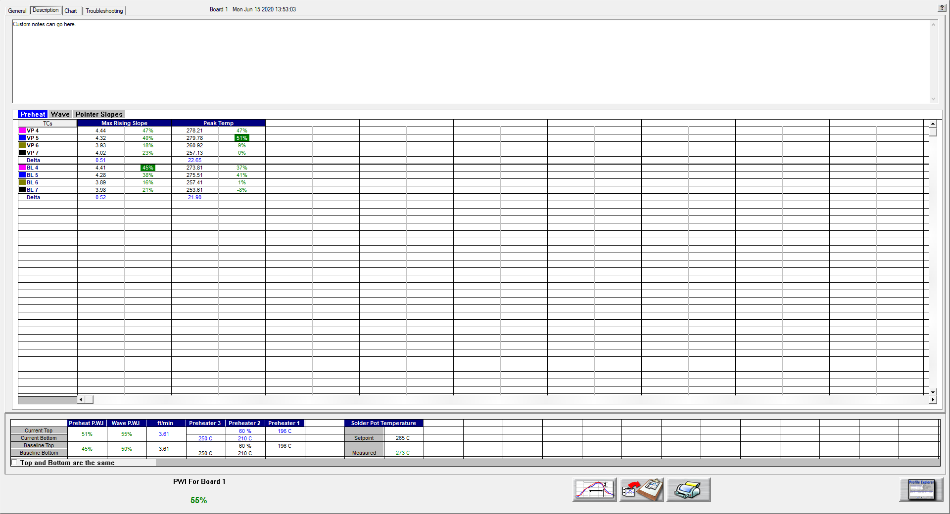

Figure 40: Virtual Profiling History – Description Tab

In Historical mode the Description tab displays the Baseline profile description notes. See Figure 40. You can edit these notes for a specific board by entering in the description area. Below the description area, the Virtual Profile and baseline statistics, and recipes are displayed. In the bottom-left corner, the PWI (and the barcode number, if enabled) for the selected board appears.

## Historical Mode - Chart Tab

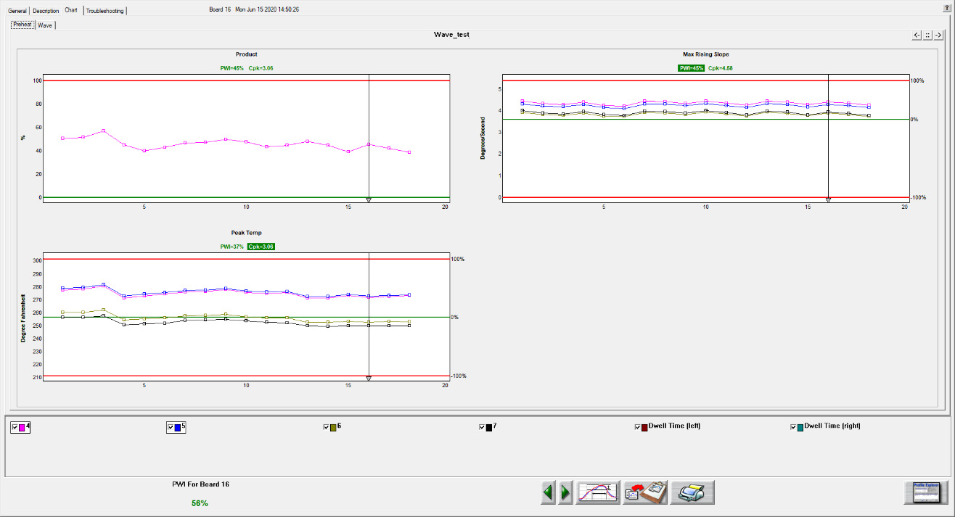

Figure 41: Virtual Profiling History – Chart Tab

The Chart tab will display a control chart for the overall profile PWI and for each individual process specification with alarm limits as defined in the Process Window setup. See Figure 41. The chart data will coincide with the Virtual Profile data for the selected board, date, and time.

### View Control Charts

The data is separated into two parts – Preheat and Wave. A tab in the upper left corner allows you to select which data to view. Each tab displays the applicable charts for that part of the process, based on the specifications chosen in the Process Window, as well as an overall PWI and Cpk chart for that section of the profile.

Depending on the screen resolution setting of the computer not all charts may fit within the screen area. Use the buttons in the upper-right corner of the Chart tab to select the number of charts to display and toggle between then.

The control charts hold all the historical Virtual Profile data for your product as selected in the Profile Explorer. Each data point on each chart represents a board that has passed through your machine.

**Board selector line -** Each chart has a Board Selector Line. The board # appears at the top of the screen, along with the date and time that board # was entered into the WPI system. You can move the Board Selector line position by clicking and dragging the small triangle at the bottom of the Board Selector line.

The Maximum PWI and Cpk for the selected board, date and time are highlighted above the corresponding chart(s).

Each chart contains data for every product thermocouple used during the profile. Below the charts you can de-select the TCs that you wish to remove from the control chart display. De-selecting a TC will remove the data for that TC from each control chart. Click the check box again to display the data for that TC. In the bottom-left corner, the PWI (and the barcode number, if enabled) for the selected board appears.

### View Chart Data

To view individual chart data, click inside the chart area of your choice. This will display that particular chart in a full screen format. Move the mouse pointer over the chart data, and a display box will appear. This display box data includes barcode number, PWI, Cpk, date, and time for each board. The date and time stamp for that board is displayed at the top of the screen.

### History Mode Chart Options Menu



Figure 42: History mode-Chart Options Menu

* **Meter window –** Right click anywhere in the full screen chart area. The Chart Options menu will appear, select Meter Window. This will display a small data box in the upper-left corner of the profile graph. This data box will display the historical – statistic data for any selected board. To select a board move your mouse pointer along the chart data, at each data point the historical – statistic data for that board appears. Right-click in the chart area again and de-select Meter Window to disable this feature.
* **Point protector –** When this feature is enabled, the software will display individual data points for each board. A small square shaped data point represents a production board. A small circle shaped data point represents a profile board. To activate this feature right click anywhere in the full screen chart area. A menu will appear, select Point Protector. This will display the individual data points on each control chart. De-selecting this feature will remove the data points from the control chart, showing only a plot of the same data. By default, the Point Protector is enabled for charts containing 20 boards or less. Click in the full screen chart area again to return to the regular Chart tab view.
* **Event History-** This feature is enabled as a default setting in the software. When viewing the charts tab while in History mode an Event History dialog box appears. The Event History dialog box will contain a list of all alarms and alarm related events that happened during the (selected) Virtual Profile.



Figure 43: Event History dialog box

* **Disabling Event History Display** - Right click anywhere in the full screen chart area. The Chart Options menu will appear, select the Event History option.

#### Charts Tab Buttons

The Charts tab will have two extra buttons found only on this screen:

|  |  |
| --- | --- |
| bt_la | **Scroll backwards in time** – Clicking on the green left arrowhead will result in displaying the *previous* set of virtually profiled boards. |
| bt_ra | **Scroll forward in time** – Clicking on the green right arrowhead will result in displaying the *next* set of Virtually Profiled boards. |

**Note**: Each chart can display a maximum of 200 data points at any given time. Every 200 data points are considered a set of data. A set of data can contain up to 200 data points, or if the production run was stopped before 200 boards were processed, a data set may contain less than 200 data points.

## Historical Mode - Troubleshooting Tab

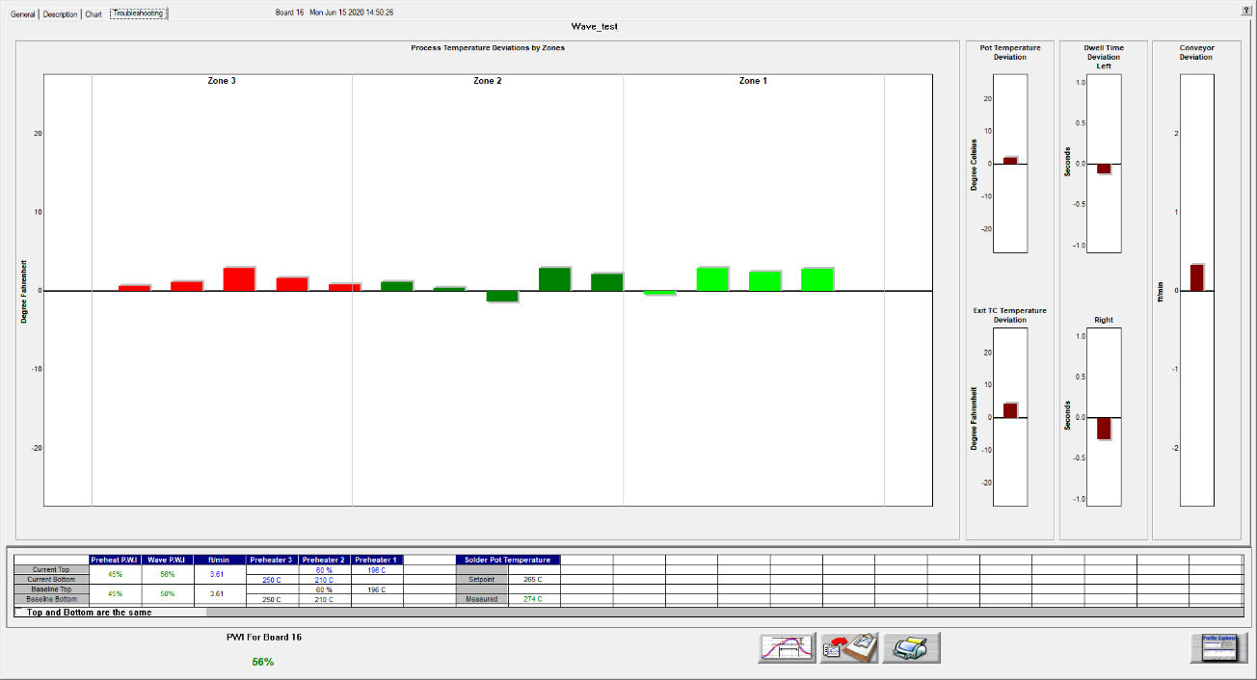

Figure 44: Virtual Profiling History – Troubleshooting Tab

The Troubleshooting tab shows historical probe temperature, dwell time, and conveyor speed deviation. The Board number, date, and time appears at the top of the screen. See Figure 44. To change the board #, go to the Charts tab and move the Board Selector Line to a different board (#) number. The PWI for the selected board appears in the bottom-left corner.

There is a total of 30 probe thermocouples inside the machine – the first 28 are installed in the preheat area. On the left side of the screen, the temperature deviation from the baseline of each of these 28 are shown. Each zone displays a different color for the probe TCs that are inside that zone. The right side shows deviation of the other sensors.

### Historical Mode Buttons

While in Virtual Profiling - Historical mode, the software displays four buttons at the bottom of the screen.

|  |  |
| --- | --- |
| bt-NAVint_Proc-menu | **View/Edit Process Window –** This lets you view and edit the process window specifications and limits. |
| bt-NAVint_Copy2Clipbd | **Copy to Clipboard –** This button copies the profile or Virtual Profile data to the clipboard for use with third-party software such as a spreadsheet application, or SPC software. |
| bt-NAVint_Print | **Print –** This button will print the current profile as displayed on the General Tab.  **Note**: If you wish to print a tab besides the General tab, pressing F9 on your keyboard will print the contents of any screen in the software. |
| graphic_104p | **Profile Explorer –** This button will return you to the Profile Explorer. Click this button when finished viewing historical Virtual Profile data. |

## Barcode Functions

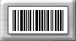WPI software has two main barcode functions, *Process Traceability*, and *Process Control*. For either barcode function, a serial barcode scanner would connect directly to the *DAU/eTPU-Alarm/Barcode port* or to the pigtail connector of the alarm relay-cable if an alarm relay is also being used. The alarm relay is required for use of the Process Control barcode function. Alternatively, a USB scanner can also be connected directly to the *DAU* through one of the USB ports. See *[Appendix C – Barcode](#_Barcode_Tab_1)* for more information.

### Process Traceability (PT)

The Process Traceability function enables process traceability with profile data for every product linked to its barcode number. The software will match the barcode number and complete process data to every single production board recorded by the system. The Process Traceability Barcode function can be used with or without the Process Control function.

### Process Control (PC)

The Process Controlfunction enables process control by reading the product barcode label before the product enters the machine and confirms that a specific area of the barcode correlates to a specified product. If the barcode string value matches the current process string value, production continues as normal. If the incoming barcode string value differs from your defined string value, an alarm is activated, and the process can be stopped until the operator acknowledges the alarm and takes the proper action. In order to utilize the Process Control feature, your barcode strings need to contain at least one character (referred to as a “String”) that is common to all boards in a production run. For example, when running “Product A”, all barcode labels for Product A would be “ABCxxxx”, where “ABC” would represent the common characters (control string) on each barcode label, and “xxxx” would represent the rest of the barcode characters, which would typically be unique to each individual board. The common character string can fall anywhere within the barcode. The Process Control Barcode function can be used with or without the Process Traceability function.

### Barcode Product Sensor

The Barcode Product Sensor (BPS) is an available product sensor used exclusively with the barcode option for added functionality. Using the BPS, the WPI system can determine if any given product has had its barcode label successfully scanned. If the product passes the sensor and there are no barcode strings that have been read into the software, then the system will give a NO READ alarm. (Alarm 5C)

### Scanner settings

The WPI barcode function is offered as a software only feature. You must provide the serial port or USB barcode scanner, support/ utility software, all communication cabling, and mounting hardware. Here are some important points to consider when planning to use WPI with the barcode option:

1. The barcode reader must have either a 9-pin D-Sub serial connector (RS-232) for communication or be a USB model that can be programmable for Serial Port interface.
2. Barcode readers with Raster scan (multi-scan) are recommended.
3. Barcode reader must be capable of the following communication settings:

**Baud Rate: 9600 bits/sec, Data Bits: 8, Parity: None, Stop Bits: 1**

1. The scanner(s) must be programmed to have both a “Line Feed” and “Carriage Return” after each string is scanned.
2. The scanner must be programmed for a single output for each board scanned.
3. You will need the barcode reader utility software to configure the barcode reader.
4. Non-standard cabling may be required for multiple barcode applications.
5. When using multiple barcode scanners, the use of prefixes is required.

## Barcode Types

Since the software does not actually read the barcode labels, you can use any barcode type that your barcode scanner is capable of reading. Verify your barcode scanner can read the barcode type prior to KIC installation. Use the manufactures utility, or Windows-HyperTerminal for verification.

### Configuration Overview

1. Program the barcode scanner settings using the software utility that is provided by the scanner manufacturer to configure the barcode scanner. If you do not have it, contact the scanner manufacturer or their website.
2. Select desired functions/settings in the Barcode tab of the Configuration Program, and then enable the barcode option(s) in Global Preferences. The WPI Hardware Status screen will help you verify your barcode reader is connected properly.
3. Test the hardware connection.

### Configure and Test the System

There are multiple ways to determine if the barcode scanner(s) hardware is configured properly and communicating with your WPI system. One is using the Hardware Status screen, another is using the DAU or eTPU Utility, and the another is using the Barcode-Log file.

**Note**: Make sure your system is properly installed and configured before you attempt to test your barcode hardware.

#### Configuration

Start by ensuring that the WPI software key is properly connected to your PC. Verify the software key is correctly installed by viewing the Hardware Status screen. Confirmation appears in the Software Key field.

If you do not see confirmation displayed, check the following:

* Check to make sure software key is properly installed and correctly seated.
* Check to make sure the key you have is programmed for Barcodes.
* Check to make sure the USB port is functional.



Figure 45: Global Preference – Barcode Option Tab

Open the WPI software. From the main menu, select the Global Preferences button, and then select the Barcode tab. Select the Barcode option(s) that apply.

There are several possible barcode hardware configurations. The correct barcode configuration will depend on the KIC hardware and barcode labeling technique. For barcode type configuration details, see the section titled [Barcode Types](#_Barcode_Types_1). For testing purposes, select any barcode option.

Select your barcode function(s) and enter any measurements that apply. The Missing Barcode Alarm feature is only for the Process Traceability function.

Choose the green check button to save your settings and return to the main screen.

### View Barcode Data On The Hardware Status Screen

**Hardware Status** – Once a barcode function is enabled, a barcode field is added to the Hardware Status screen as seen below.



Barcode field

Figure 46: Hardware Status

In the Barcode section, the last barcode read appears. In order to view the barcode value, the conveyor must be moving. The barcode information will not display until the encoder begins pulsing.

### Test Sensor Inputs With DAU or eTPU Utility

The DAU and eTPU Utility are programs that lets you verify the sensor inputs, including Product Sensor, Encoder and the barcode scanner itself when connected to the DAU or eTPU. Click “Start DAU” (or “Start eTPU”) to begin reading the connected device.

**Barcode Reader:** With the Barcode reader powered ON and connected to the DAU/eTPU, scan a barcode. The scan results appear in the “Last Barcode Read” field.

If the Barcode read fails, check the connections, and verify the barcode reader setting as previously described.

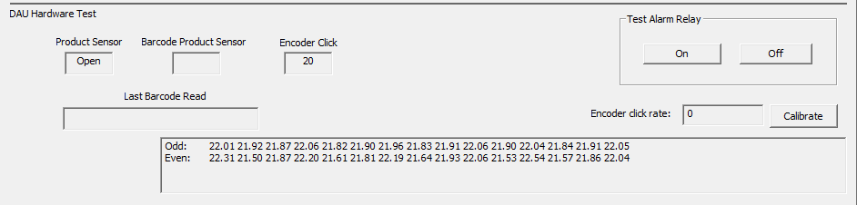

Figure 47: DAU Hardware Test

### Test With The Barcode Log Configuration File

**Barcode Log** - You can also verify that the barcode feature is configured properly or for troubleshooting purposes by viewing the Barcode-Log file. If the barcode scanner hardware is connected and functioning properly, the system generates a log file. Every barcode value read by the system is logged and viewable.

To view the barcode-log file go to C:\WPI\Log\barcodeLog.txt. This file will list the date, time, and barcode value for each barcode read through the DAU or eTPU. This information will also be displayed in the KIC Host screen.

### 

## Scanner Installation

There are several ways to configure the system for use with barcodes. The correct configuration will depend on the infeed conveyor layout, scanner hardware, and barcode labeling techniques used in your process. Contact KIC Technical Support for more information.

### Install Scanners on the Load Conveyor

For the Process Control barcode function, it is required to install the barcode scanner(s) on the load conveyor. The load conveyor-power or SMEMA is connected to the alarm relay. The alarm relay controls the load conveyor, thereby controlling the flow of product into the machine. When a Process Control or any other critical alarm is activated, the power or SMEMA to the load conveyor is cut, stopping the flow of product into the machine. This ensures that no products enter under alarm conditions.

The installation positions of the Scanner(s) and BPS are determined by your hardware set up. Below are some guidelines for installation of barcode scanners and BPS. See Figure 48

KIC 24-7 - Barcode Scanner Installation Guidelines

Figure 48: Barcode Scanner Installation Guidelines

## Virtual Profiling and Barcodes

**Note**: The USB software key must always remain connected during use.

### Process Control

There are two methods for defining the characters of a barcode string that will be used for Process Control – Wildcard (default) and Parsing. See [*Appendix C – Barcode*](#_Barcode_Tab_1) for how to change between methods.

**Wildcard -** When Virtual Profiling is started, the system produces the Barcode Process Control dialog box which gives you the opportunity to: Enter the Process Control String, Change the Process Control String, or Disable Process Control for this Virtual Profile run.

If the Process Control function is enabled (Global Preferences) and the Wildcard method is selected (Configuration Program), this dialog box will appear every time Virtual Profiling is enabled. See Figure 49. Enter the barcode control string that is specific to the product family that is running. The software reads the incoming string and compares it to that of the specified Process Control String, for every product. If the string values differ, an alarm is activated, and the process is stopped via the alarm relay device.



Figure 49: Barcode Process Control dialog

**Parsing** – Whereas with the Wildcard method, the Control String characters must be sequential, using the Parsing method allows you to specify characters in any position of the string to be the Control String.

In Profile Explorer, right click in the *Control String* column for a given product and choose *Add Control string*:



A window will open for selecting defining the characters of the control string:

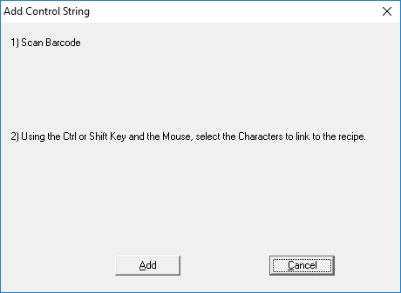

Scan a barcode for the selected product and the full string will be displayed in the window. You can then select the individual characters that will be the *Control String* for this product family. Click *Add* to save this *Control String* to the product:



The *Control String* column will now display the defined string for that product name:



With the Parsing method, you also have the ability to add more than one *Control String* for a given product by repeating the same steps above. You can remove a *Control String* for a product by right-clicking and choosing the *Edit Control String* selection.

### Barcode Product Sensor (BPS)

WPI systems using the optional BPS and Process Control barcode function will have the ability to activate an alarm if a products barcode label is not read.

When the BPS detects a product whose barcode label has not been read, or the BPS is tripped accidentally, an alarm is activated, and the process is stopped via the alarm relay. Alarm 5C appears. See Figure 50.

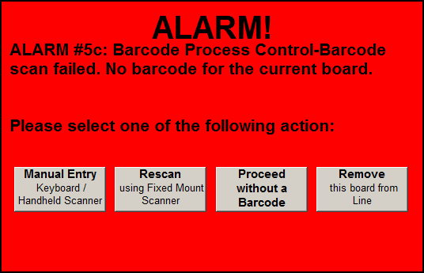

Figure 50: Alarm 5C

Control buttons on the screen let you:

* Manually reenter the barcode, using the keyboard or a handheld scanner
* Rescan the barcode with a mounted scanner
* Continue production without the barcode
* Remove the board from the line.

### Read Barcodes With A Product Traceability Scanner

If you use a Product Traceability Scanner (PTS) to read barcode labels while running VP, you will get a barcode recorded along with a PWI for every board that passes thru the machine. You enable this function by selecting *Traceability* under Barcode tab in the Global Preferences.

#### Use a PTS at the Machine Exit

When installed on the machine exit, the PTS reads barcode labels as the product exits the machine. If the barcode label is not read, Alarm 5 appears. With this configuration, there is no ability to add a barcode string to the data if this alarm was generated. See Figure 51. You can disable the Missing Barcode Alarm in the Global Preferences screen.

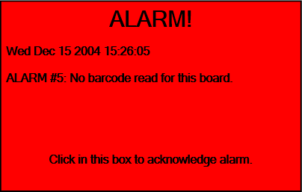

Figure 51: Alarm 5

#### Use a PTS at the Machine Entrance

When installed on a load conveyor, the PTS reads barcode labels before the products enter the machine. If the barcode label is not read, the process is stopped before the product enters the machine. This method requires an alarm relay, and load conveyor.

WPI systems using a BPS and Process traceability barcode function (PTS at machine entrance) will have the ability to activate an alarm if a products barcode label is not read or is damaged. When the BPS detects a product whose barcode label has not been read, or the BPS is tripped accidentally, an alarm is activated, and the process is stopped via the alarm relay. Alarm 5a appears. See Figure 52.

Control buttons on the screen let you:

* Manually reenter the barcode, using the keyboard or a handheld scanner
* Rescan the barcode with a mounted scanner
* Continue production without the barcode
* Remove the board from the line.

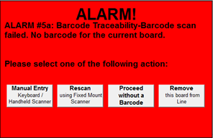

Figure 52: Alarm 5a

## Enable Barcoding Per Product

You have the ability to turn on or off the Process Control and Traceability functions on a per product basis. When the Barcode feature is active, in Profile Explorer you will find checkboxes for the two different functions to the right of each product folder. These checkboxes allow you turn on/off the feature independently for each product:

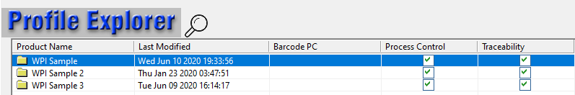

## Display the Current Barcode Queue

A button for the barcode queue is available on the Graph, Description, Charts, and Troubleshooting screens during a live VP. This allows a user to remove a product and its associated barcode string from the line before the product enters the machine. The software will display this button even if all barcode options are disabled.

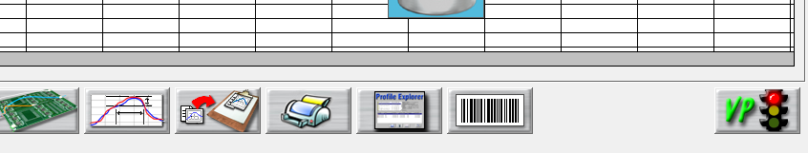

When hovering the mouse over the button, a tool tip “Display Barcode Queue” will display.

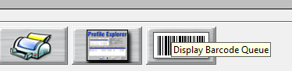

### Barcode Queue Dialog

Click the button to open the **Barcode Queue** dialog that displays a list of all the barcodes currently in the queue in order. The next barcode to be assigned to a board appears at the top of the list. A barcode is automatically removed from the list after the board has completely passed the entrance board sensor.



Notice that the **Remove** button is disabled as default. When the user clicks a barcode, the **Remove** button becomes active.



### Remove Barcode

Follow these steps to remove a barcode:

1. Click the barcode that matches the board to be removed
2. Click the **Remove** button
3. Click **Yes** on the KIC dialog that asks you to “*Confirm you want to delete this barcode string from the queue*?”   
   Clicking **No** returns the user to the Barcode queue window.



The software then removes that string from the queue and the next string in line will be assigned to the next board.





## View Barcode Traceability Information For Boards Previously Run

Barcode information is collected for all the boards that pass through the machine. Barcode information is stored only when Virtual Profiling is running. After the barcode is read, the software will display the barcode value in the bottom-Left corner of the Virtual Profile screen until the next board’s barcode is read. When viewing historical VP data, the selected board’s barcode number is also displayed in the bottom left corner of the screen. See Figure 53.

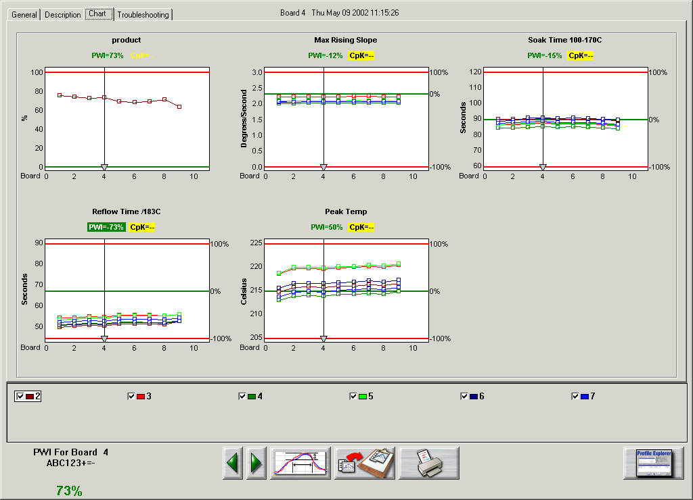

Barcode value display for most recent read by the system or selected board if viewing historical *Virtual Profile* data.

Figure 53: Virtual Profiling – Chart Tab

## Search For Barcode Entries

In the Profile Explorer screen, there is a Barcode button located at the bottom of the page. Select this button to search for specific barcoded products and view their profile information for the date/time they were processed.

Click on the product folder you want to search and then click on the Barcode button. A dialog box appears with a field to enter the barcode value with a Search button next to it. See Figure 54. You can enter the value using the keyboard, or by selecting the scanner check box and then using the barcode scanner to scan the actual barcode eliminating the need to enter the value manually.

Below this is a field that will list the time, date and PWI for that barcode, if it exists for the chosen product. Either double-click the particular listing or highlight it and then click the View Selected Profile button. This will bring you to the Historical Virtual Profile graph for that particular board. If you click on the Charts tab, the Pointer Line will coincide with that particular board for all the charts as well.

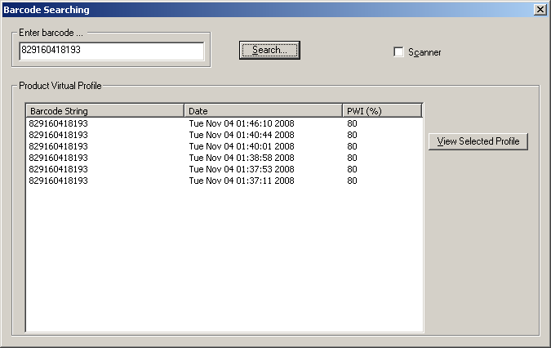

Figure 54: Barcode Search

## Live Data Output And Barcodes

The Live Data Output (LDO) function will output the thermal process data to a file. The thermal process data will include barcode information for every board when the Barcode-Traceability and Live Data Output features are both enabled. See the [Live Data Output](#_Remote_Process_Monitor_(RPM)) section in this manual for more information.

Below is an example of the KIC\_WPI\_LiveDataOutput.txt file that is generated by the system when LDO is active. See Figure 55.

**Note**: the tables below were created by importing the LDO data file into Microsoft Excel.



**Barcode data for each board**

Figure 55: Example Live Data Output text file

# Live Data Output

The Live Data Output (LDO) feature outputs Virtual Profile (VP) data in real time for use by third-party applications such as Line Balancing/Production Monitoring Host or SPC software. This data includes barcode information (where applicable) and all relevant profile data, statistics, and limits. There are several different LDO formats that can be chosen from. Examples of these formats will be shown later in this section.

**Output of the LDO file data** –When the VP is running, the statistical data from each newly completed Virtual Profile is written to the LDO file when the board exits the machine.

**Viewing LDO data** – LDO is designed to output data only and is not meant as a historical database. It is intended to be used with third party software that collects the LDO data while the Virtual Profile is running-live. If you are not running third party software to collect the LDO data, and wish you to view historical data, this can be accomplished from within the actual KIC software in use.

**LDO destination** – The location where the LDO output file is written to can be specified by the user in the ConfigurationProgram.exe utility.

**Note**: For the Live Data output to function, the appropriately programmed USB dongle key must remain connected to the PC at all times during use. You can verify your USB dongle has the LDO feature by viewing the Software Key panel in the Hardware Status screen.

**An LDO output file example**

Below is an example of the type of data included in the LDO output file:

Process Info:

Product Name:

Profile Board\_Soldered TCs

Process Window Name:

\_\_\_\_63\_37\_\_\_\_

Machine Name:

My Machine

Machine Recipe Name:

Conveyor Speed Units:

inches/minute

Temperature Scale:

Celsius

Number Data Points to Calculate CpK:

10

Number of TCs:

6

Number of Statistics:

4

Statistics Limits:

LOW

TARGET

HIGH

Max Rising Slope

0

2.3

3

Soak Time 100-170C

60

120

Reflow Time /183C

45

90

Peak Temp

205

225

Baseline Profile Info:

Profile Start Time:

Thu May 09 12:00:23 2015

Baseline PWI:

81%

Conveyor Speed (Setpoint):

36

Conveyor Speed (Measured):

36.09

Zone Number:

1

2

3

4

5

6

7

Top Setpoints

124

149

157

155

180

225

234

Bottom Setpoints

124

149

157

155

180

225

234

Barcode

Date and Time

Product

PWI

Conveyor

Max Rising Slope

PWI

CpK

Speed

TC2-data

TC2-PWI

TC2-CpK

TC3-data

TC3-PWI

TC3-CpK

c9876d

Thu May 09 12:08:11 2015

75.9

-1000000

35.8

2

-13.5

-1000000

2.1

-7.3

-1000000

ABC123+=-

Thu May 09 12:09:39 2015

75.7

-1000000

35.8

2

-13.3

-1000000

2.1

-7.1

-1000000

12345

Thu May 09 12:13:12 2015

74.6

-1000000

35.8

2

-13.8

-1000000

2.1

-7.2

-1000000

1234565

Thu May 09 12:15:05 2015

75.8

-1000000

35.8

2

-13.9

-1000000

2.1

-7.2

-1000000

Thu May 09 12:18:27 2015

73.8

7.17

35.8

2

-12.9

85.43

2.2

-6.3

84.6

Figure 56: Live Data Output text file

## LDO Formats

There are several standard LDO formats to choose from:

* LDO Standard TSV or CSV format for WordPad
* LDO Standard TSV format for Excel
* LDO 1 Board 1 File (TXT format)
* LDO 1 Board 1 File (XML format)
* LDO 1 Board 1 File (CSV format)

## Details of Output Files

### LDO Standard TSV and CSV for WordPad

* The output file type is a .TXT
* TSV format is Tab delimited
* CSV format is Comma delimited.
* The output file is first generated when the VP is started
* File is appended as each board exits and VP is calculated
* The default output file name is KIC\_WPI\_LiveDataOutput.txt
* The user can choose to define their own specific output file name
* When default or user defined naming is selected, output file is overwritten when product changeover occurs
* File name format can also be set to: PRODUCT\_YYMMDD\_HH-MM-SS.txt
* When this naming is selected, a new file is generated when product changeover occurs

### LDO Standard TSV for Excel

* The output file type is a .TXT
* TSV format is Tab delimited
* The output file is first generated when the VP is started
* File is appended as each board exits and VP is calculated
* The default output file name is KIC\_WPI\_LiveDataOutput.txt
* The user can choose to define their own specific output file name
* When default or user defined naming is selected, output file is overwritten when product changeover occurs
* File name format can also be set to: PRODUCT\_YYMMDD\_HH-MM-SS.txt
* When this naming is selected, a new file is generated when product changeover occurs

### LDO 1 Board 1 File (TXT format)

* The output file type is a .TXT
* Separate individual file is generated as board exits and VP is calculated
* File name is ProductName\_MachineName\_YYMMDD\_HH-MM-SS\_BarcodeString (Barcode string included when applicable)
* User cannot change file name – with exception of not including barcode in file name

### LDO 1 Board 1 File (XML format)

* The output file type is a .XML file
* Separate individual file is generated as board exits and VP is calculated
* File name is ProductName\_MachineName\_YYMMDD\_HH-MM-SS\_BarcodeString (Barcode string included when applicable)
* User cannot change file name – with exception of not including barcode in file name

### LDO 1 Board 1 File (CSV format)

* The output file type is a .CSV file
* Separate individual file is generated as board exits and VP is calculated
* File name is ProductName\_MachineName\_YYMMDD\_HH-MM-SS\_BarcodeString (Barcode string included when applicable)
* User cannot change file name – with exception of not including barcode in file name

## Configure LDO

1. With the WPI software shut down, browse to the C:\WPI folder and run the ConfigurationProgram.exe application, and select the LDO tab:

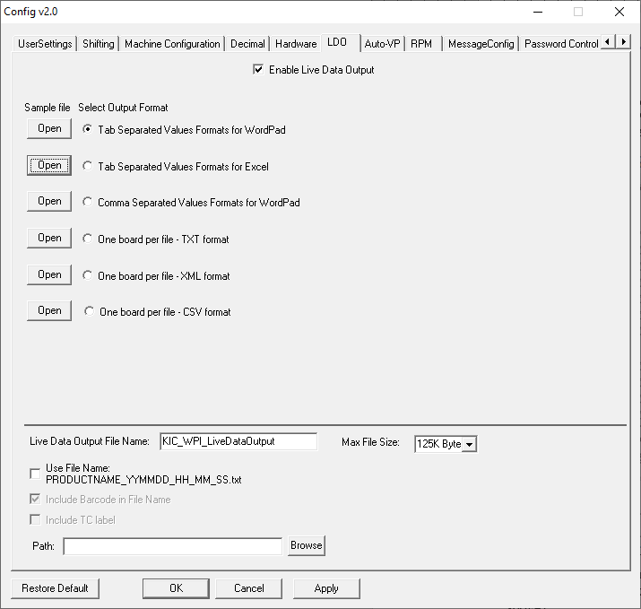

1. Check the “Enable Live Data Output” checkbox
2. Select the desired Format

**Note:** You can view samples of each output type by clicking on the *Open* button to the left of a selection.

1. The type of Format chosen will affect what naming structure for file will be used (See Details of Output Files above).
2. Select the destination path for the output file by clicking on the Browse button. This needs to be a location on the local drive.
3. “Max File Size” lets you specify how large the LDO output file can get before a new one is started.

If a VP is running for an extended amount of time, and the Tab or Comma separated for WordPad or Excel is being used, once the maximum file size is reached a new file will be generated and the new file name will be appended with a \_# after the file name.

## Delete Accumulated LDO Files

In time, accumulating LDO files can take up too much hard disk space and need to be deleted. The software provides an *Auto Delete* function that lets you specify time intervals for automated file purging. You can specify a maximum number of days–up to 1827 (five years)–that the system retains the files before automatic purging. You can also select a time in the 24-hour cycle for the system to automatically check for files that exceed the maximum day limit.

1. In the WPI folder, double-click on the **AutoDelete** icon. 

The Auto Delete LDO files screen appears:



1. Click in the *Max days to exist* field, and type in a new value.



|  |  |
| --- | --- |
| 1. Use the drop-down list to select an hour during the day to check for old files.   C:\Users\dklueck\Desktop\Auto Delete LDO time to check2.png   1. Click the Apply button. | C:\Users\dklueck\Desktop\Auto Delete hour list exposed.png |

## Remote Process Monitoring

**Note**: The software key must remain connected at all times during use for RPM capabilities to function.

KIC Remote Process Monitoring (RPM) enables customers to view real-time thermal process data and process status for any WPI on their wave solder machines from any authorized computer on the network.

* The WPI provides valuable thermal process information in real-time. The RPM can supply this information to all relevant decision makers wherever they happen to be in the factory. The results are better data management, efficient process management and oversight, and faster reaction to thermal process issues in the factory.
* RPM provides superior information sharing for the factory as a whole. WPI monitors, controls, and displays at the machine, the thermal process information for a single wave solder machine. RPM will, on a single screen, show all the pertinent data for all the machines in the factory on any authorized computer on the network.
* RPM translates complex process issues into a very easy to understand format. Quality managers, production managers, engineering managers, and line supervisors will, for the first time, access meaningful factory-wide quality and productivity information for the thermal process in real-time without the need for staff meetings, lengthy reports, interpretation, and unnecessary visits to the factory floor

RPM is comprised of three main software applications, and one optional software component:

1. **WPI software:**

The RPM for the WPI data is a dongle-protected software option. This software runs on the WPI system on a computer at the wave solder machine. RPM’s main function is to send data over a network to the KIC Server software.

While RPM is enabled, a separate application called WatchDog runs in the background continuously monitoring the connection between each WPI system and the KIC Server(s).

1. **KIC Server software:**

The KIC Server software is installed onto a computer or drive on the network and acts as a host for all WPI systems running on the network with the RPM output. It automatically connects to all the WPIs that are running RPM and passes on the data to any authorized computer on the LAN that is properly logged on. A maximum of 100 WPI systems per KIC Server is possible. The KIC Server has a setup menu for creating and editing usernames and passwords for KIC Viewer users.

1. **KIC Viewer software:**

The KIC Viewer is installed on any remote computer on the network (i.e. at your desk) and is used to view the data from all WPI systems connected to the KIC Server. This is done by logging on to the KIC Server.

1. **Win VNC:**

Win VNC is a third-party software application that allows you to remotely control or view the history for any WPI client PC on the same LAN. This can be useful for clearing alarms, loading recipes, and system administration.

In full operation, the combined software and systems function as follows: (See Figure 57.)



Figure 57: RPM functional diagram

* Each WPI system runs in Virtual Profiling mode, monitoring the process and giving real-time profile/process data for each production board. The Virtual Profile data is stored locally on the WPI client PC.
* The Machine Name, Product Name,Process Window Index (PWI), Real-Time Cpk, and current Alarm State (green, yellow, red: with alarm text) are sent to the KIC Server as each board exits the machine.
* The KIC Server accepts the data from allWPIs configured to send data, acting as a host for all the data.
* The KIC Viewerlogs on to the KIC Server and displays the pertinent data for all machines, on one screen, updating each one as boards exit and new data is sent.

## Configure RPM Output

### WPI Client PC

To enable the RPM feature:

1. Close the WPI software if open.
2. Using Windows Explorer, browse to the C:\WPI folder and run the ConfigurationProgram.exe application.
3. Select the RPM tab
4. Check the “LON in use” checkbox
5. Enter the IP address of the PC that will be running the *KIC Server* application.

LON Oven ID can be left blank, as the *KIC Server* software will automatically assign it a position.

1. Click Apply, then OK to close the Configuration Program.

When the WPI software is launched you will see two icons displayed in the notification area, as shown:

 

**Note**: The WPI icon will change based on the connection state with the KIC Server.

|  |  |
| --- | --- |
|  |  |
| WPI is not connected to a KIC Server | WPI is connected to a KIC Server |

If the WPI is not connected to a KIC Server, check to make sure the KIC Server:

* Hosting mode enabled (KIC Server-click the Start to Host button)
* Displays the communication status of the WPI systems that are connected.

For more details, see the [KIC Server](#_KIC_Server) section of this manual.

### KIC Watchdog

The KIC WatchDog is a software program that runs in the background when RPM is enabled. Its main function is to continuously monitor communication between the WPI client PC and the KIC Server PC.

**Note**: The KIC WatchDog software is not user configurable.

KIC WatchDog automatically starts up when WPI launches with RPM enabled (DO NOT CLOSE IT). The KIC WatchDog’s Icon displays on the bottom right corner as shown below:

KIC WatchDog Icon

RPM Icon

 

## KIC Server

The *KIC Server* software acts as a host for all networked WPI systems running the RPM option. The software connects all these systems and passes their data over the LAN to any authorized, properly logged on computers running the *Viewer* application.

You must install the *KIC Server* software on a LAN-connected PC on the same LAN as the WPI software. This PC cannot simultaneously serve as a WPI client, but it can run the Viewer application. The KIC Server can manage up to 100 WPI systems and has a menu for creating and editing usernames and passwords for KIC Viewer-users. Your WPI installation media includes the KIC Server software, but the application requires the continuous connection of an appropriate software key.

### Install the KIC Server:

**Note**: You must install the KIC Server manually.

1. Browse the WPI installation media for the KIC Server folder.
2. In the KIC Server folder, run the file Setup.exe.

The installation begins automatically.

1. Follow the on-screen directions.

**Note**: It may be helpful to copy the KIC Server shortcut to the Windows-Startup folder especially for dedicated-KIC Servers.

### Launch the KIC Server:

1. From the Windows desktop, click on: Start » Programs » KIC » KIC Server

**Or**

1. From Windows Explorer open C:\KIC Server\KICServer.exe

### Icons

Once the KIC Server application is launches, an icon appears in the notification area.

|  |  |
| --- | --- |
| When first launched, the KIC Server application is idle; you must select the Start to Host button in order to enable hosting by the KIC Server. See Figure 58. | Figure 58 |
| Once you select the Start to Host button, the icon will change indicating the KIC Server can accept connections. See Figure 59. | Figure 59 |

### KIC Server Window Functions

The KIC Server window is shown in Figure 60. The screen permits the following six functions:

1. Add new users and passwords for KIC Viewers to connect.
2. Edit/delete users and Passwords
3. View the connection time and IP address for each WPI client PC that is connected
4. View the KIC Viewer-User name and connection time.
5. Maximum number of Ovens - Enter the number of machines you wish to display in the KIC Viewer window.
6. Start to host – Enables/disables the KIC Servers’ connection mode.

#### Add a new user

1. Enter the new username.
2. Enter the new password.
3. Select the Add button.

You are added to the list of users. To access a list of users, select the List of Users dropdown menu.

#### Change a password

1. Click on the List of Users dropdown menu.
2. Select the user that you wish to modify.
3. Enter the new password for that user.
4. Select the Change Password button.

The user’s password is updated immediately.

#### Delete a user

1. Click on the List of Users dropdown menu.
2. Select the user that you wish to modify.
3. Select the Delete button.

The user account deletes immediately.

Figure 60: KIC Server Window

**Maximum number of Ovens** – This value controls the number of WPI system boxes displayed on the KIC Viewer screen the maximum number of machines is 100, minimum 1.

**Start to host** – The KIC Server will not accept connections until this button is selected. You must manually select this button to enable hosting by the KIC Server application.

## KIC Viewer

*KIC Viewer* software lets you remotely view production data from all WPI systems connected to the *KIC Server*. The software is included on the WPI installation media and can be installed on a desktop PC or any computer on the network. It can be installed on a separate PC or on the same PC with the KIC Server or the WPI client.

**Note**: Once installed, you first need to *enable* the application in the configuration file and *connect* to the *KIC Server* before you can launch the application.

### Install the KIC Viewer

You must install the KIC Viewer manually.

1. Browse the WPI installation media for the folder named *KIC Viewer*.
2. In the folder, run the file **Setup.exe**.
3. When the installation begins, follow the on-screen directions.

### Configure the KIC Viewer Application

You can configure the application in two ways:

1. Using the networking path – this method with allow you to view historical data via a separate application called “App for Viewer”.
2. Using a VNC application – this method will allow you to view historical data via the use of VNC software to directly access the WPI Client software/PC.

### Use KIC Viewer by the Networking Path

|  |  |
| --- | --- |
| 1. Close the KIC Viewer application and then open the configuration file at the following location:   C:\Kicviewer\Configure\kwConfigure.kcfgfile – setup:   1. Set **EnableRemoteControl** flag to = **0**. 2. Set**[RemoteControlPC] Enable** flag to = **1**. 3. Select File/Save, then close the file. |  |

### Use KIC Viewer using VNC

|  |  |
| --- | --- |
| 1. Close the KIC Viewer application and then open the configuration file at the following location:   C:\Kicviewer\Configure\kwConfigure.kcfgfile – setup:   1. Set **EnableRemoteControl** flag to = **1**. 2. Set**[RemoteControlPC] Enable** flag to = **1**. 3. Select File/Save, then close the file. | C:\Users\dklueck\Desktop\Enable KICViewer VNC.png |

### Connect to the KIC Server

To connect to a *KIC Server*, enter a valid username and password from the *KIC Viewer* machine. See the [KIC Server](#_KIC_Server) section for details.

**Note**: It is very helpful to have the IP address of the PC running the *KIC Server* application as this information is required each time a *KIC Viewer* connects to a *KIC Server*.

### Launch the Application

1. From the Windows desktop, click: Start » Programs » KIC » KIC Viewer
2. From Windows Explorer, open C:\KIC Viewer\KICViewer.exe
3. Enter the KIC Server IP address, a valid username and password. See Figure 61.



Figure 61: KIC Viewer – Connect

The *KIC Viewer* main screen with its toolbar menu appears:



Figure 62: KIC Viewer – Main Screen

#### The KIC Viewer Toolbar Button Menu

|  |  |
| --- | --- |
| KICViewer--Toolbar - View Icon Display Icon view (View)  KICViewer--Toolbar - View Chart Display Chart view (View)  KICViewer--Toolbar - Connect Connect to KIC Server (Connect)  KICViewer--Toolbar - Auto-Update Turn Auto-Screen mode On/Off (View)  KICViewer--Toolbar - Prev Page Display Previous page (View)  KICViewer--Toolbar - Next Page Display Next page (View) | KICViewer--Toolbar - Reload Config Reload Configuration (Configuration)  KICViewer--Toolbar - About About box (Help)  KICViewer--Toolbar - Sort Cpk Asc Sort by ascending Cpk values (Layout)  KICViewer--Toolbar - Sort Cpk Des Sort by descending Cpk values (Layout)  KICViewer--Toolbar - Sort PWI Asc Sort by ascending PWI values (Layout)  KICViewer--Toolbar - Sort PWI Des Sort by descending PWI values (Layout)  KICViewer--Toolbar - Sort Orig Sort by Original order (Layout) |

#### Configuration

1. Reload the configuration – This feature manually reloads the configuration in the event you changes the configuration without exiting the KIC Viewer software.
2. Oven selection – Allows you to turn On/Off the machines to view. See Figure 63.



Figure 63: KIC Viewer – Activate/Deactivate Ovens

### Icon View

The Icon view provides the machine name, product name, Process Window Index (PWI) value, Cpk value, and alarm state for each product as they exit the mahcine with WPI. The alarm states are color-coded (green, yellow, red) in accordance with the standard WPI alarm categories. This information is organized as a box per machine. See Figure 64.



Figure 64: KIC Viewer – Icon View

A grey machine box can indicate there is a problem with the WPI system configuration on that machine:

1. The WPI client PC is no longer connected to the KIC Server application.

As soon as the WPI client PC begins running Virtual Profiling again, the box will return either green, yellow, or red based on the current conditions in that machine.

If the KIC Server application was closed, each KIC Viewer will wait until the KIC Server is launched again. If for any reason the KIC Viewer does not automatically reconnect, select Connect from the main menu, and enter a valid username and password to reconnect.

1. The WPI client PC is no longer running Virtual Profiling
2. No products have passed through the machine yet. The icon for each WPI system will remain the color grey until the first board has passed through the machine.

#### View Historical Data

By right-clicking on a machine box in the Icon View, you can view the history for any machine via the Profile Explorer.

**Note**: In order to use this feature, WinVNC software program must be installed and configured.

#### View History Display

Only the current product folder appears.

If you want to see all products profiled on this machine, then click on the “Browse” button (top right corner).

|  |  |
| --- | --- |
|  | Figure 65: Profile Explorer via KIC Viewer |

Click **OK** in the pop-up box asking to select a working folder. Then all of product names appears as shown in Figure 65.

Click on the WPI main screen button to exit View History mode. The history view provides all the standard WPI information such as all the production event logs, production run data, and basic SPC graphs.

### Chart View

The chart view displays the PWI value for each of the last 100 products processed through each WPI system. See Figure 66.



Figure 66: KIC Viewer – Chart View

In the chart view, right‑click on a machine box to display a full-screen chart for that machine. See Figure 67.



Figure 67: KIC Viewer – Full-screen chart view

### WinVNC

Virtual Network Computing (VNC) is remote control software that allows you to view and interact with another computer anywhere on a local network. The two computers do not even have to be the same type or have the same operating system. VNC also has the capability to remotely control any WPI client PC.

WinVNC is a third-party software application that is not distributed by KIC. VNC software can be downloaded from the internet at the following address: <http://www.realvnc.com/download.html>

VNC software contains multiple applications including VNC Server. Run VNC Server on the WPI client PC while Virtual Profiling is running in order to view historical data or remotely control any WPI client PC via the KIC Viewer application.

A VNC’s icon appears on the bottom right corner of the monitor. See Figure 68.



Figure 68: VNC task tray icon

### Modify VNC properties:

|  |  |
| --- | --- |
| 1. Double Click on the VNC icon.   The Current User Properties screen (Figure 69) appears.   1. Enter a password for other computer to access this client PC. (You are asked to enter this password each time any KIC Viewer attempts either Viewing History, or Remotely Controlling this WPI client PC) 2. Click the **OK** button. | Figure 69: VNC Properties |

# O2 Live (Optional)

**Note**: The software key must remain connected at all times during use for *O2 Live* capabilities to function.

*O2 Live* is an optional feature that allows you to display an O2 PPM measured value on a profile, or Virtual Profile data. *O2 Live* is not an oxygen analyzer, but an option that allows for the output from a user’s existing analyzer to be read in and displayed by the WPI software. An external interface device connects between the output of the oxygen analyzer, and the PC (USB port) running the WPI software (*See TFS-330210-000 Automatic System Hardware Installation and Maintenance Manual for more details about the interface device)*. This O2 PPM value is available in the following areas of the software:

* Baseline Profile
* Virtual Profile (Live)
* Virtual Profile (Historical data)
* SPC
* LDO
* RPM

## Configuration

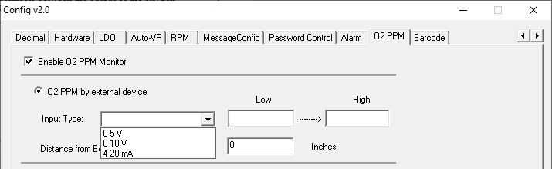

Figure 70: O2 Live Configuration

1. With the WPI software shut down, browse to the C:\WPI folder, run the *ConfigurationProgram.exe* application and select the O2 PPM tab.
2. Select “Enable O2 PPM Monitor”
3. From the Input Type drop-down menu, choose the option that corresponds with the type of output used on the customer’s oxygen analyzer.
4. The Low and High values will correspond to the minimum and maximum range of the output; e.g. a Low of 0=0 volts, and a High of 500 equals 5 volts.
5. Enter the distance from the WPI Board Sensor (at entrance of machine) to the location of the O2 sample port (from the O2 analyzer) inside the machine.
6. Click the Apply and OK buttons at the bottom of the Configuration Program to save changes and close.

## Operation



When *O2 Live* is enabled, checkboxes in the *O2* column in Profile Explorer allow you to select by product, whether the O2 PPM values will be collected and displayed during VP.

During Virtual Profiling, a “floating” window displays on the screen showing the measured value, and is color-coded based on the measured value:



Figure 71: O2 PPM Floating Windows

Below are the formulas used for calculating the O2 PPM value depending on type of analyzer output:



Figure 72: O2 PPM formulas

# VP Idle Mode (Optional)

**Note**: The software key must remain connected at all times during use for *VP Idle Mode* capabilities to function.

*VP Idle Mode* is an *optional* feature that allows the WPI software to automatically go into a type of “sleep –mode” during Virtual Profiling if the machine is equipped with an automated ‘energy saving’ capability. When energy savings features are enabled, the machine control software can modify several of the process parameters – such as conveyor speed, or zone setpoint temperatures. When this occurs, the KIC software would normally alarm on the detected changes to the process. Using VP Idle Mode allows the software to ignore those changes during energy saving periods, thus eliminating unnecessary warnings/alarms from being activated.

During VP Idle Mode, the crystal ball will be grey, the statistics chart will be blank, no VP data will be calculated, and no process related alarms or warnings will display or be recorded. When the entrance board sensor is triggered, the system will automatically exit Idle Mode and return to normal VP operation.

## Configuration

The feature is enabled by shutting down the software, running the ConfigurationProgram.exe (in the C:\WPI directory) and selecting “Use VP Idle Mode” in the area shown below, and entering the amount of time the machine should be empty before entering Idle Mode:

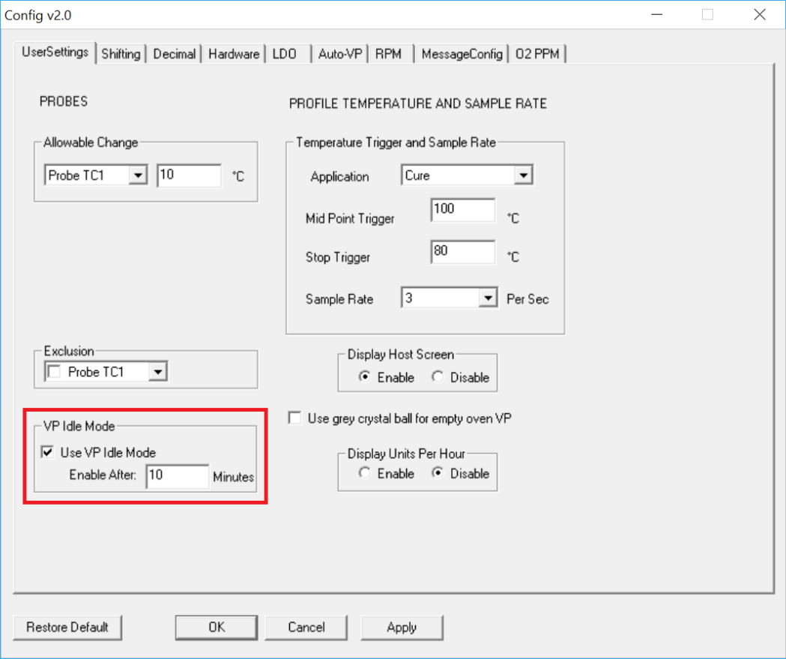

Figure 73: VP Idle Mode Configuration

When VP is running, there will be an additional button on the screen allowing you to manually Enter/Exit VP Idle Mode at any time:



# Units Per Hour

The Units Per Hour (UPH) function can display on the General Tab when VP is running, a count of how many boards (Units) have been processed in the last hour. The number automatically resets back to 0 at the top of the hour.

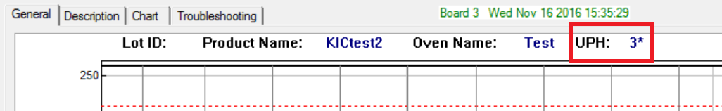

Figure 74: VP Idle Mode Configuration

## Configuration

The feature is enabled by shutting down the software, running the ConfigurationProgram.exe (in the C:\WPI directory) and selecting “Enable” in the area shown below:

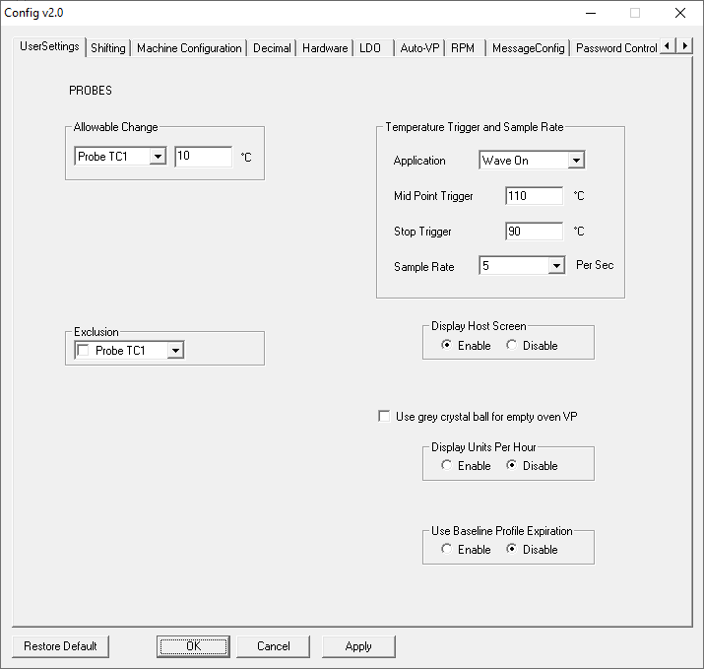

# Auto-VP

Auto-VP is an available feature that allows for an automated changeover process. Typically, during a product changeover, an Operator has to manually stop the currently running VP, then go into the wave machine software and select and load the correct recipe for the next product to be processed. Then they must go into the KIC software and select the corresponding product and load that VP. This can sometimes lead to the wrong selection being chosen by the user.

Through the use of barcodes or MES control programs, the Auto-VP feature can eliminate the need for Operator intervention in the product changeover process. The correct VP is automatically loaded based on information sent to the software.

There are multiple configurations of the Auto-VP feature depending on the capabilities and processes in place in the factory. Please contact KIC Tech Support to identify if this functionality can be implemented with your system.

# Password Protection

To enable the basic Password Protection feature, go to the *Global Preferences* screen, select the *Password Protection* check box, and enter the desired password. See Figure 75.



Figure 75: Password Protection

Items that are password protected:

* Global Preferences button on the main screen
* In the Process Window Screen – Saving or deleting Process Windows or changes to Process Windows
* In the Profile Explorer – Delete a profile
* In the Profile Graph and Statistics screen – Access to the Optimization tab

You can also configure the software to have different access for different user levels. For more information on additional password protection features, see [*Appendix C: Password Control – Multi User*](#_Password_Control_–).

# Profile Printing

The WPI software will print profiles only from within the profile display screens. Click on the printer icon button at the bottom of the profile display to open the Profile printout setup menu. There are two print formats available – Portrait or Landscape.

## Portrait Mode

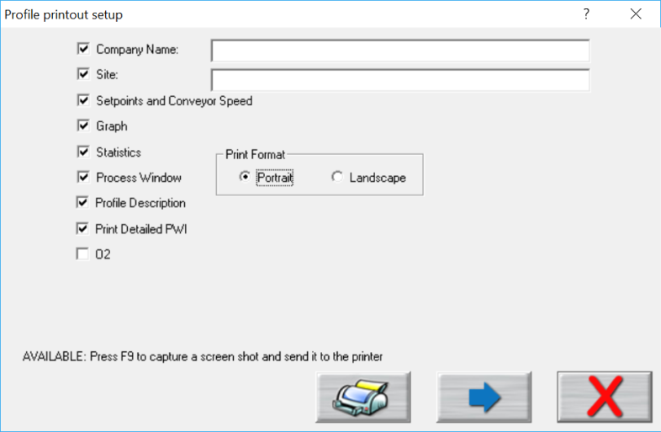

Print

Preview

Print

Cancel

Figure 76: Profile Print Format #1 Options

1. Check the items you wish to include on your profile printout.
2. Press the **Print** button to print the report.
3. Press the **Print Preview Button** to display a preview of the report. See Figure 77.

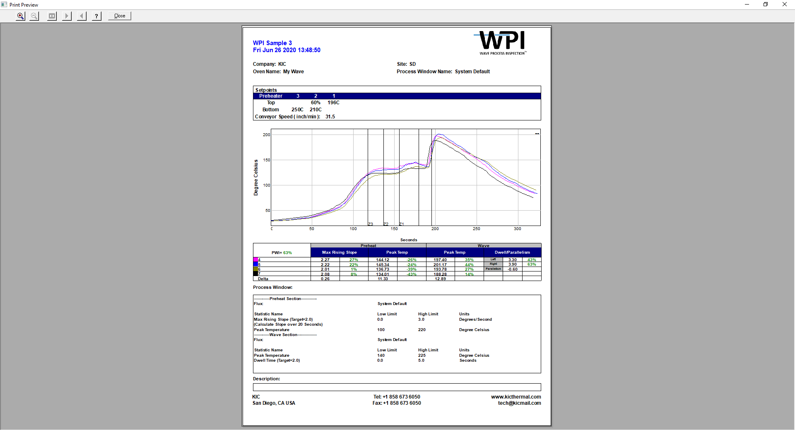

Figure 77: Sample Portrait Print Preview

## Landscape Mode

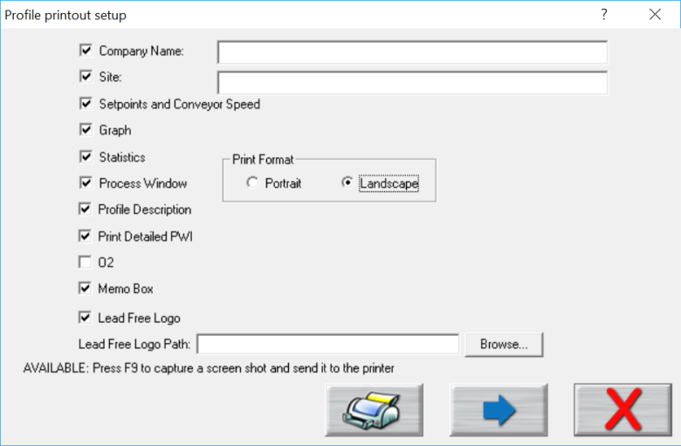

Print

Preview

Print

Cancel

Figure 78: Profile Print Portrait Options

Below are the additional options available with Landscape mode:

* **Memo Box** –Enables/Disables a Memo Box area for Draft, Review and Approval Signatures and Dates.
* **Lead Free Logo** – Enables/Disables the Lead-Free Logo display area.
* **Lead Free Logo Path** – When “Lead Free Logo” is enabled, specify the path to any BMP image file that you want to appear in the Lead Free Logo display area on the report.

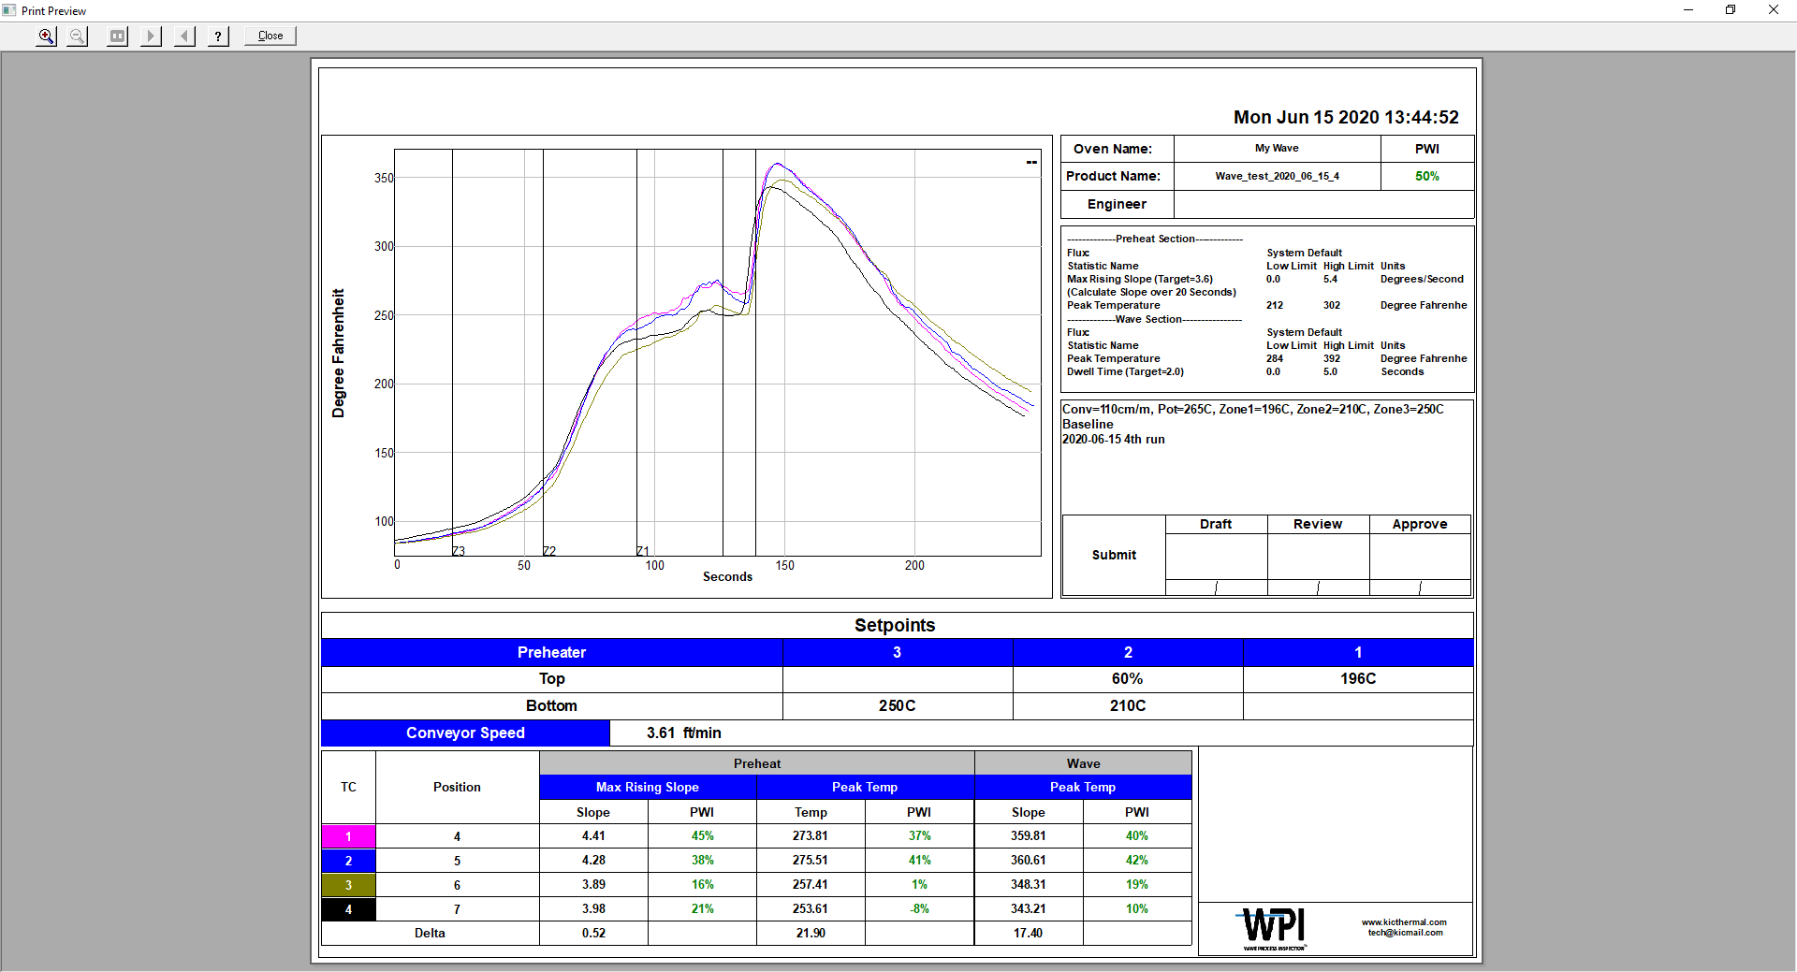

Figure 79: Sample Landscape Print Preview

Optionally, you can print the contents of any screen in the WPI software by pressing **F9** on your keyboard. The **F9** function will not work while viewing the Profile Printout Setup dialog box.

**Note**: Before printing, make sure you have defined a printer for use with Windows.

# Write Data To and View WPI Data Over A Network

**Note**: This feature cannot work in conjunction with RPM.

## Write Data To A Network Drive

The WPI software can be configured to write the collected data (oven files, process windows, profiles and historical VP data) to a network drive location. This would allow data from one or even multiple systems to be stored in one centralized location (Server/Shared Hard Drive).

The first step necessary is to map a network drive from the PC running the WPI software to the desired network location. Due to the multiple varieties of OS and network configurations, KIC cannot detail this step. We recommend you contact your IT/Network administrator for setting this up. Below is a typical example of this setup. See Figure 80.

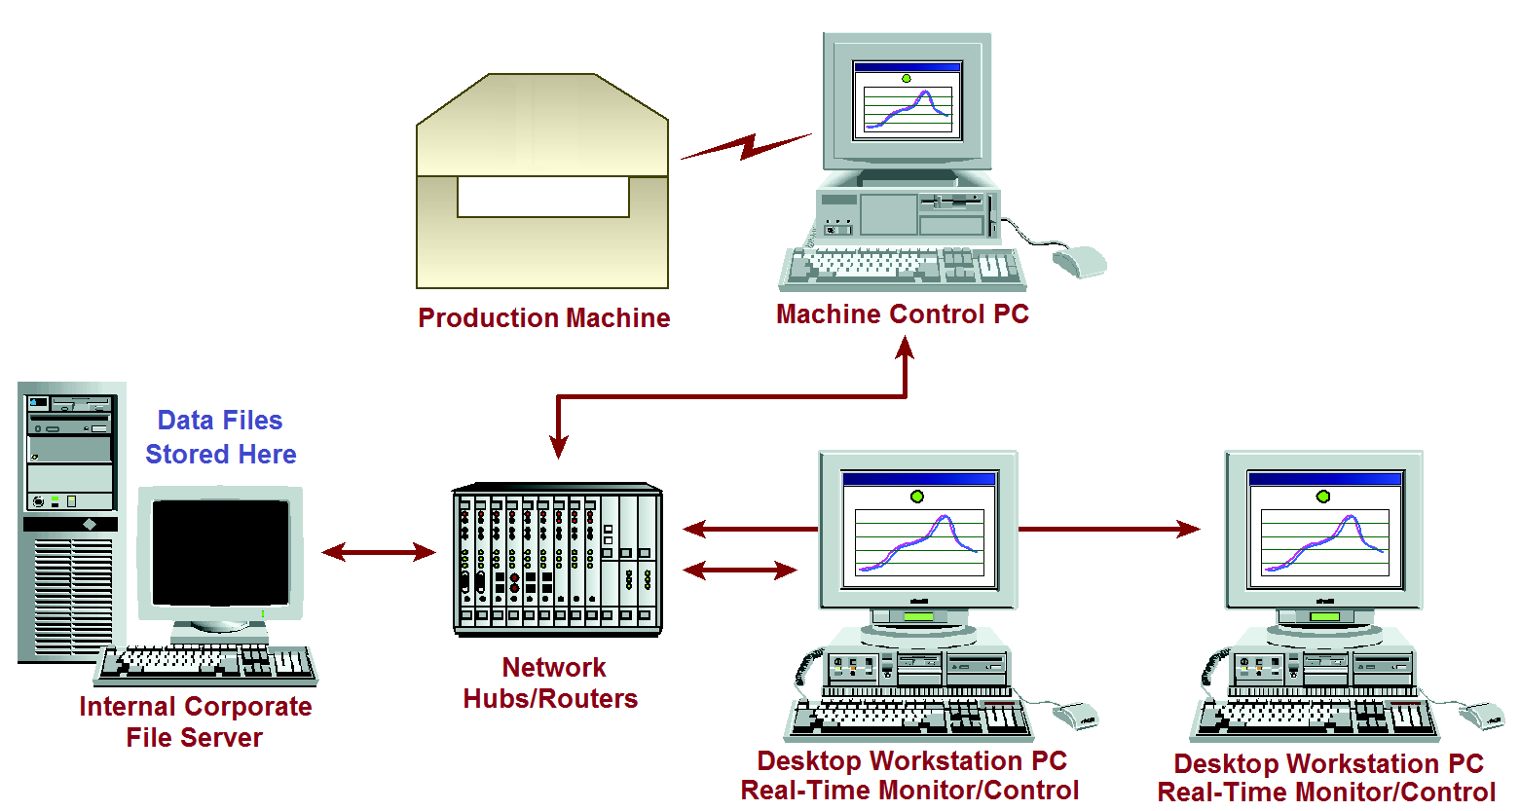

Figure 80: Example Network with WPI

Once you have mapped the drive, create a folder on the network drive and copy in the following folders from the C:\WPI directory – Ovens, Process Specs, and Profiles. Once completed, follow the steps below on the PC where the WPI software is installed:

1. Ensure the KIC software is closed, open Windows Explorer, and locate the file:

C:\WPI\Log\KIC2000DataPath.kiccfg

1. The KIC2000DataPath.kiccfg file will open up in Notepad: See Figure 81.

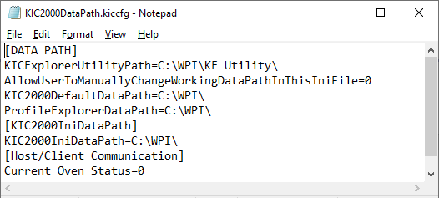

Figure 81

1. Change the line AllowUserToManuallyChangeWorkingDataPathInThisIniFile=0 to the value =1: See Figure 82.

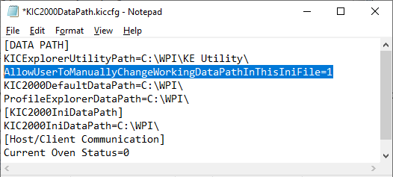

Figure 82

1. Change the line shown below to = the desired network location. **Note:** This will be the main network folder you created and copied the Log, Ovens, Process Spec, and Profiles folders into. See Figure 83.

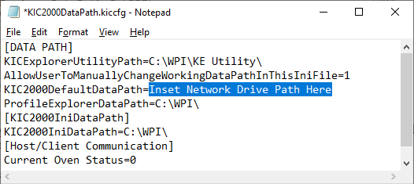

Figure 83

1. Once the DataPath.kiccfg file has been modified with the new locations, choose File/Save from the drop-down menu to save the changes.
2. Close Notepad and start the software.
3. With the WPI software open, go to the Profile Explorer:

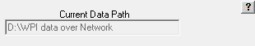

Figure 84

Your new network drive should be displayed in the upper right-hand corner of the screen as the Current Data Path. See Figure 84.

**Note**: The Network path will be grayed out and cannot be changed from inside of Profile Explorer.

All data collected in this WPI application will now be written to the network folder chosen.

**Note**: If you have multiple WPI systems, you will need to create a separate folder on the Network drive for each system – e.g. KIC Line 1, KIC Line 2, etc.

If the network is unavailable when accessing various areas of the software (Define/Edit Process Window, Run A Profile, Profile Explorer), a message will appear alerting you to the issue:



When this occurs, you are still able to use the software but only working with files (ovens, Process Windows, profiles) that are located in the local directory. It will temporarily reset back to the local install directory and any new files generated or updated will be saved in the local directory (C:\WPI). If the network connection is re-established, the WPI software must be restarted to begin writing directly to the network directory again.

Any data that was collected while the software was offline will be moved to the network directory after the connection has been re-established and the WPI software is restarted.

## View Historical Data

You can also view all collected data over the network from any computer that has the WPI software installed.

**Use the following steps to view historical data over the network:**

1. From your remote computer, start the WPI software and click on the “I am not going to run profiles or live WPI” button. See Figure 85.

**Caution**: Do not choose this button when working at the PC where the WPI hardware is installed.

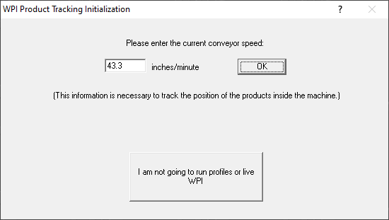

Figure 85

1. The software will open up normally. When the main screen appears, click the Profile Explorer button.
2. A **Browse** button is enabled in the upper right hand corner of the screen: See Figure 86.

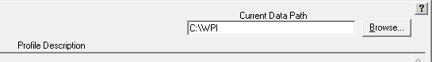

Figure 86

You can now click the Browse button and point to the directory where your profiles are. Keep in mind that you want to direct it to the root directory of the main “Profiles” folder.

For example: If the profiles are in the folder F:\WPI\Profiles\Board A, you would direct it only to the folder F:\WPI\.

# Status Messages And Alarms

The software communicates system status through messages that it displays on the monitor. Some simply report an operating condition, some provide a warning that process parameters are changing, and still others, called *alarms,* announce out-of-spec conditions, operational failures, lost communications, and other process critical problems that might require immediate corrective actions.

|  |  |
| --- | --- |
| Alarm messages typically appear in red. An alarm status may accompany a signal from the DAU/eTPU to the alarm relay, which in turn may trigger hardware-related events such as sounding audible alarms, lighting signal towers, or stopping infeed conveyors. |  |

Some status messages and alarms are specific to different functions of the software. Some may appear when you are first running profiles to establish a baseline. Others appear only when you begin Virtual Profiling.

## Acknowledge Alarms

|  |  |
| --- | --- |
| Once displayed on the monitor, an operator needs to acknowledge the alarm, clicking on it to notify the software that the message has been received and make the displayed panel disappear. |  |
| You can use the basic password protection to limit the ability to acknowledge alarms. To do so, you first need to specify the following value in the KIC2000UserSettings.kiccfg file:  [HOST]  UsingPasswordwithRedAlarm=1  **Note**: Enabling this function only applies to alarms. A simple mouse click acknowledges and clears warning messages.  Next, you need to specify a password on the Global Preferences screen *Engineer Password* option. Once password protection is in place, clicking a red alarm message displays a prompt that requires you to enter the password to acknowledge the alarm and remove the message. |  |



## Messages During Profiling and Baseline Profiling

During the profiling portion prior to starting a Virtual Profile, you may experience some conditions that generate alarms or notification messages. Below is a table of some of the messages that you might see during this process: See Table 1.

|  |  |
| --- | --- |
| **Message Alarms** | **Message Description** |
| **Message, High PWI** | Recent profile of xxx%, PWI must be 90% |
| **Message Alarm H1** | DAU/eTPU Communication Failure - wait 5 seconds and try again |
| **Message Alarm H7** | Conveyor has stopped or encoder has been disconnected Virtual Profiling cannot be started. |

Table 1: Profiling System Alarms

## System Message and Alarms

### Message, High PWI

|  |  |
| --- | --- |
| If the verification profile PWI is >= 100%, you will receive this message when starting the VP.  If there was a problem with the most recent profile, it can be deleted, and the system will try to use the next most recent profile as the baseline profile. Otherwise, you are advised to run another profile. See Figure 87. | Figure 87: Message High PWI |

### Alarm H1

|  |  |
| --- | --- |
| No communication. This message can appear when trying to start VP and the DAU/eTPU is disconnected or not communicating. If it’s a basic timing issue, waiting 5 seconds can allow a connection to the DAU/eTPU to be re-established. See Figure 88. | Figure 88: Alarm H1 |

### Alarm H7

|  |  |
| --- | --- |
| This alarm will appear when trying to start a Virtual Profile from the Profile Explorer. The machine conveyor must be running and set to the correct speed settings in order to start Virtual profiling. See Figure 89. | Figure 89: Alarm H7 |

### Alarms and Messages during Virtual Profiling

The software incorporates the use of warning and alarm dialog screens to let you know if there is a problem and the cause for that problem. Below is a partial list of the warning and alarm dialog screens with explanations. These Alarms are active only when Virtual profiling is running.

| **Process Alarms** | **Description** | **Activates Alarm Relay** |
| --- | --- | --- |
| **Alarm # 1** | PWI=x% - Process is out of spec | **Yes** |
| **Alarm # 5** | No Barcode read for this board. –or–  No Barcode read for xxx boards. | **No** |
| **Alarm # 5A** | Process Traceability barcode scan failed | **Yes** |
| **Alarm # 5C** | Process Control barcode scan failed | **Yes** |
| **Alarm # 8** | The length of the current product does not match the length of the product during the baseline profile. | **No** |
| **Alarm # 11** | The KIC speed sensor has detected that the conveyor speed has changed significantly since the baseline. | **Yes** |
| **Alarm # 12** | Incorrect Process Control String (Barcode Option). | **Yes** |

Table 2: Virtual Profiling – Process Alarms

|  |  |  |
| --- | --- | --- |
| **Hardware Alarms** | **Description** | **Activates Alarm Relay** |
| **Alarm H1** | DAU/eTPU Communication Failure (happened after Alarm H2) | **Yes** |
| **Alarm H2** | DAU/eTPU Lost Communication with PC.  Note: This alarm condition can activate the alarm relay that is controlled by the DAU/eTPU | **Yes or No** |
| **Alarm H7** | Conveyor Stopped or Speed Encoder broken or not connected properly. | **Yes** |

Table 3: Virtual Profiling – Hardware Alarms

|  |  |  |
| --- | --- | --- |
| **Warnings** | **Description** | **Activates Alarm Relay** |
| **Warning # 2** | This process is likely to go out of spec soon. | **No** |
| **Warning # 3** | The last profile was out of spec. | **No** |
| **Warning # 4** | Machine temps have changed significantly since baseline. | **No** |

Table 4: Virtual Profiling – Warnings

### When Alarm #5a Occurs

When the Barcode Traceability feature is enabled and the Barcode Product Sensor (BPS) detects a product whose barcode label has not been read, or the BPS is tripped accidentally, the alarm #5A is activated and the process is stopped via the alarm relay.

Alarm #5A displays four alarm buttons: **Manual Entry Keyboard/Handheld Scanner, Rescan using Fixed Mount Scanner, Proceed without a Barcode, and Remove this board from Line.**

#### Manual Entry Keyboard/Handheld scanner

Click this button when you want to enter the barcode again by using either the keyboard or a handheld scanner connected to a USB Port.

|  |  |
| --- | --- |
| 1. Click the **Manual Entry Keyboard/Handheld Scanner**  button.   The software displays the Barcode input field and hides all other unselected buttons. |  |
| 1. Type in the new barcode and press the **Enter** key.   The software will clear the alarm message and deactivate the Alarm relay to allow the board into the |  |
| The barcode string will be added to the VP data for that board: | |

#### Rescan Using Fixed Mount Scanner

Click this button when you want to scan the barcode again by using the fixed mount Barcode scanner.

|  |  |
| --- | --- |
| 1. Click the **Rescan using Fixed Mount Scanner**  button.   The software displays the Barcode input field and hides all other unselected buttons. |  |
| 1. Scan the barcode with the fixed mounted Barcode scanner. |  |

|  |
| --- |
| Once the barcode is scanned, the software will clear the alarm message and deactivate the Alarm relay to allow the board into the machine.  This barcode string will be added to the VP data for that board: |

#### Proceed Without a Barcode

Click this button when you want to process the board without any barcode.

|  |  |
| --- | --- |
| 1. Click the **Proceed without a Barcode**  button.   The software will clear the alarm message and deactivate the Alarm relay to allow the board into the machine without a barcode. |  |
|  | |

#### Remove this board from Line

Select this button if this board will *not* be going into the machine at this time.

|  |  |
| --- | --- |
| 1. Click the **Remove this board from Line**  button. |  |
| 1. Remove the board from the link conveyor. |
| 1. Click the green OK check button Description: \\RND\RND_Service\For DaveK\RPI\RPI Graphics\RPI Art File\bt-NAVint_Check.bmp.   The software clears the alarm message and deactivates the Alarm relay to get ready for the next board.  If user clicks the “Cancel” button, the software returns to alarm #5A. |  |

### When Alarm #5c Occurs

When the Barcode-Process Control feature is enabled and the Barcode Product Sensor (BPS) detects a product whose barcode label has not been read, or the BPS is tripped accidentally, the alarm #5C is activated and the process is stopped via the alarm relay.

Alarm #5C displays four alarm buttons: **Manual Entry Keyboard/Handheld Scanner, Rescan using Fixed Mount Scanner, Proceed without a Barcode**, and **Remove this board from Line**.

#### Manual Entry Keyboard/Handheld Scanner

Click this button when you want to enter the barcode again by using either the keyboard or a handheld scanner connected to a USB Port.

|  |  |
| --- | --- |
| 1. Click the **Manual Entry Keyboard/Handheld Scanner**  button.   The software displays the Barcode input field and hides all other unselected buttons. |  |
| 1. Type in the new barcode and press the **Enter** key.   The software will clear the alarm message and deactivate the Alarm relay to allow the board into the machine. |  |
| **NOTE:** This barcode will be added to the board if the software *also* is using the Barcode-Traceability feature. | |

#### Rescan Using Fixed Mount Scanner

Click this button when you want to scan the barcode again by using the fixed mounted Barcode scanner.

|  |  |
| --- | --- |
| 1. Click the **Rescan using Fixed Mount Scanner**  button.   The software displays the Barcode input field and hides all other unselected buttons. |  |
| 1. Scan the barcode with the fixed mounted Barcode scanner. |  |

|  |
| --- |
| Once the barcode is scanned, the software will clear the alarm message and deactivate the Alarm relay to allow the board into the machine.  **NOTE:** This barcode will be added to the board if the software also is using the Barcode-Traceability feature. |

#### Proceed without a Barcode

Click this button when you want to process the board without any barcode.

|  |  |
| --- | --- |
| 1. Click the **Proceed without a Barcode**  button.   The software will clear the alarm message and deactivate the Alarm relay to allow the board into the machine without a barcode. |  |
|  | |

#### Remove this board from Line.

Select this button if this board will *not* be going into the machine at this time.

|  |  |
| --- | --- |
| 1. Click the **Remove this board from Line**  button. |  |
| 1. Remove the board from the link conveyor. |
| 1. Click the green OK check button Description: \\RND\RND_Service\For DaveK\RPI\RPI Graphics\RPI Art File\bt-NAVint_Check.bmp.   The software clears the alarm message and deactivates the Alarm relay to get ready for the next board.  If user clicks the “Cancel” button, the software returns to alarm #5C. |  |

### When Alarm#12 Occurs

When the Process Control feature is in use, and a barcode string is received that differs in format specified for the current product, the software will display a red alarm message - Alarm#12 – with three buttons: Stop Virtual Profiling, Process with current Barcode, Remove the board from Line.

#### Stop Virtual Profiling

|  |  |
| --- | --- |
| 1. Click the **Stop Virtual Profiling**  button. |  |
| 1. If there is still product in the machine, an additional message will display to wait until they all exit. |  |
|  |  |

#### Process with Current Barcode

Users may deactivate the alarm relay to allow a board into the machine even if the barcode is in incorrect. Use this button to stop the alarm when you want to use the barcode that is on the label.

|  |  |
| --- | --- |
| 1. Click the **Process with Current Barcode** button . |  |
| This barcode will be added to the board if the **Traceability** feature is also enabled in the **Barcode Option** tab. |  |

#### Remove This Board From Line

You use this feature when you want to remove a PCB out of Line before it is passed into the machine, but are going to keep the current Virtual Profile running.

|  |  |
| --- | --- |
| 1. Click the Remove this board from Line button . |  |
| 1. Remove the board from the line and then click the green check button Description: \\RND\RND_Service\For DaveK\RPI\RPI Graphics\RPI Art File\bt-NAVint_Check.bmp. |  |

# Light Tower

There are two available light towers – one is connected directly to the optional Alarm Relay and uses a single Red light; the other connects to the USB port of the PC, and uses 3 colored lights – Red, Yellow, and Green.

Both lights are a means of providing an audio or visual cue when the automatic system software has determined that the process has reached an out-of-control condition.

## Standard Light Tower

This light tower plugs directly into the *Alarm Relay* box. It uses a single Red light with an audible buzzer, which are both activated anytime an alarm condition occurs. Because it is controlled directly by the *Alarm Relay*, the light and audible buzzer will stay on for as long as the *Alarm Relay* is energized.

## 3 Color USB Light Tower

As this light tower connects to a USB port on the PC running the WPI, it can be used with or without the *Alarm Relay*. With the use of the USB Light Tower, you get additional visual information on the state of your process through a variety of LED indicators – Red, Yellow, and Green. You also have the ability to mute the audible buzzer when an alarm condition occurs. When an alarm occurs, a small button will appear in the upper left corner of the Crystal Ball. Clicking on this button will mute the audible buzzer. Clicking the button a second time will un-mute the buzzer. If left muted, and the process returns to an in-spec condition, the buzzer will be automatically be active again when the next alarm occurs.



### LED Light Status

When VP is not running – All LEDs and buzzer are turned off

When VP is running and the process is in-spec, but the machine is empty – GREEN LED flashing

When VP is running and the process is in-spec with product in the machine – GREEN LED on solid

When VP is running and the process is in a Warning condition – YELLOW LED on solid

When VP is running and the process is in an Alarm condition – RED LED on solid

When VP is running and the process is in an Alarm condition w/Buzzer muted – RED LED flashing

To customize the operation of either the USB Light Tower or the Alarm Relay, see the [Alarm Tab](#_Alarm_Tab) section.

**Note**: For more information about the Light Tower and Alarm Relay, see the *Automatic System Hardware Installation Manual* (TFS-330210-000).

# **Appendix A:** **The Process Window Index**

**A Method for Quantifying Thermal Profile Performance**

## The Problem

While there are currently statistically valid methods for quantifying pick and place and screen printer performance, there is no widely accepted method for comparing performance of thermal profiles, and thus, no quantifiable system of ranking thermal process performance. Once a thermal profile has been run, it is judged as being either in or out of spec, and perhaps subjectively judged as being OK, good, or really good. Efforts to track process performance for SPC or QC generally focus on a single, or a small group, of profile statistics; for example, peak temperature of one or two thermocouples on a golden board. The Process Window Index is a statistical method for ranking thermal profile and thermal process performance.

## Define the Process Window Index

|  |  |
| --- | --- |
| The Process Window Index is a measure of how well a profile fits within user defined process limits. See .  This is done by ranking process profiles on the basis of how well a given profile “fits” the critical process statistics. A profile that will process product without exceeding any of the critical process statistics is said to be inside the Process Window. The center of the Process window is defined as zero, and the extreme edge of the process window as 99%. | Process-Window-Index  Figure 90: Process Window and PWI |
| A “Process Window Index” of 100% or more indicates that the profile will not process product in spec. A “Process Window Index” of 99% indicates that the profile will process product within spec, but it is running at the very edge of the Process Window. A “Process Window Index” of less than 99% indicates that the profile is in spec and tells users what percentage of the process window they are using: for example, a PWI of 70% indicates a profile that is using 70 percent of the process spec. | PWI-Theory  Figure 91: The Process Window Index (Single Statistic—Peak Temperature of one Thermocouple) |

The PWI tells users exactly how much of their process window a given profile uses, and thus how robust that profile is. The lower the PWI, the better the profile. A PWI of 99% is risky because it indicates that the process could easily drift out of control. Most users seek a PWI of below 80%, and profiles with a Process Window Index between 50% and 60% are commonly achieved (if the oven is sufficiently flexible and efficient).

Figure 91 shows the Process Window Index for the Peak Temperature of a single thermocouple. The Process Window Index for a complete set of profile statistics is calculated as the worst case (highest number) in the set of statistics.

For example: if a profile is run with six thermocouples, and four profile statistics are logged for each thermocouple, then there will be a set of twenty-four statistics for that profile, and the PWI will be the worst case (highest number expressed as a percentage) in that set of profile statistics. Note that Figure 92 shows the user-designated critical statistics for a single thermocouple.

PWI How Determined - Leaded R0511A -- NoTitle NoBorder

Figure 92: The Process Window Index  
(Multiple Statistics for a Single Thermocouple and Final PWI Calculation)

## Calculate the PWI

To calculate the Process Window Index: i=1 to N (number of thermocouples); j=1 to M (number of statistics per thermocouple); **measured\_value[i,j]** is the [i,j]th statistic’s value; **average\_limits[i,j]** is the average of the [i,j]th statistic’s high and low limits; and **range[i,j]** is the [i,j]th statistic’s high limit minus the low limit.

PWI Calculation Formula R0811A No Border

Figure 93: Formula for calculating the PWI

Thus, the PWI calculation includes all thermocouple statistics for all thermocouples. The profile PWI is the worst case profile statistic (maximum, or highest percentage of the process window used), and all other values are less.

**Note:** When using non-centered Target values, a modified formula is used.

## Benefits of Ranking Thermal Profile Performance

The analysis of thermal profiles with the Process Window Index offers four significant benefits. The first is that profiles can be easily compared, and users can be confident that they are using the best profile their process can achieve. Before the PWI was available for profile analysis, comparing profiles was subjective, and users could never be certain they had the best profile for their product. The PWI provides an excellent opportunity for process improvement and its use is a significant step towards Zero-defect Production.

The second benefit is that the PWI greatly simplifies the profiling process. When used in advanced profiling tools, all profile statistics are reduced to a single number (the PWI) that even the most inexperienced operator can understand. This means significant savings in terms of training costs and a reduction in defects caused by operator error. It further means that in a few minutes, an inexperienced operator can setup an oven with the optimal profile, a job that formerly could take an experienced engineer hours.

The third benefit is that because the PWI reflects the performance of the whole profile, it provides much better indicator of process capability than tracking a single statistic. The PWI thus provides excellent data for SPC and other QC monitoring programs while simplifying data gathering and reducing process monitoring costs.

Finally, the PWI gives users a simple method for comparing thermal process performance. Comparisons may be made between individual lines on the shop floor, between processes at multiple plants, and between processes using dissimilar equipment. The ability to quantify thermal process performance will give electronics assemblers a means for comparing the performance of their soldering equipment. This is of value in selecting equipment, for buy off, and for process troubleshooting.

Table 5 is the result of a series of tests comparing oven performance using several sizes of PCBs. Each board was profiled in the given oven, and then an automated profile prediction tool was used to find the optimal profile for that board in the given oven. After the oven setpoints were changed and the oven stabilized, a second profile was run to confirm that the predicted PWI had been achieved. Table 5 shows that there is significant variation in oven performance between various makes and models. In this test, Oven C had more zones than Ovens A and B, and performed better, as would be expected.

|  |  |  |  |  |  |
| --- | --- | --- | --- | --- | --- |
| **Oven** | | **Board Type** | | | |
| **Manufacturer** | **Model** | **Motherboard** | **Cell Phone** | **Display Adapter** | **Mainframe** |
| A | X | PWI = 87% | PWI = 62% | PWI = 79% | PWI = 126% |
| B | Y | PWI = 71% | PWI = 58% | PWI = 61% | PWI = 93% |
| C | Z | PWI = 33% | PWI = 29% | PWI = 34% | PWI = 58% |

Table 5: Comparison of Oven Performance – Best Achievable PWI

## Conclusion

The simplicity of the Process Window Index makes its validity as a statistical tool readily apparent and its adoption as an industry standard clearly offers a significant opportunity for the improvement of the soldering process. The advantages detailed above point to its value in demystifying the soldering process and open the door to precision control of a process that has been ignored for too long. Issues like the coming of Lead-free electronic assembly mean that electronics assemblers can no longer be complacent about their soldering process. Sophisticated tools utilizing the PWI as a standard for accurately measuring the thermal process will mean more efficient production, improved and simplified process control, and higher quality final product.

# Appendix B: Configuration Program

The system has many individual software settings that can be changed to suit the users process and or hardware set up. The configuration program tool facilitates quick and easy system setting changes, saving the user from the complications of manually editing the configuration files.

**Note:**  Only persons with advanced training in the automatic system software should modify these settings. Changes using this tool will directly affect the data collected by the system. Configuration software tool location:

C:\WPI\ConfigurationProgram.exe

## User Settings Tab

**Allowable Change** – Defines how much deviation is allowed in any one of the probe TC’s before a Warning condition is generated.

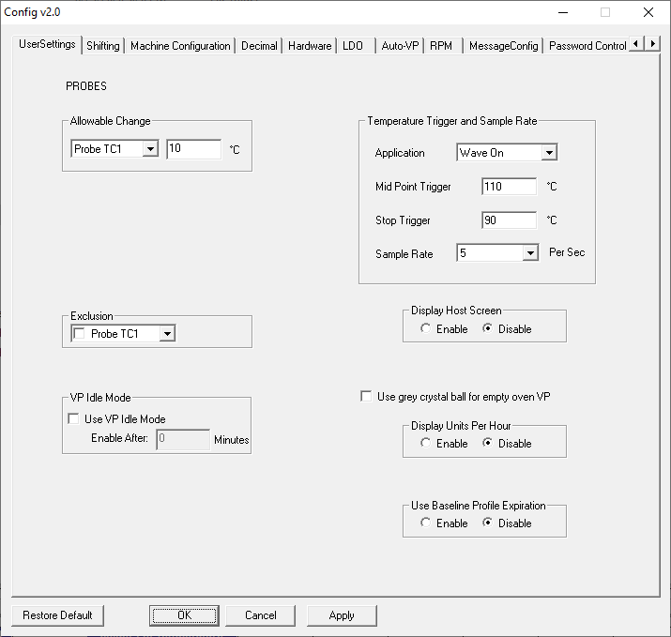

**Exclusion** – Allows user to disable any of the 30 probe TC’s from the VP calculations.

**VP Idle Mode** – Optional feature that can be used along with energy savings features of some machines.

**Display Host Screen** – Enables/disables the display of the Host diagnostic screen.

**Display Units Per Hour** – Enables live display on top of VP general tab that tracks how many products have been processed in the past hour (value resets at the top of each hour).

**Use Baseline Profile Expiration** – Automatically require new baseline profiles after specified number of days.

**Temperature Triggers and Sample Rates**

The temperature triggers dictate when the profile begins and ends allowing for more consistent data collection. This area of the tool allows you to change the temperature trigger values as well as sample rate for each application type.

There are three temperature triggers:

**Start -**The profile Start temperature trigger is always 2C above the “Maximum Product Temperature at start of profile” setting in the Global tab of the Global Preferences screen. This value can be changed as needed from as low as 15C to as high as 40C.

**Mid Point –** The midpoint temperature trigger must be higher than the start trigger, and the End trigger. Be sure the temperature in your process will achieve this setting, or the profile will fail to download.

**End –** The profile will end when all of the thermocouples attached to the profiler have cooled to below the End-Temperature trigger setting.

**Sample rate –** Set the sample rate for each application type.

### Use Baseline Profile Expiration

Enabling this function allows the system to require a new baseline profile is run after a specified number of days have elapsed. When enabled, additional functions will appear on various screens in the software.

**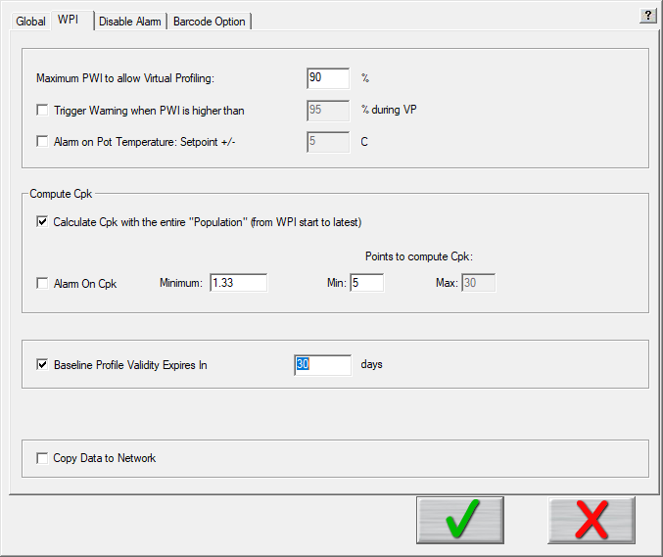**

**Global Preferences/WPI Tab** – When it is enabled in the Configuration Program, it adds an additional selection to this tab. Selecting the checkbox allows you to define the number of days after a baseline profile is run that it will automatically expire. This feature can be used to ensure that the system is always using an up to date profile as the baseline.

Note: When expired, the profile will still be viewable. However, it will not be able to be used as the baseline for monitoring production.



**Profile Explorer – Search Button** - When the expiration feature is enabled, you will see a new button appear in Profile Explorer:

1. Click this button to access a search window which will allow you to easily identify when each of your baseline profiles will expire.
2. Enter the number of days (window of time remaining until profiles will expire), and then click Search.
3. All products with a baseline profile set to expire within the specified timeframe will be displayed.
4. Selecting a particular product and clicking on the *Run New Baseline Profile* will automatically take you to the *RUN A PROFILE* screen and will select that product name.

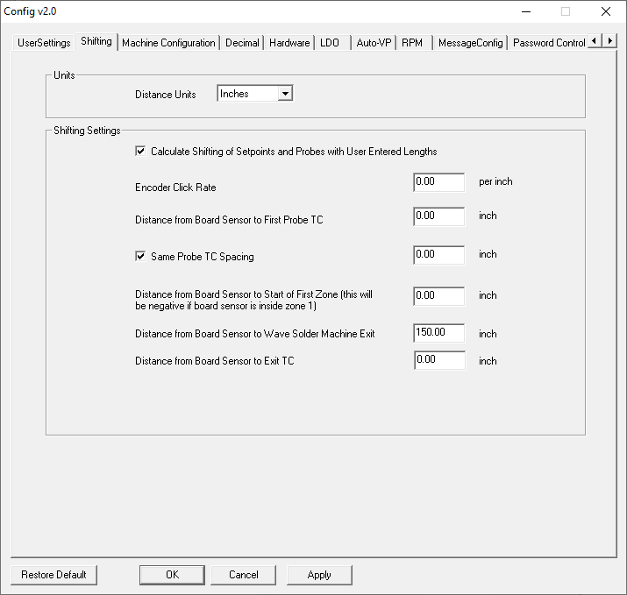

## Shifting Tab

The information entered in this area is used for proper alignment of the profile data, as well as the installed sensors, relative to the layout of the Wave Solder machine the system is installed in.

Select the check box and then enter the required measurements. Contact KIC Technical Support for assistance.

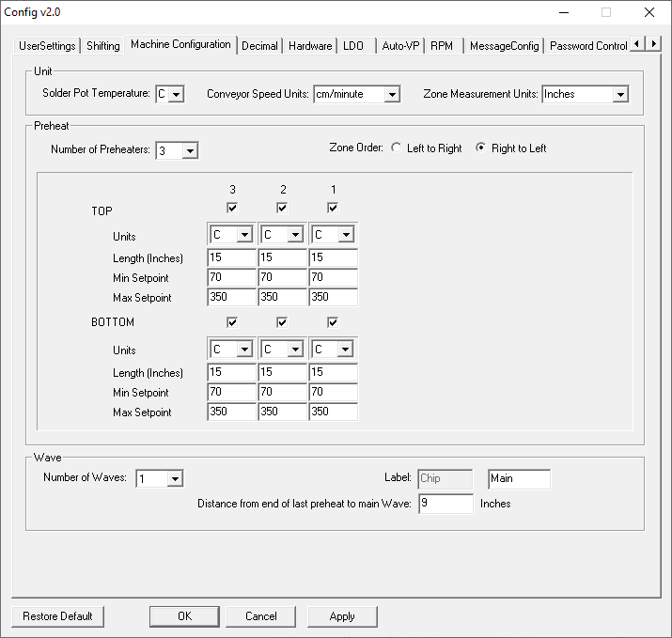

## Machine Configuration

This tab is used for specifying the layout of the Wave Solder machine. The units of measure of the different areas are selected, the number, and configuration, of the preheat zones, as well as the number and labels for the solder waves.

## 

## Decimal Tab

This area controls the number of decimal places for the Conveyor Speed and Zone Setpoints displays in the software.

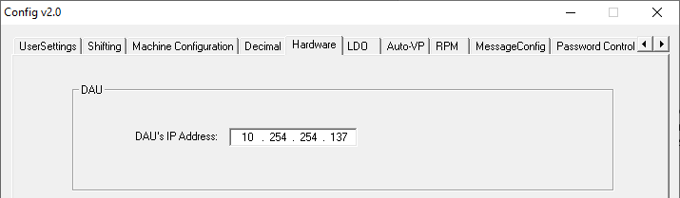

## Hardware Tab

This area specifies the configuration of the DAU or eTPU network address.

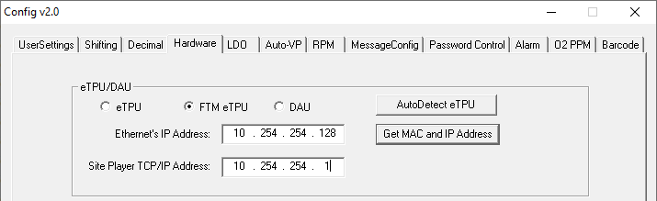

## LDO Tab

See [LDO Configuration](#_Configure_LDO) section

## Auto-VP Tab

Auto-VP is a specialized feature for product changeovers that is dependent on a wide variety of variables. There are multiple configurations of the Auto-VP feature depending on the capabilities and processes in place in the factory. Contact your systems supplier or KIC Technical Support to identify if this functionality can be implemented with your system

## RPM Tab

See [RPM Configuration](#_Remote_Process_Monitoring) section

## Message Config Tab

When certain messages are displayed in the software, the user can select a checkbox for “Do not show this again”. If checked, that message box becomes “disabled”. This area allows the user to enable or disable those messages.

## Password Control – Multi-User

The software offers a Multi-User Control capability to configure certain functions as password protected and, thus, requiring the use of specific user levels.

The user types are:

* Administrator
* Engineer
* Tech
* Operator (default)

### Access to the Password Control Tab

By default, the Multi-User Control is disabled. When this password function is enabled, it will require the entering the default Administrator password before the Configuration Utility can be accessed. The Password Control tab can only be used by the Administrator, or the Engineer/Tech user types if specified.

If the Multi-User Control is enabled and a user starts the utility, the utility will not launch until they enter the correct password (Default Administrator password is Admin). If the user does not have the password, they can Cancel and close the utility.

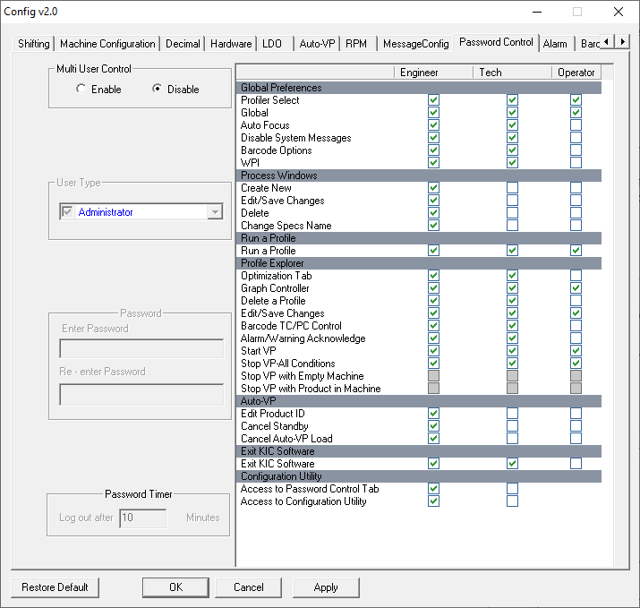

### Multi-User Control

To apply Multi-User Control, Administrators will click the **Enable** radio button and then click **OK**.

The confirmation dialog is answered, and then the utility must be restarted.

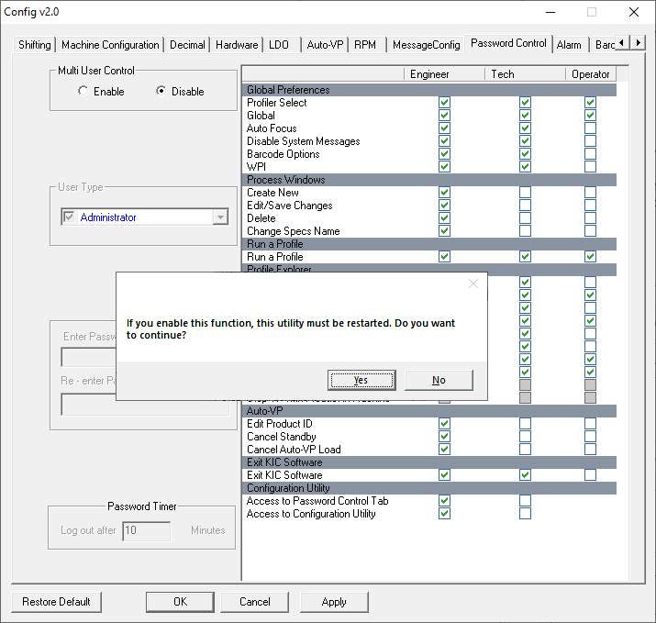

When the administrator logs back in, a password is required.

### Password Control Tab

The **Password Control** tab allows administrators to manage passwords and permissions for each user type. The image below represents the Password Control tab when Multi-User Control is enabled. This tab displays a **Password Control Chart**, highlighted, which contains a list of every area in the software. At the bottom of the list, you can give access to the rest of the Configuration Utility tabs, and the Password Control tab individually.

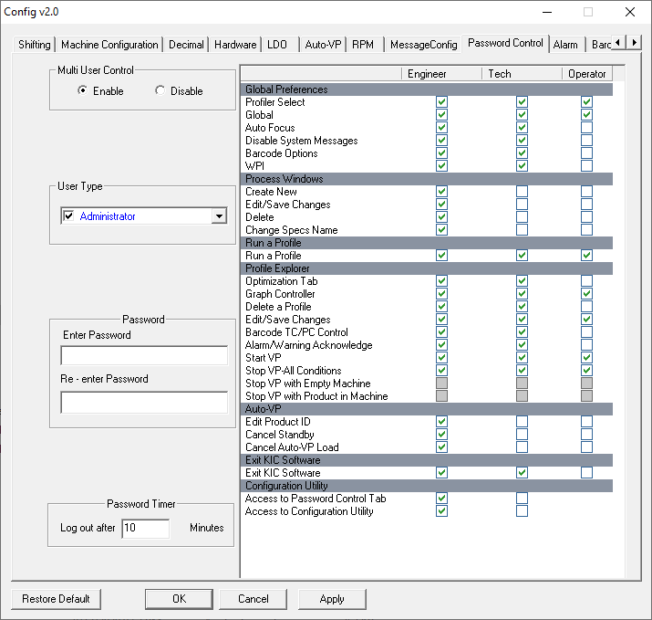

**Stop VP Selections**

There are three different available options for controlling when a VP can be stopped:

* Stop VP – All Conditions: This is the default setting. An authorized user can stop the VP at any time.
* Stop VP with Empty Machine: User can stop the VP only when there is no product in the machine.
* Stop VP with Product in Machine: When user clicks Stop button, they have a choice to wait for products to exit the machine, or they can force a stop even if there is still product inside.

NOTE: To enable use of either of the second two options, the *Stop VP – All Conditions* selection must be unchecked.

**Examples of Stop VP Selections**

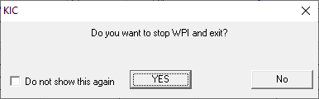**Stop VP with Empty Machine:**

Clicking yes will immediately stop the

current VP and return to the Profile

Explorer screen.

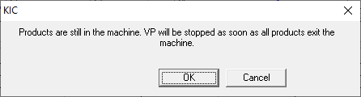**Stop VP with Product in Machine (Not Authorized):**

OK – Clicking OK will acknowledge this message window and the VP will stop automatically once the last board exits the machine.

Cancel – The *Stop* request will be cancelled, and the VP will continue to run.

**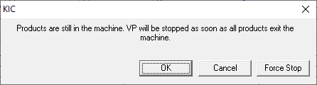Stop VP with Product in Machine (Authorized):**

OK – Clicking OK will acknowledge this message window and the VP will stop automatically once the last board exits the machine.

Cancel – The *Stop* request will be cancelled, and the VP will continue to run.

Force Stop – The VP will stop immediately and return to the Profile Explorer screen.

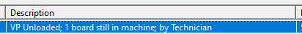

If the ‘Force Stop’ selection is used, additional notes will be automatically added into the *Description* column in Profile Explorer. It will note which user level stopped the VP, and how many products were still in the machine when the stop occurred.

### User Type Area

The **User Type** pick list allows the Administrator to select and enable the password function by user type.

By default, each user in the menu will be unchecked/disabled. By selecting a user type, you not only enable or disable the password entry field and the Password Timer, but also select the type of user to enable and configure.

The columns in the **Password Control Chart** will be enabled depending on the user type selected:

Administrator = All columns enabled

Engineer = All columns enabled

Tech = Only Tech and Operator columns enabled



### Password Area

The Password entry fields are disabled until a user type is selected.

When a user type is selected, the **Enter Password** fields will display as ‘XXXXX” if a password had previously been entered. When a user enters a password ‘X’s will show to indicate an entry, but not show the actual password. After entering a password in the two fields, click the Apply button before changing to another User Type.

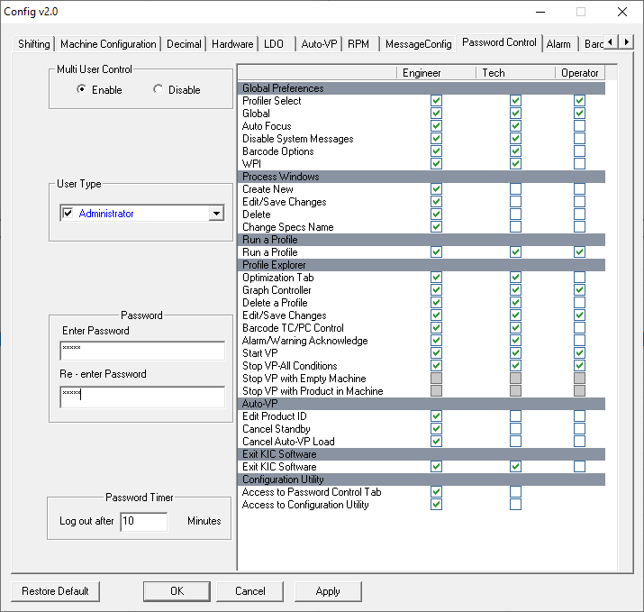

### Password Timer Area

The **Password Timer** is configurable and represents the amount of time before the user is automatically logged out due to being idle.

### Main Screen With Password Control

With Password Control enabled, the software Main Screen with display a Log In button with a letter on it.

O = Operator (default)

A = Administrator

E = Engineer

T = Tech

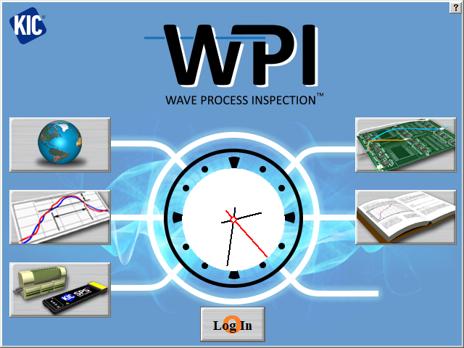

Note that the Operator user type is the default, and typically has the least access privileges.

#### Main Screen Log In

When the Log in button is clicked, the software displays a drop-down menu, as shown here.

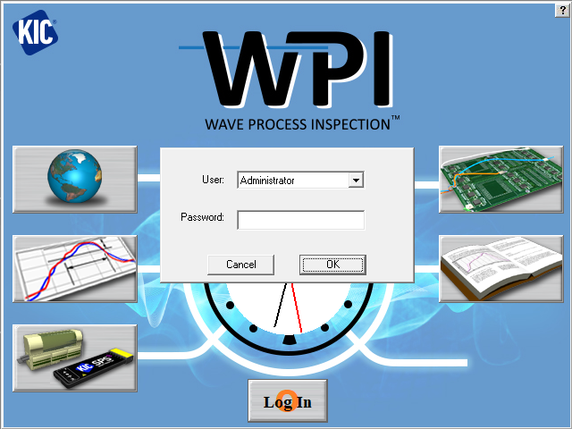

Note that you can log in from most screens, such as from the Log in button in the lower left of the Graph screen.

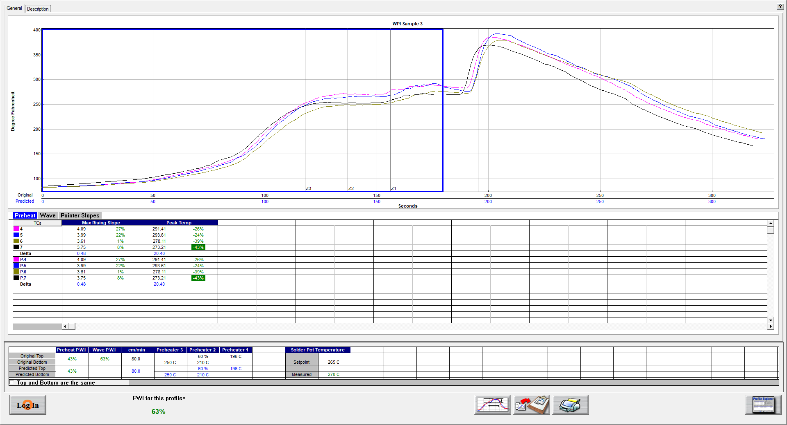

### Example of Limited Access to Functions

This screenshot shows the limited access that an Operator, for example, may have. Notice that there are no privileges to create, edit, delete, or save changes.

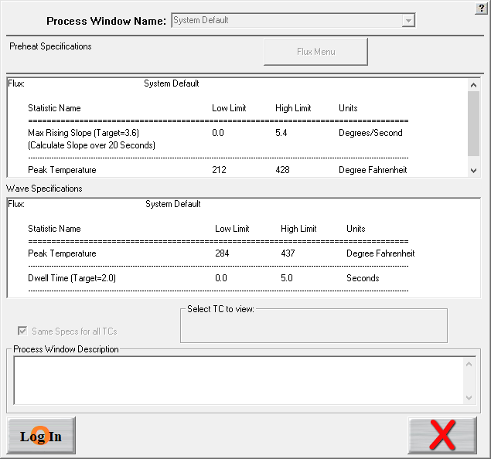

### Responding to an Alarm

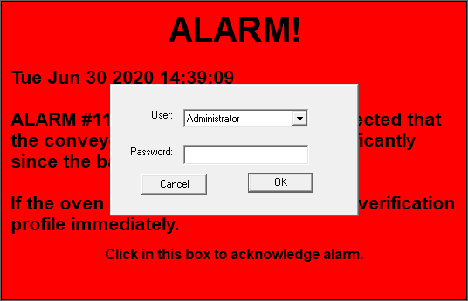

## Alarm Tab

The Alarm tab allows for enabling of the USB Light Tower, and for customizing the operation of the *Alarm Relay* functions.

### Alarm Relay Matrix configuration

When the *Alarm Relay* is in use, you can match the alarm output behavior to your specific production needs through the Alarm Relay (AR) Matrix. By default, the system only outputs a signal to the relay when it is running Virtual Profiling and an alarm (red crystal ball) condition. The alarm condition prompts the DAU/eTPU to send a signal that energizes the *Alarm Relay*, letting it power an audible or light indicator or stop an infeed conveyor

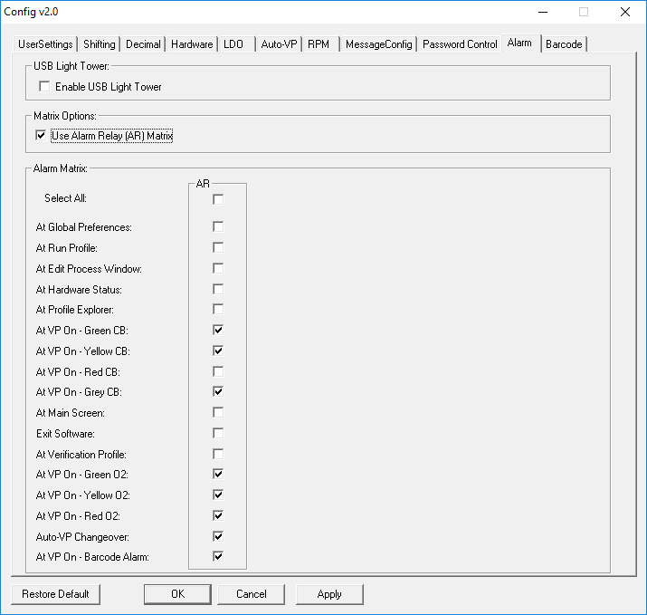

When enabled, a list of operational conditions appears. If an item is checked, the Alarm Relay will be energized during that condition. If an item is unchecked, the relay will be de-energized at that condition. For example, you might want to keep boards from entering the machine except when the Virtual Profile is in a green or yellow crystal ball state. Selecting all other items except those two will result in stopping the infeed conveyor from allowing boards to enter under any other condition.

Even if someone tried to bypass the entire system by shutting down the KIC software, it can be configured so that it still would not allow product to enter. The matrix gives you more control over your process, ensuring that system is in use whenever product is run.

**NOTE:** When the *USB Light Bar* is used, changing the settings in this Matrix will not alter the *USB Light Bar* operation. It will only affect the operation of the *Alarm Relay.*

|  |
| --- |
|  |

### USB Light Tower configuration

#### Enable/Disable USB Light Tower



To enable the use of the USB Light Tower, enable the checkbox on the Alarm tab. This will enable the default operation of the USB Light Tower as previously described.



When enabled, you will also have the ability to customize the operation of the USB Light Tower. Select the *Use USB Light Tower Matrix* checkbox to activate the matrix functions.

#### USB Light Tower Matrix

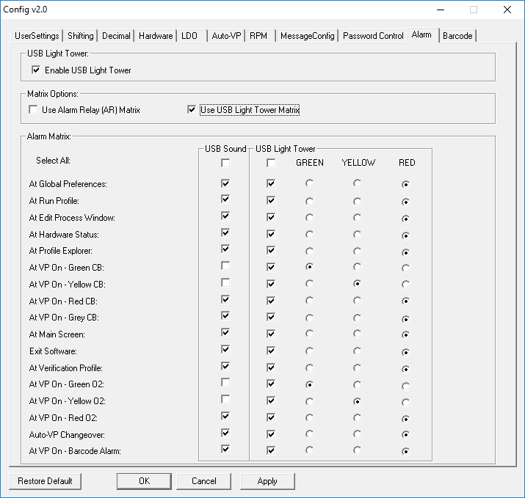

When enabled, a list of operational conditions appears. The matrix allows for enabling individually, the sound and light operation for each condition. If an item is checked, the sound or light turns on during that condition. If an item is unchecked, the sound or light will be off at that condition.

When the Light function is enabled for a condition, one of three colors can be chosen to appear.

## Barcode Tab

The **Barcode** tab is used for configuring some of the barcode interface functions and some barcode operations.

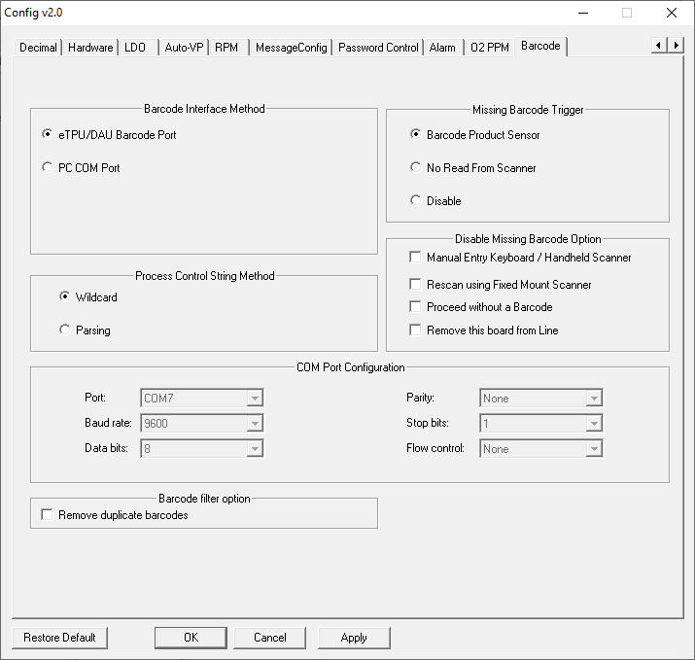

### Barcode Interface Method Area

The **Barcode Interface Method** area specifies where a barcode string will be coming in:

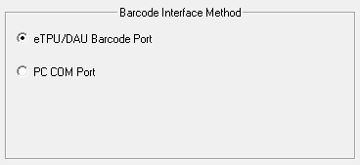

**eTPU/DAU Barcode Port** – via 9 pin serial connection on eTPU/DAU, or DAU USB port.

**PC Com Port** – via 9 pin serial port or USB Port on PC. **NOTE:** To use a USB barcode scanner, it must be programmable for a USB Serial Port interface.

If PC Com Port is selected, the **COM Port Configuration** area also becomes active. This area specifies which Com Port the scanner is connected to, and the Com settings. This area must be configured when using either a DB9 (Com Port) or USB connected scanner and connecting directly to the PC:



### Missing Barcode Trigger Area

The **Missing Barcode Trigger** area specifies what method is used to trigger the Missing Barcode Alarm function.

**Barcode Product Sensor** – requires the installation of the BPS sensor adjacent to the barcode scanner. If this sensor is triggered, and a barcode is not received, the Missing Barcode Alarm is generated.

**No Read From Scanne**r – some scanners can be programmed with a “No Read” output. If “No Read” is the string received, the Missing Barcode Alarm is generated.

**Disable** - the software will never generate a Missing Barcode alarm. Typically used when some other process verification is in use and the alarm from KIC is not required/desired.

NOTE: When either **“No Read From Scanner”** or **“Disable”** is selected, some of the configurations previously referenced in the [*Barcode Section*](#_Barcode_Tab) will automatically be disabled.

### Process Control String Area

This area allows you to select which method of Process Control string identification will be used in the software:



**Wildcard**: Default setting; This method requires that the *Control String* being defined is always an uninterrupted, consecutive grouping characters – either at the beginning, middle, or end – of a barcode string.

**Parsing:** This method allows you to select any specific characters from within a barcode string to be used as the *Control String.* The Parsing method is helpful when the locations of the Control Strings vary from product to product.

### Disable Missing Barcode Option Area

This area allows you to disable some of the available choices that are given when a Barcode alarm is displayed:



The four selections listed represent buttons that a user can click on when a Barcode alarm appears on the screen. By selecting a particular checkbox, the software will no longer display that button on the alarm message dialog window.

For example, when the barcode option is in use, and you never want a product to be allowed to enter the machine without the associated barcode string attached to the data, you can select the ‘Proceed without a Barcode’ checkbox. This will prevent that button from being accessible. Below is an example of a Missing Barcode Alarm condition, when that function is disabled. The open spot is where the ‘Proceed without a Barcode’ choice would have been displayed:



### A screenshot of a cell phone Description automatically generatedBarcode Filter Area

For situations where a barcode scanner always sends out multiple scans for each barcode read, enabling this function forces the software to ignore duplicate barcode strings. Once a given string is received, it will ignore any duplicate receipts of that same string. When a different string is received, the filter function resets.

# Contact KIC

|  |  |
| --- | --- |
| **On the Web**  You can find the latest KIC product news along with a library of useful information at our website:  [www.kicthermal.com](http://www.kicthermal.com) or [www.kic.cn](http://www.kic.cn) | map |

**KIC Technical Support**

KIC Tech Support (phone) is available by email:

Americas: [tech@kicmail.com](mailto:tech@kicmail.com)

Europe: [europe.tech@kicmail.com](mailto:europe.tech@kicmail.com)

Asia: [asia.tech@kicmail.com](mailto:asia.tech@kicmail.com)

**KIC Product Training**

Contact KIC Customer Support by email, [training@kicmail.com](mailto:training@kicmail.com)

**KIC Sales**

Contact KIC sales:

USA: [sales@kicmail.com](mailto:sales@kicmail.com)

Europe: [europe.sales@kicmail.com](mailto:europe.sales@kicmail.com)

Asia: [asia.sales@kicmail.com](mailto:asia.sales@kicmail.com)

China: [asia.sales@kicmail.com](mailto:asia.sales@kicmail.com)

**Find the KIC Representative in Your Area**

Send an email or visit our web page to find a local representative.